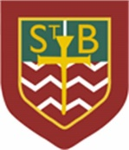St Barbara’s Primary School
Curricular Areas | Primary 7 Suggested Daily Learning Activities  Tuesday 12th May
Literacy | - What did you do over the bank holiday weekend? I would like you to write a short recount of what you did during the long weekend. Take care when structuring your writing and try to use some interesting vocabulary. Remember to double check your spelling and punctuation.  - Today we are going to focus on exploring similes and metaphors. It’s important that you are able to identify the difference between a simile and a metaphor. The activities I have set below are further explained under this grid;  - Identify which statements are similes and which are metaphors.  - Read the passage and select the similes and metaphors included in the text.  - Identify the metaphors within the extract of the poem, ‘The Highwayman’ by Alfred Noyes.  - Answer the follow up questions about the poem.  Complete these activities in your jotter and remember you can send me over any work that you have completed.  - Find a quiet place in your house today and spend some quality time reading. It is very important that you do some personal reading every day.
Numeracy | - I would like you to try and complete some of the activities from this weeks’ Daily Rigour. I have attached a copy of this weeks’ edition of the newspaper. Watch the video link below to find out last weeks’ solutions.  https://www.youtube.com/watch?time_continue=9&v=Icej4kh0qNk&feature=emb_logo  - I have created a new pod on Study Ladder. This pod has 8 different fun activities that revises how to multiply and divide by 10, 100 and 1000. I would like you to log in to Study Ladder and try to complete as many of these tasks as possible. If you need your Study Ladder log in details feel free to contact me and I can send them over to you.  - We all know how important it is to feel confident with our times tables. Today I would like you to focus on a times table that you still find a little bit tricky. The activity I have attached below might be a fun way to revise your chosen times table. This is simple to make and makes learning that times table, that keeps catching you out, a lot more fun. You can do this for as many times tables as you would like.
Health and Wellbeing | - What is the best way to keep our minds positive and bodies healthy? Another home workout challenge. Choose a different home workout than you selected last week and try to complete it with as much energy as possible. Good luck and remember to have some water handy, I think you might need it.  - Today I would like you to remember to be grateful for the little things, even in difficult times. Try to do something nice for someone in your household today to show them how much you appreciate them.
TIOF | - I would like you to say another decade of The Rosary today. On a Tuesday we celebrate the ‘Sorrowful Mysteries’. Today we will explore the second ‘Sorrowful Mystery’, Our Lord is Scourged at the Pillar, (Matthew 27:26). Go to the May altar that you have created or find a quiet spot in your house and close your eyes. If you have your own set of rosary beads it might be a nice idea for you to use them.  - In our lesson last week we looked at different medals honouring Mary. Today we are going to learn the story behind one of those medals, Our Lady of Czestochowa. I would like you to read the story of Our Lady of Czestochowa that I have attached below. When you have read the story I want you to use what you have learned and create a storyboard telling of the travels of this famous painting. I have also included a template for the storyboard, however, if you want to create your own, feel free to do so.  - Remember to go on to The Diocese of Motherwell Twitter page to access the Daily Angelus Challenge.
Additional Tasks | If you wish to complete more tasks please select one or two tasks from your Second level grid for May.

Similes and Metaphors
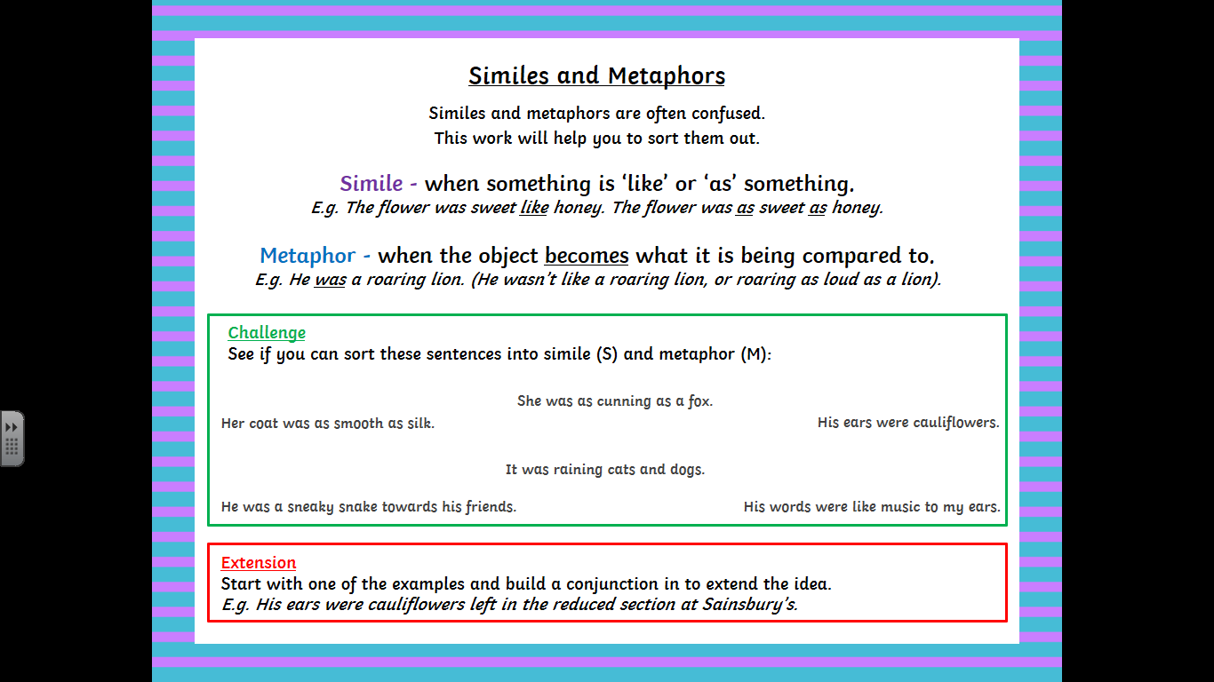

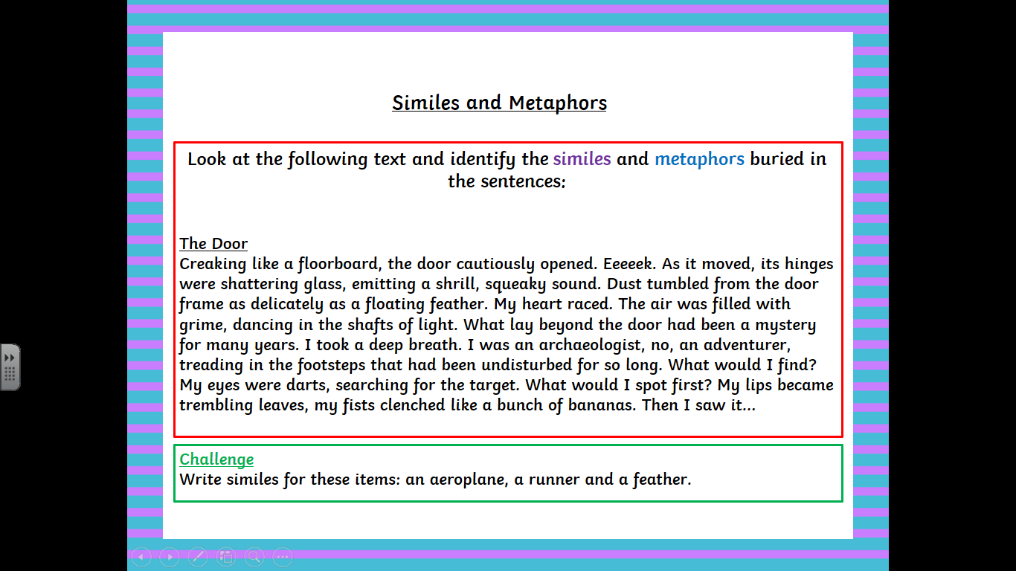

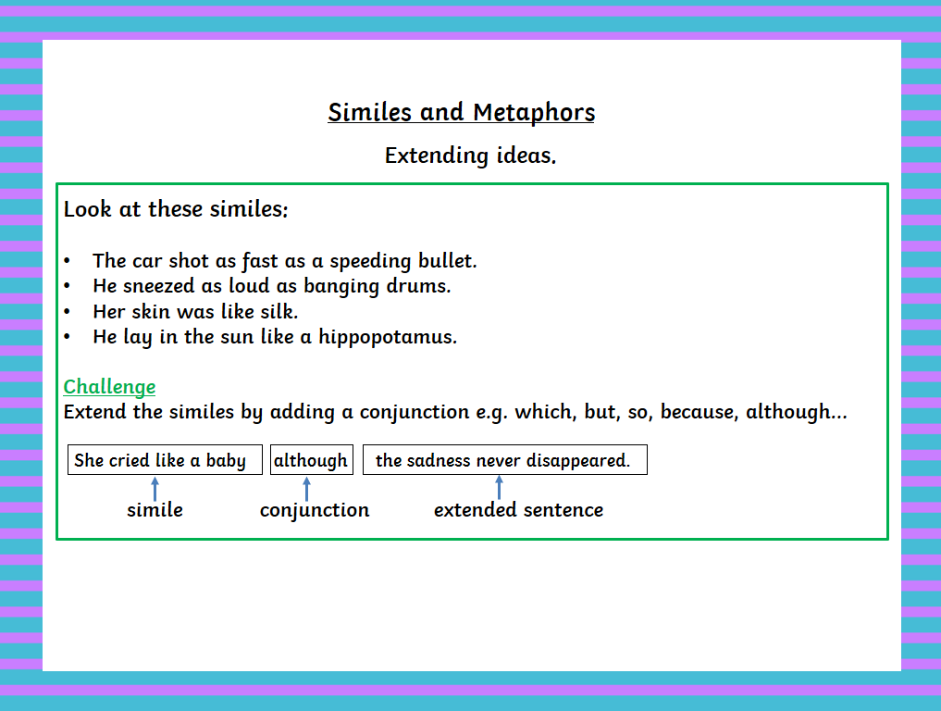

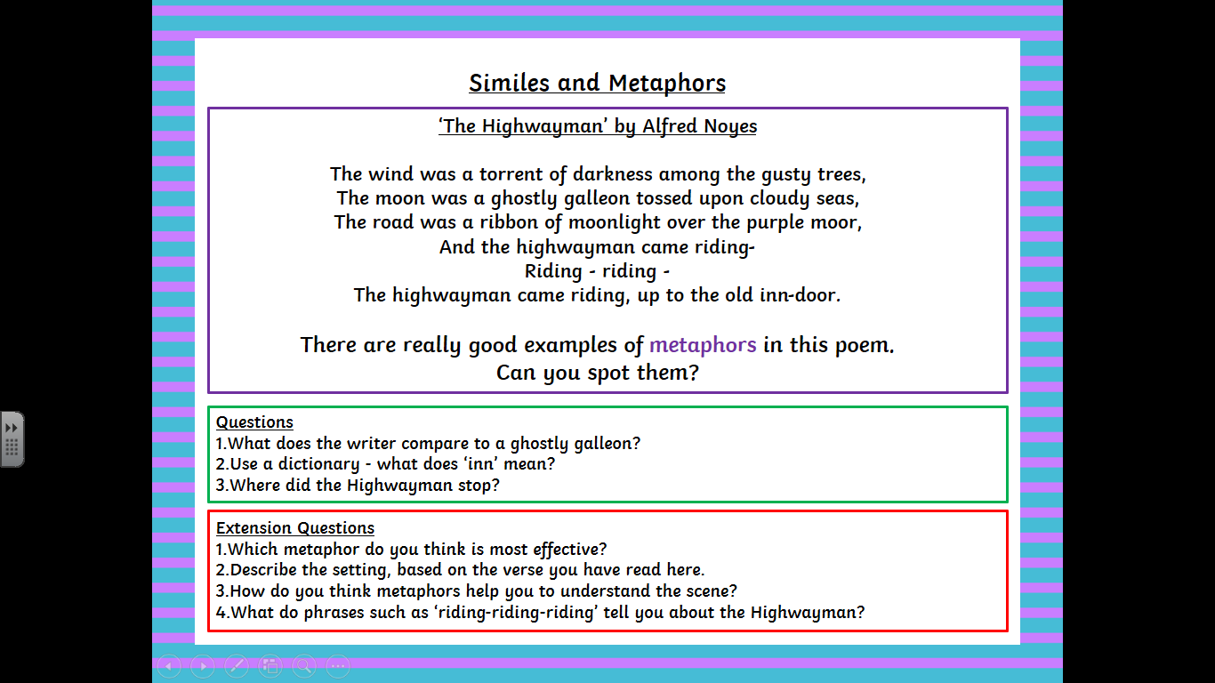

Daily Rigour

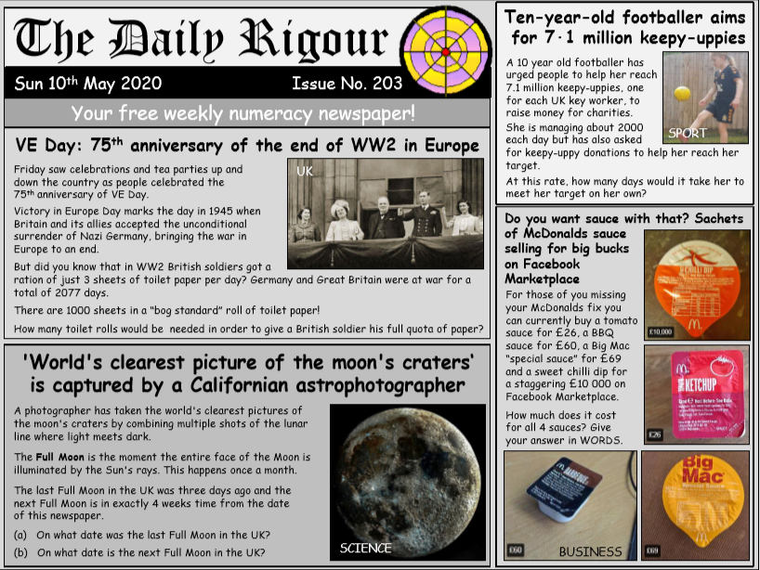

Home Workout Challenges

Our Lady of Czestochowa

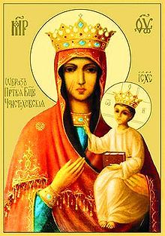
Northeast of the ancient city of Krakow, Poland, is the small town of Czestochowa. To every Pole the name means but one thing – Mary’s Sanctuary. On a nearby hill – the Bright Hill, Jasna Gora in Polish – the Monks of St Paul the Hermit have a monastery. In the chapel of Our Lady in their monastery church, is the famous painting of the Blessed Virgin. This painting of the Mother of God holding the Child Jesus in her arms, bears the title, Our Lady of the Bright Hill (Jasna Gora) she is the Patroness and Protectress of the Poles; the Queen of the Crown in Poland.
The history of Our Lady of Czestochowa is the history of Poland. Traditional holds that this picture of Mary was painted by St Luke the Evangelist on a table which was taken from the house of the Holy Family to the house of St John, by Mary, after the crucifixion. It is thought that it was made by Jesus and His father, Joseph.
It was the Christians of Jerusalem who presented this picture to St Helen, the mother of Constantine. She in turn gave it to her son and so it was put in his palace at Constantinople. The salvation of this city while besieged by the Saracens was ascribed to Our Lady’s intercession. The Byzantine Emperors showed great devotion for this picture and were able to hide it during the Iconoclast (breaking of images) persecution, thus saving it from destruction at the hands of the heretics who tried to destroy all statues and images. In 989, upon the marriage of Princess Anna, the sister of the Emperor, to Prince Vladimir of Kiev, the picture of Our Lady of Czestochowa was a wedding gift taken to her, to the Ukraine.
In the fourteenth century the picture was again in danger due to the Tartar raids. In a dream the wish of Our Lady was made known to Prince Ladislaus of Opol and in fulfillment of it, the holy image was taken to Jasna Gora. At that time the monks of St Paul the Hermit were invited to come from Hungary and be the custodians of the shrine. During the Hussite persecution, heretic s plundered the monastery and the church. They hurled the precious image of Our Lady of Czestochowa to the ground and it was broken into three pieces. But when they tried to carry it off, the wagon bearing the image could not be moved. In rage one of them drew a sword and struck Our Lady’s cheek twice. As he raised his arm a third time he fell dead on the spot. Seeing this, his comrades fled in terror.
Under King Ladislaus II of Poland a commission of artists restored the painting but no effort on their part could remove the sword strokes which remain to this day. These artists at the time placed a silver background over the upper part of the picture on which five scenes were engraved. These are: the Annunciation, the Adoration of the Christ child, the Scourging at the Pillar, Christ mocked by the soldiers, and St Barbara, to whom Poles had a great devotion.
The Kings of Poland were especially devoted to Our Lady of the Bright Hill; at her shrine they, with their people sought intercession in all needs of the nation. In danger from the Turks, during invasion by Swedes, under siege by Prussians, Austrians and Russians, after the partition of Poland in 1795, during the German invasion of 1939, and today under Communism, the hearts of Poles have ever turned to Our Queen. Her shrine at Jasna Gora is for them a symbol of their faith and hope.
On May 7, 1957, Polish Catholics entered the first year of the “GREAT NOVENA” as their nine-year program of prayer is called. It was in 1956 that a million Polish pilgrims visited the shrine and out of that pilgrimage grew the Jasna Gora Vow, to prepare for the 1000 anniversary of Poland’s conversion, known as the Sacred Millennium, by nine years of prayer and work for a Christian life. Thus today, even though the picture of Our Lady of Czestochowa is framed in somber black, the Polish Catholics turn once aging to Mary and hold themselves loyal subjects of the Queen of the Crown of Poland, Our Lady of Jasna Gora or Czestochowa.
Story Board Template- Our Lady of Czestochowa
1. It is believed that St Luke painted the image on a table made by St. Joseph for the home of the Holy family.

6. The Kings of Poland turned to the shrine of Our Lady when they sought intercession for the needs of their country.

