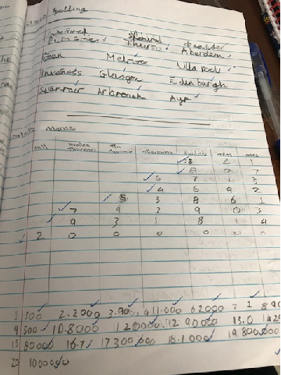**Spelling and Maths Tasks**

**Well done, Euan!!!!**