Thursday 7th May- morning prayer.
Literacy  IALT decode words using phonemes. | Phonics Task- consolidation  Starter- Alphabet name and sounds- My name is A, my sound is a.. (orally)  Warm-up- read through the phonics cards- see how many you know! (sh for shop, ch for chest…)  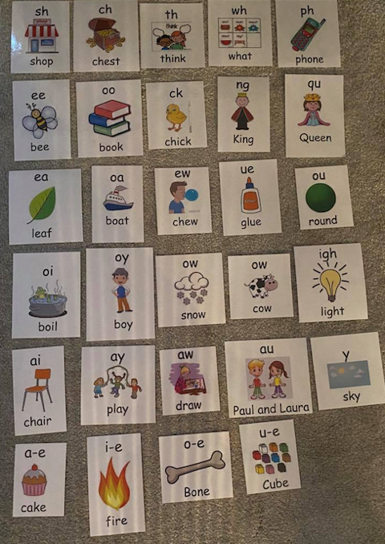  Capital letters group- Some phonemes have different letters but make the same sound. ou (round) and ow (cow) both make the same sound.  Can you think of anyone ou or ow words…  Watch this video to revise words with ou or ow > https://www.youtube.com/watch?v=ySRd-Amrd28  Complete the tasks below-  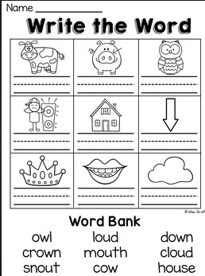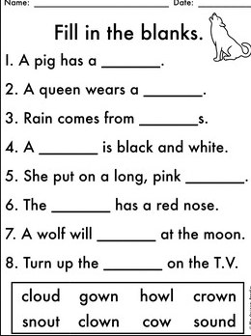  Full stops group- ay (spelling rule- the ‘ay’ phoneme is always at the end of a word-eg, play).  Watch > https://www.youtube.com/watch?v=eoy1JXYPn6w  Complete the task’s below-  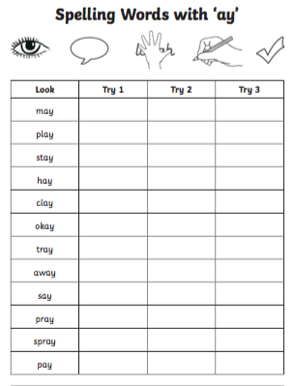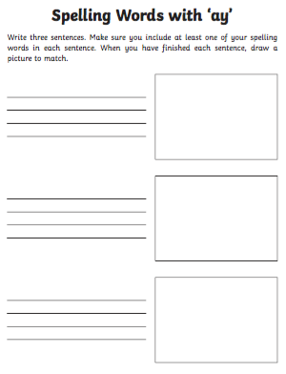  Reading Task- Oxford Owl  We are going to have another look at our reading books today.  Apples- I would like you to search for ‘Key Trouble’ and read this out loud to someone at home.  Bananas- I would like you search for ‘Christmas Adventures’ and read this out loud to someone at home.  Strawberries- I would like you to search ‘A Monster Mistake’ and read this out loud to someone at home.  After you have read your book, I would like you to select one of the tasks from the grid below.  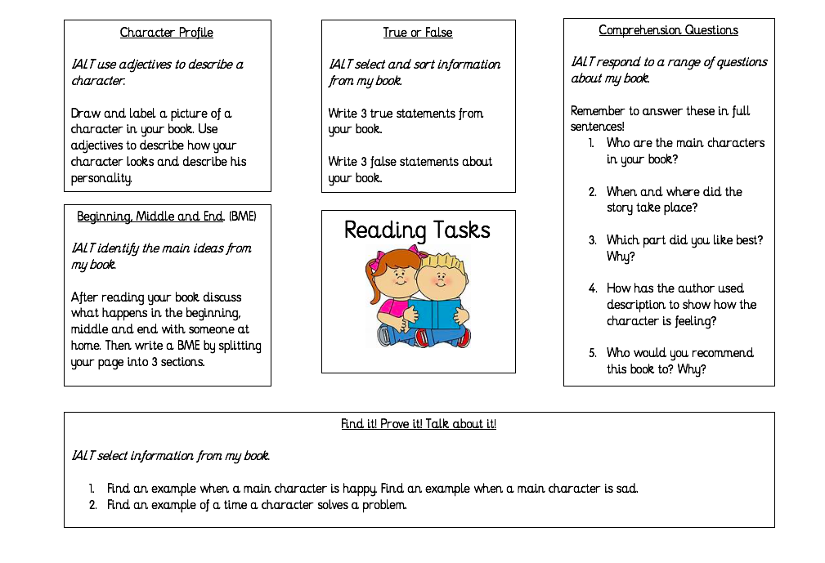
Numeracy  IALT | We are going to focus on odd and even numbers today.  Watch this video-  https://www.youtube.com/watch?v=-kHtGbnYKGc  Now that we know a bit more about odd and even numbers using your 100 number square that you completed for Monday’s task, I would like you to colour in the odd and even numbers using 2 different colours. It should look something like this afterwards.  Can you notice a pattern?  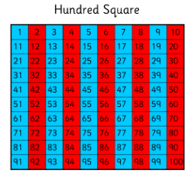  Challenge- Get someone at home to ask you to circle numbers before, after and between on your 100 number square. (eg, Can you circle the number before 15)  Once you have done this I would like you to complete the worksheet below …are the numbers even or odd? Use the pictures to help you decide!  Remember the rules when you are making your decision >  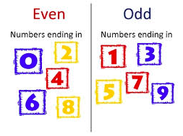  Odd or Even task- Complete this on the worksheet or in your jotter.  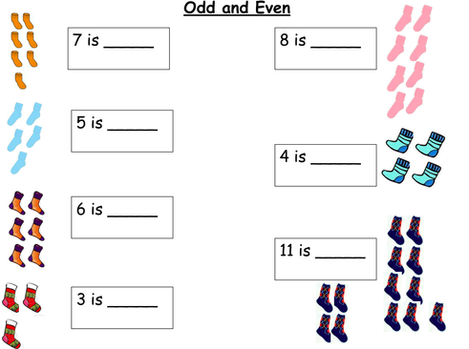
HWB | Tomorrow is meant to be another beautiful day so why not go a lovely walk outside to finish your day of learning.  I have really enjoyed going out my daily walk each day. During my walk tomorrow my little sisters and I are going to go on a scavenger hunt, why don’t you join in as well!  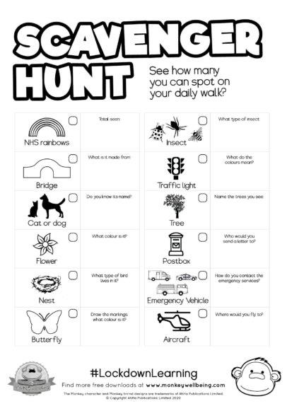  I can’t wait to see what we will spot!
T.I.O.F | We should now be on day 5 of the DOM Angelus. Have you been following? I would like you to follow today’s video.  After, record it by colouring in one of your flowers for today.  We are continuing to honour Mary during the month of May. I hope you managed to create a lovely Altar somewhere at home. A beautiful hymn that I love to sing during the Month of May is Bring Flowers of the Rarest. Why not try learn this and sing along.  https://www.youtube.com/watch?v=Ld4FNjK4IEQ
IDL topic | Thank you so much for helping Barnaby Bear on Monday! Thanks to you, Barnaby Bear managed to go on his adventure across Scotland and see some beautiful sights.  There is a power point on the blog to see what he got up to along with a few tasks for you to help him complete.  If you would like to see more about what Barnaby Bear got up to, here is a video of his time in Edinburgh, Scotland’s capital city.  https://www.youtube.com/watch?v=Fa5_MHHij4E

