**The Good Shepherd**

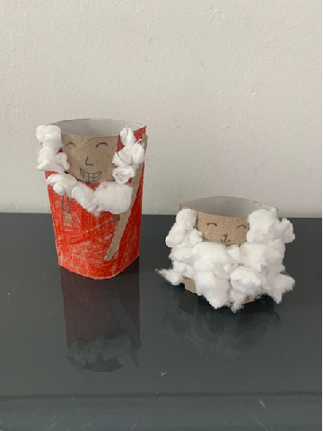**by Rachel**