**GOLD Challenge: 1**

Write the population of each country

**using words**:

[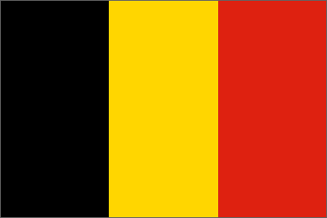](http://www.google.co.uk/url?sa=i&rct=j&q=&esrc=s&source=images&cd=&cad=rja&uact=8&ved=0ahUKEwiS_8WgyObOAhUEWRoKHbF4AbQQjRwIBw&url=http://www.mapsofworld.com/flags/belgium-flag.html&psig=AFQjCNE-cSUZ1Qjg4M413kz2Acnz9nwbRQ&ust=1472558021898020)a) Belgium:

**10,449,361**

[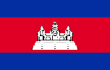](https://www.google.co.uk/url?sa=i&rct=j&q=&esrc=s&source=images&cd=&cad=rja&uact=8&ved=0ahUKEwjhvsmzyObOAhXHMBoKHRSPCx4QjRwIBw&url=https://en.wikipedia.org/wiki/Flag_of_Cambodia&psig=AFQjCNGYdZpr1nBS2kmvCBykbweuB4d-GA&ust=1472558062151820)b) Cambodia:

**15,458,332**

[](https://www.google.co.uk/url?sa=i&rct=j&q=&esrc=s&source=images&cd=&cad=rja&uact=8&ved=0ahUKEwiL6K3HyObOAhUFDxoKHVStA_gQjRwIBw&url=https://en.wikipedia.org/wiki/Flag_of_the_Czech_Republic&psig=AFQjCNE_1Jfy6Xcosm4vrhqngHB3tTVWnw&ust=1472558103489446)c) Czech Republic:

**10,262, 014**

[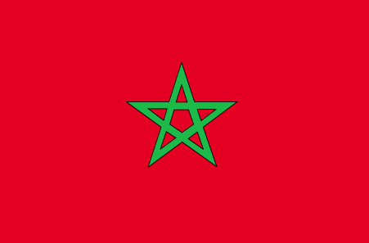](http://www.google.co.uk/url?sa=i&rct=j&q=&esrc=s&source=images&cd=&cad=rja&uact=8&ved=0ahUKEwjQ_MHWyObOAhWJ1BoKHTwIAbUQjRwIBw&url=http://www.worldatlas.com/webimage/flags/countrys/africa/morocco.htm&psig=AFQjCNHvWkgx2EQ5s51KzVqLL4Cc_HBOJg&ust=1472558134469234)d) Morocco:

**32,987,038**

[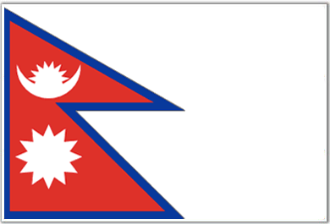](http://www.google.co.uk/url?sa=i&rct=j&q=&esrc=s&source=images&cd=&cad=rja&uact=8&ved=0ahUKEwj03P_pyObOAhVF1BoKHUx5CcUQjRwIBw&url=http://www.mapsofworld.com/flags/nepal-flag.html&psig=AFQjCNEvJHmbhbjNVv1EIxiW9G7J_FB4eA&ust=1472558173408289)e) Nepal:

**30,986,003**

[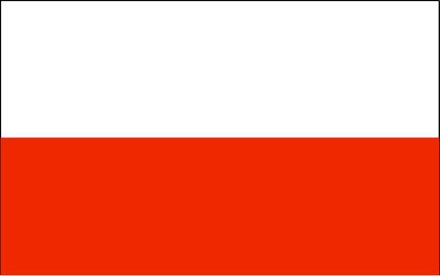](http://www.google.co.uk/url?sa=i&rct=j&q=&esrc=s&source=images&cd=&cad=rja&uact=8&ved=0ahUKEwiMmpX7yObOAhVJHxoKHUxNAq4QjRwIBw&url=http://www.worldatlas.com/webimage/flags/countrys/europe/poland.htm&psig=AFQjCNF_8Nzoo3PQpCgG_NP7T6nS1YSQvA&ust=1472558212030398)f) Poland:

**38, 046, 325**

[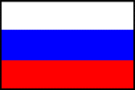](http://www.google.co.uk/url?sa=i&rct=j&q=&esrc=s&source=imgres&cd=&cad=rja&uact=8&ved=&url=http://www.muller-berlin.com/&psig=AFQjCNGeJq2t19aJNjMTL00qnEtHf8Gz5A&ust=1472558251995372)g) Russia:

**142, 470,019**

**Which of these countries has the greatest population?**

**Which has the smallest population?**

**Gold Challenge: 2**

Practise writing these large amounts **using digits**.

a) Write Robinho’s transfer fee in figures. He cost Manchester City **thirty two million, five hundred and ninety-five thousand pounds.**



b) Berbatov cost Manchester United **thirty million, seven hundred and fifty thousand, five hundred and eight pounds.**

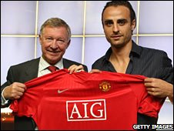

c) Liverpool signed Torres for an estimated **twenty three million, five hundred thousand and ten pounds.** Change these words into figures.



d) The most expensive player ever bought cost **forty five million, three hundred and twenty five thousand, five hundred and ninety five pounds.** Write these words in figures.

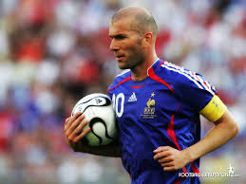

**. Wayne Rooney**

**Wayne Rooney**