St Barbara’s Primary School
Curricular Areas | Primary 7 Suggested Daily Learning Activities  Wednesday 6th May
Literacy | - For reading today explore the First News newspaper article, I’m In Mum’s Bad Books. When you have finished reading the article, read the questions and then skim and scan the text before attempting to answer any of the questions. Answer the questions in your jotter and remember to use the question to help you structure your answer. The answers are in the text so always refer back to the article to help support you. I have attached a link to today’s article, questions and answers on the Primary 7 GLOW homepage. Remember no peeking at the answers before you give the questions a go!  - I am missing you all terribly and thought the following task might be a fun way to find out what you have all been up to since lockdown started. Today I would like you to write me a post card detailing what you have been doing. What have you and your family been doing? How have you been spending your days in the sunshine? Have you learned any new skills that will be useful for the future? What has been your favourite thing that you have done during lockdown? What has been your toughest challenge? I have attached a postcard writing template to the Primary 7 GLOW homepage.
Numeracy | Over the past few days we have been revising how to multiply and divide by 10,100 and 1000. Today I would like you to complete some activities that help consolidate what we have been learning.  - Complete the Space Invaders game. Move from each level by multiplying and dividing the given numbers by 10, 100 and 1000. Read the instructions carefully before completing the activity.  - Who wants to be a millionaire? Take part in the quiz and test your knowledge of multiplying and dividing by 10. 100 and 1000. Can you win £1,000,000?  I have attached the worksheet and PowerPoint for these activities on the Primary 7 GLOW homepage.
Health and Wellbeing | - Can you use the alphabet fitness grid below to spell your name? To continue with our warm-up why not use some of our focus homophones to do some additional exercise? Time to get our hearts pumping!  - Yoga is a great way to relax and help promote a positive mindset. Click on the link below to take part in Yoga for teens by Adriene.  https://www.youtube.com/watch?v=7kgZnJqzNaU
Science | Time for a little bit of science! Today BBC Bitesize are delivering a lesson on how plants reproduce. To find out more, watch the video clips and complete the follow up activities.  When you have finished watching the BBC Bitesize tutorial have a go at completing the pollination activity that I have included below. Can you remember the steps for pollination to take place? Rewrite the sentences in chronological order.
Additional Tasks | If you wish to complete more tasks please select one or two tasks from your Second level grid for May.

Fitness Warm-up
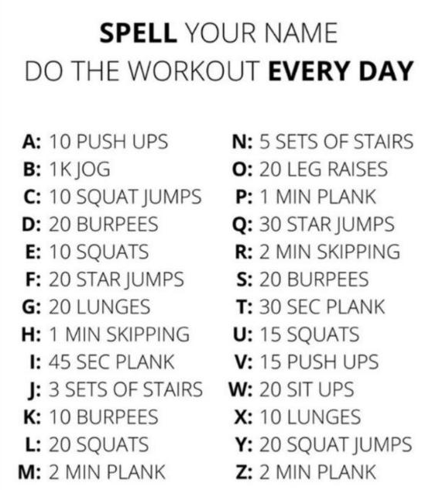
Pollination Process

