[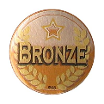](https://www.google.co.uk/url?sa=i&url=https%3A%2F%2Fwww.thenaughtyseat.co.uk%2Fbronze-medal-sports-stickers-1713-p.asp&psig=AOvVaw0ftIti9M5UMnCrjuyV9v6N&ust=1588699257259000&source=images&cd=vfe&ved=0CAIQjRxqFwoTCLCUr4_cmukCFQAAAAAdAAAAABAD)**Place Value**

**Bronze Challenge**

Write the population of each country **using words**:

[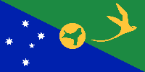](https://www.google.co.uk/url?sa=i&rct=j&q=&esrc=s&source=images&cd=&cad=rja&uact=8&ved=0ahUKEwidsOSI0ObOAhWFWBoKHdviDZIQjRwIBw&url=https%3A%2F%2Fen.wikipedia.org%2Fwiki%2FFlag_of_Christmas_Island&bvm=bv.131286987,d.d2s&psig=AFQjCNG6MDab8Z0P-Rv4UsT2x1ZOlaDYlg&ust=1472560119555521)a) Christmas Island:

**1,530**

[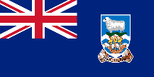](https://www.google.co.uk/url?sa=i&rct=j&q=&esrc=s&source=images&cd=&cad=rja&uact=8&ved=0ahUKEwiH9eea0ObOAhUHOxoKHdvnA4wQjRwIBw&url=https%3A%2F%2Fen.wikipedia.org%2Fwiki%2FFlag_of_the_Falkland_Islands&bvm=bv.131286987,d.d2s&psig=AFQjCNFQizpwfJCApjzXwsj-ZjPlD-81TA&ust=1472560157410847)b) Falkland Islands:

**2,840**

[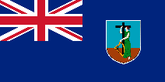](https://www.google.co.uk/url?sa=i&rct=j&q=&esrc=s&source=images&cd=&cad=rja&uact=8&ved=0ahUKEwjB6MCt0ObOAhVEqxoKHe1mBDUQjRwIBw&url=https%3A%2F%2Fen.wikipedia.org%2Fwiki%2FFlag_of_Montserrat&bvm=bv.131286987,d.d2s&psig=AFQjCNF9pbg7U1TPmhmsMc3Qd-_YqCVxnA&ust=1472560196824428)c) Montserrat:

**5,205**

[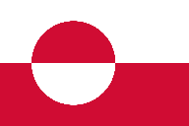](https://www.google.co.uk/url?sa=i&rct=j&q=&esrc=s&source=images&cd=&cad=rja&uact=8&ved=0ahUKEwj4tbS90ObOAhUKAxoKHUmTDcQQjRwIBw&url=https%3A%2F%2Fen.wikipedia.org%2Fwiki%2FFlag_of_Greenland&bvm=bv.131286987,d.d2s&psig=AFQjCNHQCEACBSldvrECD8bKIjoBAEfAGw&ust=1472560230156111)d) Greenland:

**57,728**

[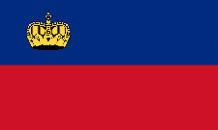](https://www.google.co.uk/url?sa=i&rct=j&q=&esrc=s&source=images&cd=&cad=rja&uact=8&ved=0ahUKEwjWw63O0ObOAhXB1xoKHVf6BWMQjRwIBw&url=https%3A%2F%2Fen.wikipedia.org%2Fwiki%2FFlag_of_Liechtenstein&bvm=bv.131286987,d.d2s&psig=AFQjCNGvC1wLUdtX_S54GAeP-3ND9TnVQA&ust=1472560266029807)e) Liechtenstein:

**36,984**

[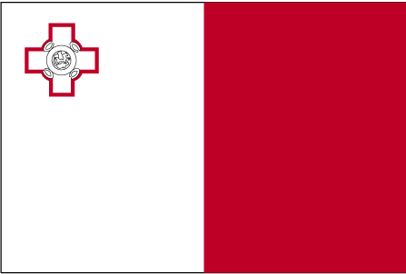](https://www.google.co.uk/url?sa=i&rct=j&q=&esrc=s&source=images&cd=&cad=rja&uact=8&ved=0ahUKEwiJ5oXj0ObOAhXL0hoKHV4uDgoQjRwIBw&url=https%3A%2F%2Fcommons.wikimedia.org%2Fwiki%2FFile%3AMalta_flag_large.png&bvm=bv.131286987,d.d2s&psig=AFQjCNHY_VXZmv-PI6uirtmICFmADkskGQ&ust=1472560295116994)f) Malta:

**412,655**

[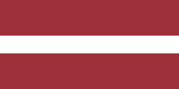](https://www.google.co.uk/url?sa=i&rct=j&q=&esrc=s&source=images&cd=&cad=rja&uact=8&ved=0ahUKEwjh3Pnz0ObOAhUC2hoKHRHCA2YQjRwIBw&url=https%3A%2F%2Fen.wikipedia.org%2Fwiki%2FFlag_of_Latvia&bvm=bv.131286987,d.d2s&psig=AFQjCNHLoJUsEWnGQqqWnpqIUS7bU7F2xA&ust=1472560344152782)g) Latvia:

**2,165,142**

[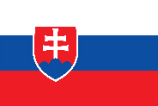](https://www.google.co.uk/url?sa=i&rct=j&q=&esrc=s&source=images&cd=&cad=rja&uact=8&ved=0ahUKEwjXssOC0ebOAhXGHxoKHWYcCkQQjRwIBw&url=https%3A%2F%2Fen.wikipedia.org%2Fwiki%2FFlag_of_Slovakia&bvm=bv.131286987,d.d2s&psig=AFQjCNFieykYtwVbKaZAE3kgNwo3CT_Pyg&ust=1472560375294968)h) Slovakia:

**5,492,182**

**Place Value**

**Silver Challenge**

Write the population of each country **using words**:

[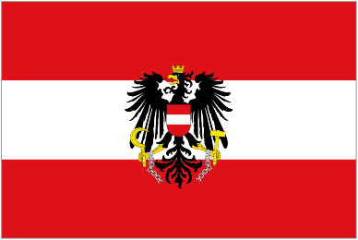](http://www.google.co.uk/url?sa=i&rct=j&q=&esrc=s&source=images&cd=&cad=rja&uact=8&ved=0ahUKEwjZtv3KzObOAhXC1BoKHchjBQgQjRwIBw&url=http%3A%2F%2Fwww.flags.net%2FAUST.htm&psig=AFQjCNFHfR1xuSw3uaF2cihfiiEPKY1EWQ&ust=1472559182515117)a) Austria:

**8,223,431**

[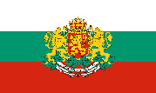](https://www.google.co.uk/url?sa=i&rct=j&q=&esrc=s&source=images&cd=&cad=rja&uact=8&ved=0ahUKEwjpg6rfzObOAhWC6RoKHRyUAyUQjRwIBw&url=https%3A%2F%2Fen.wikipedia.org%2Fwiki%2FFlag_of_Bulgaria&bvm=bv.131286987,d.d2s&psig=AFQjCNHRA-YUaXahXluaiEABu0i8hInUpA&ust=1472559226015739)b) Bulgaria:

**6,942,328**

[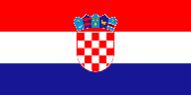](https://www.google.co.uk/url?sa=i&rct=j&q=&esrc=s&source=images&cd=&cad=rja&uact=8&ved=0ahUKEwjdm5b7zObOAhUH1hoKHdnaCV8QjRwIBw&url=https%3A%2F%2Fcommons.wikimedia.org%2Fwiki%2FFile%3AFlag_of_Croatia.svg&psig=AFQjCNExQUUhkl5kPfJunRnthhlxtf_mnw&ust=1472559284874696)c) Croatia:

**4,470,318**

[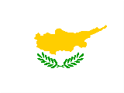](http://www.google.co.uk/url?sa=i&rct=j&q=&esrc=s&source=images&cd=&cad=rja&uact=8&ved=0ahUKEwjDneuNzebOAhWJ1xoKHbGJBd8QjRwIBw&url=http%3A%2F%2Fwww.freestockphotos.biz%2Fstockphoto%2F11594&bvm=bv.131286987,d.d2s&psig=AFQjCNHXm1OP54yqFfZuaFJSlbu-TZ2EVA&ust=1472559320538502)d) Cyprus:

**1,172,346**

[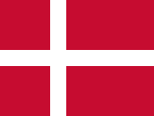](https://www.google.co.uk/url?sa=i&rct=j&q=&esrc=s&source=images&cd=&cad=rja&uact=8&ved=0ahUKEwjIzZOezebOAhWCXBoKHYwnD0kQjRwIBw&url=https%3A%2F%2Fen.wikipedia.org%2Fwiki%2FFlag_of_Denmark&bvm=bv.131286987,d.d2s&psig=AFQjCNESz2jBwJVZokQn2If9UdWpA1xC0A&ust=1472559359257956)

e) Denmark:

**5,556,380**

[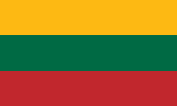](https://www.google.co.uk/url?sa=i&rct=j&q=&esrc=s&source=images&cd=&cad=rja&uact=8&ved=0ahUKEwjEwL-szebOAhXJLhoKHfBPCTIQjRwIBw&url=https%3A%2F%2Fen.wikipedia.org%2Fwiki%2FFlag_of_Lithuania&bvm=bv.131286987,d.d2s&psig=AFQjCNHskbzVeEihryTEGiC7euoaWZNszQ&ust=1472559388842858)f) Lithuania:

**3,505,738**

[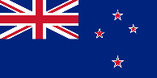](https://www.google.co.uk/url?sa=i&rct=j&q=&esrc=s&source=images&cd=&cad=rja&uact=8&ved=0ahUKEwihhNm6zebOAhWK2xoKHVJeDLsQjRwIBw&url=https%3A%2F%2Fen.wikipedia.org%2Fwiki%2FFlag_of_New_Zealand&bvm=bv.131286987,d.d2s&psig=AFQjCNFByX-HZNGl9Xzuqa8tWg4RysInYQ&ust=1472559418860086)g) New Zealand:

**4,401,802**

**Silver Challenge: Extension**

Which of these countries has the largest population?

Which has the smallest?