‘As long as we keep Scilly Rock astern of us we can pull home easily enough,’ Daniel said softly.

‘But how are we going to do that if we can’t see it?’ I whispered, taking the oar he was handing me. ‘I can’t see it anymore.’

‘We can hear it though, can’t we?’ he said. ‘Listen.’ And certainly I could hear the surge of the sea seething around Scilly Rock as it always did even on the calmest of days.

‘Hear it?’ he said. ‘Just keep that sound astern of us and we’ll be able to feel our way home. Gweal must be dead ahead from here. There’s no swell to speak of, so we won’t go on the rocks. All we have to do is to hug the coast all the way round and that’ll bring us nicely into Popplestones.’

And so we began to row, only a few strokes at a time, stopping to listen for the sea around Scilly Rock. It was not long though before I began to think that Gweal was not at all where it should have been. We had already been rowing quite long enough and hard enough to have reached it by now. Then I thought that, perhaps the current must have dragged us off course, that we must be somewhere between Samson and Bryher, that I could still hear Scilly Rock somewhere astern of us and distant, but Daniel was no longer even sure of that.

We pulled until our arms could pull no longer, but still no land loomed up out of the fog as we expected. Within half an hour we had to admit to each other that we were quite lost. We sat over our oars and drifted, straining our ears for the wash of the sea against the rocks, anything to give us some idea of where we were. The fog though seemed to obscure and shroud the sounds of the sea just as it was hiding the islands that we knew lay all around us. Even the piping of invisible oystercatchers was dulled and deadened as the dark came down through the fog and settled around us.

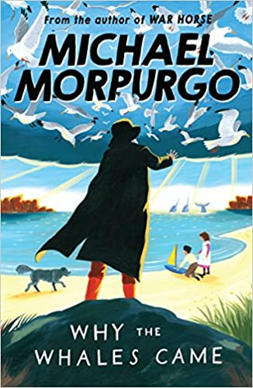Strange as it may seem, the darkness came as a kind of comfort to us, for at least it was the kind of blindness we were accustomed to. Even Daniel who was never fond of the dark seemed relieved at the onset of night. We searched now for some crack in the blackness about us, a glimmer of a light from the shore that would guide us safely home. We sat beside each other huddled together and silent, the damp jib sail wrapped around us to keep out the cold, peering constantly into the impenetrable night and listening, always listening for the hiss of surf on the shingle or the distant muted charge of the waves against the cliffs.

Often during that long, long night our hopes were raised by the whisper of waves

on some far shore, and we would row frantically towards it for a few minutes and then sit silent and listen again, only to discover it had been nothing but wishful thinking, a trick of the mind. Either it was that or we had simply been rowing the wrong way – we could never be sure which.

In this dense darkness all sense of direction, time and space seemed to be distorted.

Each time our hopes were raised only to be dashed, and each time the disappointment was all the more cruel and all the more lasting.

The cold had numbed my feet up to my knees and my hands could no longer feel the oar I was pulling. I wanted so much just to go to sleep, to give up and go to sleep. But Daniel would not let me.

**Understanding the Text**

**Answer the following questions. You can go back to the text at any point.**

**Please answer in full sentences.**

1. What is the setting for this part of the story?
2. How many characters are there?
3. What did Daniel say they could use to find their way home?
4. How did the characters try to keep warm?
5. How was the narrator feeling at the end of the extract?

**Looking at Language**

1. Explain these phrases in your own words.

**a** dead ahead **b** hug the coast

**c** off course **d** wishful thinking

1. Explain the meaning of these words as they are used in the story.

Use a dictionary to help you.

**a** astern **b** seething

**c** swell **d** loomed **e** obscure

**f** onset **g** impenetrable

**h** muted **i** distorted

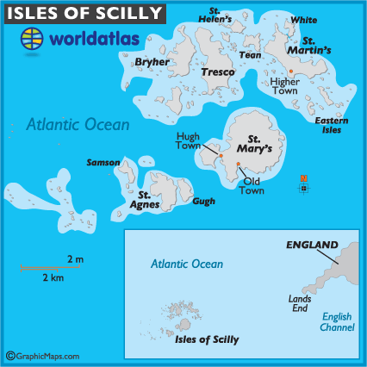

**Exploring the story**

**Scotland**

[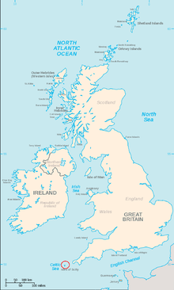](https://www.google.co.uk/url?sa=i&url=https%3A%2F%2Fen.wikipedia.org%2Fwiki%2FIsles_of_Scilly&psig=AOvVaw3zCpmUw9PMut5g_-SlL6GF&ust=1588694493840000&source=images&cd=vfe&ved=0CAIQjRxqFwoTCKDJ7LDKmukCFQAAAAAdAAAAABAT)

**Isles of Scilly England**