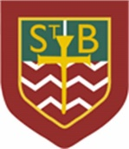**St Barbara’s Primary School**

|  |  |
| --- | --- |
| **Curricular Areas** | **Primary 7 Suggested Daily Learning Activities**  **Tuesday 5th May** |
| **Literacy** | 1. **Today’s starter task is another Boggle word game. Can you use the following letters to create as many words as possible- n, w, o, a, l, m, e, r, w and c? Try to challenge yourself by creating words using as many letters as possible.** 2. **Can you use this week’s focus homophones in the correct context? Write a detailed and interesting sentence for each of this week’s focus homophones.**   **This week our focus homophones are: threw, through, piece, peace, except, accept, here, hear, to, too and two.**   1. **It’s important that we continue to work on our fluency and reading comprehension. Today I would like you read a few chapters of your personal reader, try to read aloud to someone in your household to help develop your fluency and expression. I have also attached an unfamiliar text to the Primary 7 GLOW homepage. I would like you to read this text and answer the follow up comprehension questions.** |
| **Numeracy** | 1. **For today’s numeracy starter task complete the maths challenge from the 2nd level May calendar. Today’s question explores multiples. I have attached the calendar below in case anyone needs a copy of it however remember you can also access it on Twitter #alittlebitofmathseverday.** 2. **Today we are going to focus on dividing by 10,100 and 1000. You coped well with this area of maths when we explored it together in class however I have included some refresher clips for you below from Rigour Maths.**   **You can choose to complete either the bronze, silver or gold questions. If you would like to do more than one set of questions, go ahead. I have attached the questions below.**  **Bronze refresher clip**  [**https://www.youtube.com/watch?v=cYP_XIZBOIQ&feature=youtu.be**](https://www.youtube.com/watch?v=cYP_XIZBOIQ&feature=youtu.be)  **Silver refresher clip**  [**https://www.youtube.com/watch?v=_Z08DGpU4cw&feature=youtu.be**](https://www.youtube.com/watch?v=_Z08DGpU4cw&feature=youtu.be)  **Gold refresher clip**  [**https://www.youtube.com/watch?v=QtLobk8vAro&feature=youtu.be**](https://www.youtube.com/watch?v=QtLobk8vAro&feature=youtu.be) |
| **Topic** | **As I mentioned before the Easter holidays, over the next few weeks we are going to do a little bit of research about World War 2. I know how interested you all are in finding out more about this topic.**  **At the beginning of a new topic we spend some time exploring what we already know about the topic. Today you are going to record any facts you already know about World War 2. Normally we use a mind map format to record our prior knowledge however you may choose the format in which you record what you already know about this historical topic. I have included a lay out idea for you below.** |
| **TIOF** | 1. **Today we are going to say another decade of the rosary, we are going to try and do this every day during the month of May. On a Tuesday we celebrate the ‘Sorrowful Mysteries’. Today we will explore the first ‘Sorrowful Mystery’, The Agony of Our Lord in the Garden (Matthew 26:36-56).** 2. **During the month of May we honour Mary, the mother of Jesus. Why do we honour Mary? It is important to remember the vitally important role that she played. How instrumental she was.**  * **Think of some adjectives that you would use to describe Mary. i.e. brave, meek, gentle, loving, caring etc. Record these adjectives in your jotters.** * **I have attached a worksheet about medals which honour Mary. I would like you to answer the questions on the sheet and then design your own medal to honour Mary during her special month.** |
| **Additional Tasks** | **If you wish to complete more tasks please select one or two tasks from your Second level grid for May.** |

**May 2nd Level Maths Calendar**

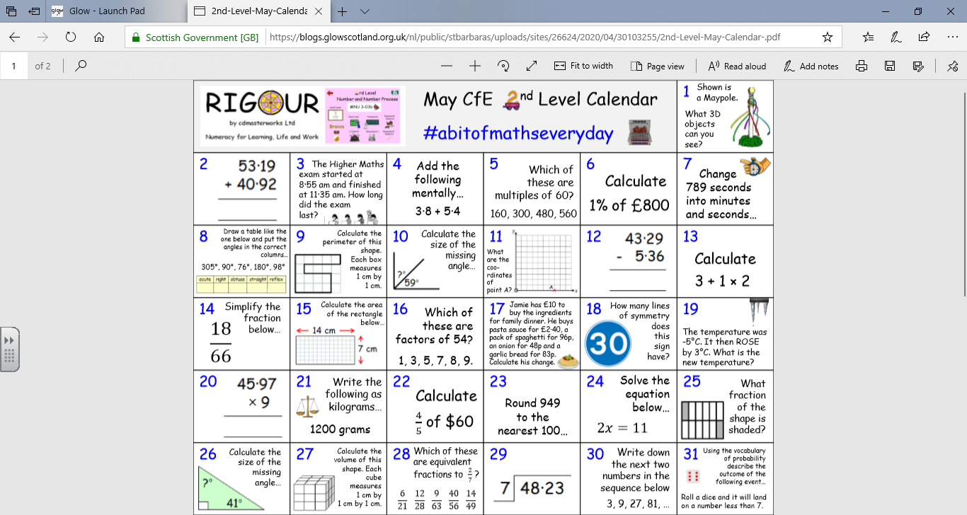

**Dividing by 10, 100 and 1000 Questions**

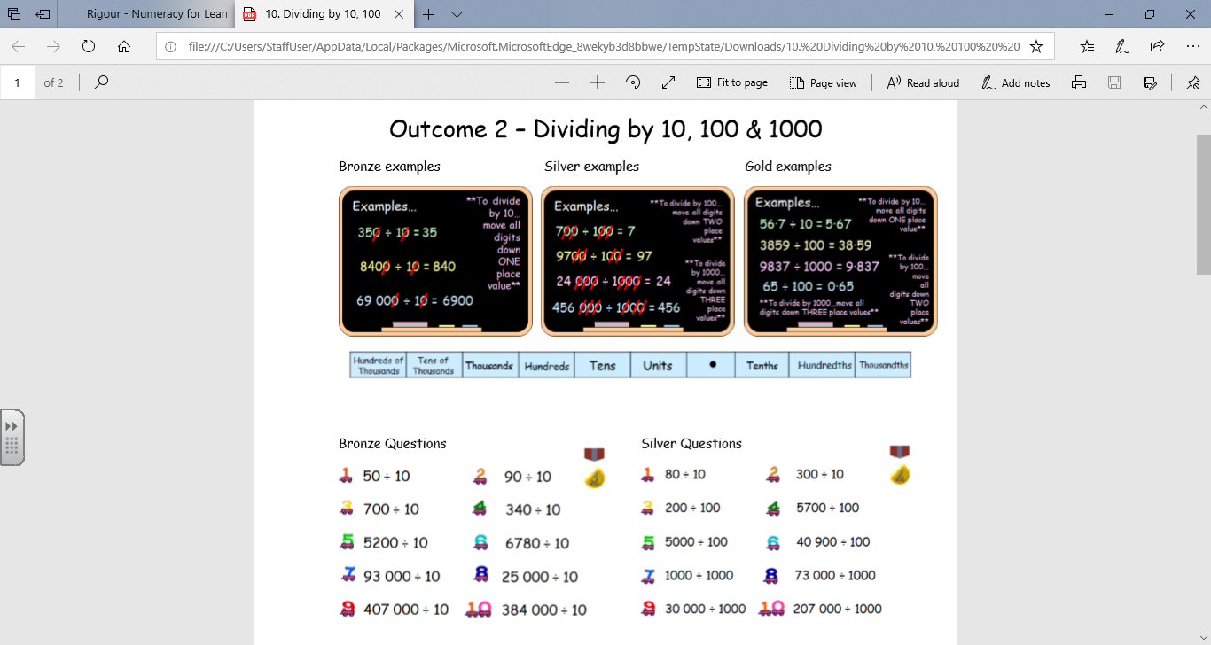

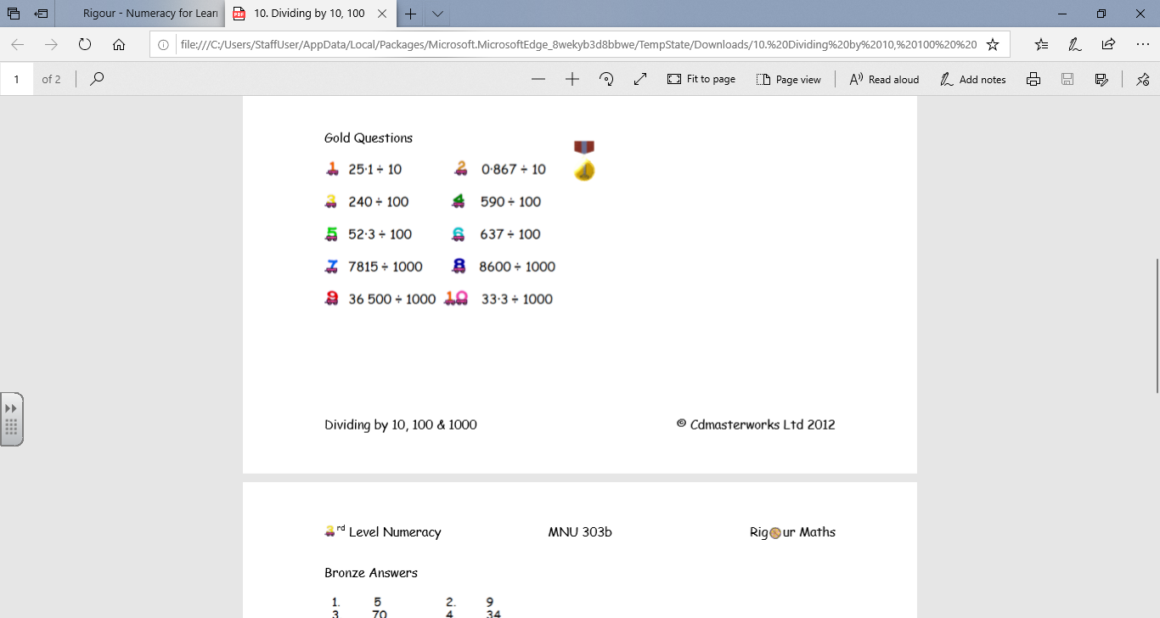

**Dividing by 10,100 and 1000- Answers**

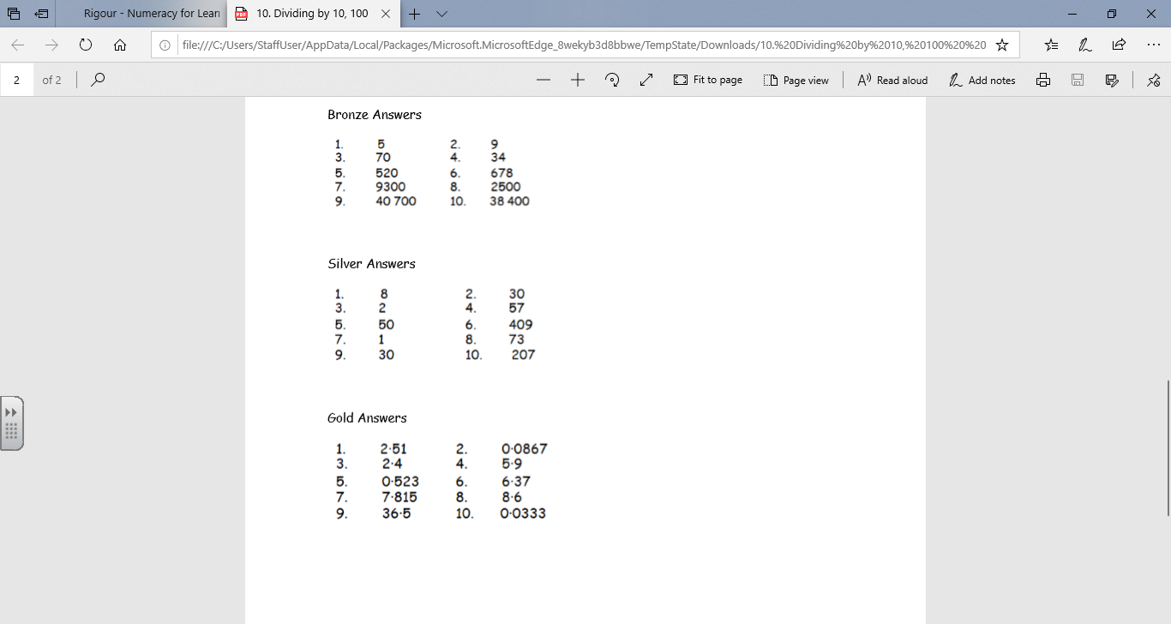

**World War 2**

L.I. To record our prior knowledge about World War 2.

**World War 2**

**Medals Honouring Mary**

Below are some examples of existing medals which honour Mary.

Please explore the questions below, you may do some research on the internet to help support your answers.

1. Why does Mary have so many different titles?
2. Can anyone explain the stories behind any of the medals depicted?
3. Do you own a medal of Mary? Why would someone want to own one?

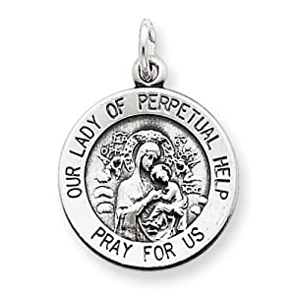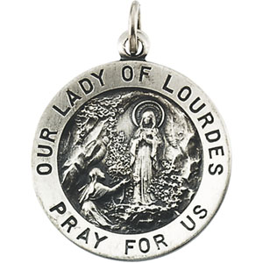[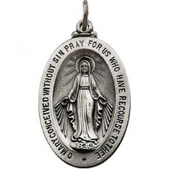](http://www.google.co.uk/imgres?q=miraculous+medal&hl=en&safe=active&biw=1024&bih=662&gbv=2&tbm=isch&tbnid=1pvfjuTo61gHpM:&imgrefurl=http://www.waterfalljewelers.com/products/Religious_Jewelry/Sterling_Silver_Miraculous_Medal_Multiple_Sizes_Available-R5020.html&docid=oSfWzkLJBPgw2M&imgurl=http://www.waterfalljewelers.com/images/products/r5020.jpg&w=810&h=810&ei=upuaT7rsMYmG4gSQ2f3-Dg&zoom=1&iact=hc&vpx=756&vpy=301&dur=125&hovh=225&hovw=225&tx=149&ty=105&sig=106994356765278212434&page=2&tbnh=159&tbnw=160&start=17&ndsp=24&ved=1t:429,r:5,s:17,i:119)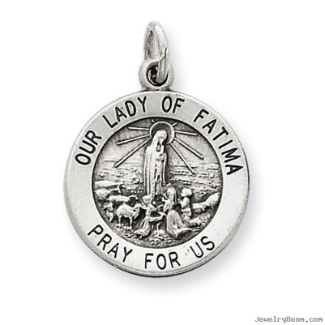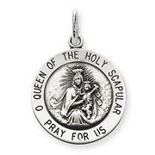

**In the space below design your own medal honouring Mary.**