Monday 4th May-
Literacy  IALT use a range of strategies to help me spell. | Let’s begin the day with our days of the week and months of year song.  Watch> https://www.youtube.com/watch?v=R087lYrRpgY  After that I would like you to take out your common word flash cards and try your best to read all our common words we have learned so far.  - You all enjoy playing BANG! So why not show someone at home how to play. You can place your words upside down, turn them over and read. If you get the word correct you can keep it, if not turn it back over for another try.  or  - I know we also loved playing SPLAT! in class so you could put all your words out and get someone at home to shout out a word, you have to find and SPLAT the word as quick as you can.  Once you have done this I would like you to have a read at your new common words this week. You all loved finding your new words in a word search so I have made one for you to try at home!  Challenge- why not make your own one for someone at home to try!  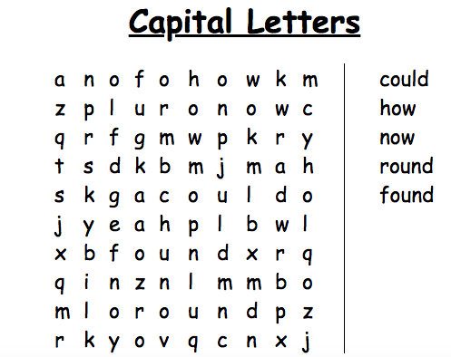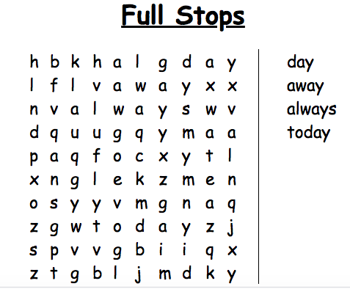  Once you have completed your word search, I would like you to choose a fun spelling strategy to spell your common words. You could use play doh, shaving foam, pasta!  Capital letters spelling words- Could, how, now, round, found, Full stops spelling words- Day, away, always, today  Remember to use our spelling strategies to help you spell.  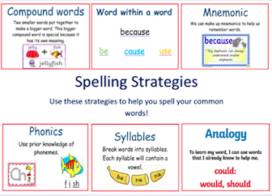  Reading- Oxford Owl > https://www.oxfordowl.co.uk/  Simply log in to this website by clicking- the pink ‘my class login’ button at the top right hand side.  Enter the username- miss shreenan p2 & password- books  Apples- I would like you to search for ‘Key Trouble’  Listen to the audio before having a go at reading it yourself.  Once you have read the book I would like you to play Activity 1 and Activity 2.  Bananas- I would like you search for ‘Christmas Adventures’. Listen to the audio before having a go at reading it yourself. Once you have read the book I would like you to play Activity 1 and 2.  Strawberries- I would like you to search ‘A Monster Mistake’. Listen to the audio before having a go at reading it yourself. Once you have read the book I would like you to play Activity 1 and 2.
Numeracy | This week we are going to be focusing on number processes.  It is important we continue our oral maths, this maths activity from your grid is a perfect way to get your brains active.  Out loud, count forward in:  - 2s from 0-20  - 5s from 0-50  - 10s from 0-100  - 100s from 0-900  - 5s from 15-60  - 10s from 30-120  - 100s from 200-900  Now use the same numbers but count backwards.  To warm up for today’s task, we are going to sing along with Jack Hartmann as he counts to 100 by 1’s > https://www.youtube.com/watch?v=rkxjAa3755U  Once you have completed this I would like you to try count to 100 forwards and backwards orally, challenge try counting on from any given number. (eg, can you count on from 13-38 in 1’s)  Once you are confident at doing this I would like you to complete the task below by filling in the missing numbers in this 100 number square.  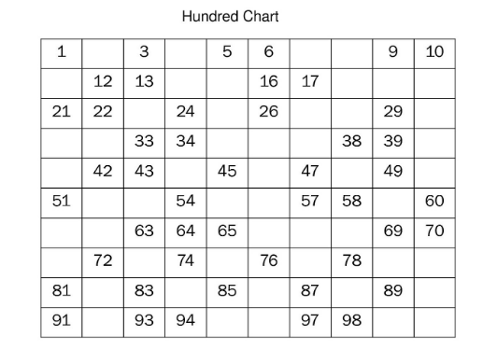
HWB  IALT improve my fitness. | Select one of these to complete to ensure you stay active today.  - Joe Wicks on YouTube @ 9:00am  - Jumpstart Jonny dance and work outs @ 9:00am  - Oti Mabuse Strictly Come Dancing live dance class @11:30
IDL topic | Around the World in 7 weeks  Now that we have our passports and are all packed, we can begin our journey around the World. Miss Shreenan can’t go anywhere without Barnaby Bear so he is going to be coming along with us!  First stop is a tour around Scotland.  Barnaby Bear found lots of great pictures of places he would like to go visit in Scotland but Barnaby Bear has forgotten where these places are and what they are called! He needs your help…  Can you complete this worksheet to help us set off on our adventure? (you can use the internet to help you with supervision from an adult)  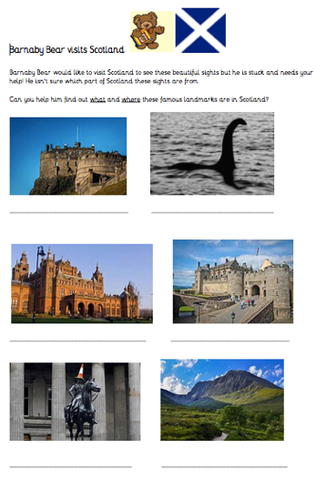
T.I.O.F | During the month of May, the Motherwell Diocese has set a challenge. For every weekday during May, a new video will be tweeted for families to do at home and these will also be hosted on the website and on Face book.  I would like you to try follow this during the month of May.  I have attached below the Daily Angelus Challenge card to help you record your prayers each day of the Angelus. Challenge- try colour the full card in by the end of May.  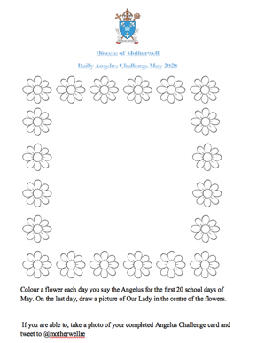  Yesterday was Good Shepherd Sunday. I would like you to listen to the story and the important message it is teaching us.  Click> https://www.youtube.com/watch?v=ar732X9uO3I  This story teaches us that Jesus is always there for us when we need him. We are like the sheep and Jesus is the Good Shepherd. Our Good Shepherd loves us and will protect us. When we have Jesus as our shepherd we are safe.  Here is a great art activity you could try at home.  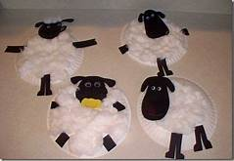  I have attached a template below that you can use.

