St Barbara’s Primary School
Curricular Areas | Primary 7 Suggested Daily Learning Activities  Monday 4th May
Literacy | - Continue reading the novel that I have set for you on the Scholastic Learning Zone website. Aim to get this novel completed by Wednesday as I am going to set some new novels for you all. Read a few more chapters of your novel today and complete the follow up metalinguistics activity that I have attached below.  - Today we are going to be revising some homophones. We have spent a lot of time in class exploring homophones. Who can define what a homophone is?  Homophones are words that sound the same as another word but have a different meaning, and often a different spelling.  This week our focus homophones are: threw, through, piece, peace, except, accept, here, hear, to, too and two.  I would like you to write these homophones out three times each in your jotter. Use a dictionary and record the definitions of each of our focus homophones.
Numeracy | - Get your brains switched on this morning and complete one of the number pyramid challenges that I have attached below. You have to add the numbers in the two bricks to get the answer to the brick above, this activity has to be done mentally. Draw the pyramid out in your jotter and complete.  - The Daily Rigour is a great numeracy newspaper. I would like you to try and complete some of the activities from the articles. I have attached a copy of this weeks’ edition of the newspaper. This is a great way to develop your confidence when exploring a range of mathematical language. Watch the video link below to find out the solutions for last weeks’ edition of The Daily Rigour.  https://www.youtube.com/watch?v=rU8V7zqIAiI&feature=youtu.be  - Today we are going to focus on multiplying by 10,100 and 1000. You were all very confident with this area of maths when we explored it together in class however I have included some refresher clips for you below from Rigour Maths.  You can choose to complete either the bronze, silver or gold questions. If you would like to do more than one set of questions, go ahead. I have attached the questions below.  Bronze refresher clip  https://www.youtube.com/watch?v=DZJaaM_niHM&feature=youtu.be  Silver refresher clip  https://www.youtube.com/watch?v=OSzdwmnFFxM&feature=youtu.be  Gold refresher clip  https://www.youtube.com/watch?v=pli4gpBPu5A&feature=youtu.be
Health and Wellbeing | - Today when you are out your daily walk why not complete the Outdoor Daily Walk Challenge that I have attached below? It’s something different to do and you can get your whole family involved.  - Who is missing a trip to Nando’s? To get our hearts pumping today let’s try a little Nando’s Challenge; can you handle the spice? I wonder who can achieve the most points. See below for further instructions.
TIOF | - The Diocese of Motherwell have asked the school to share with you that every weekday during May, they will tweet a new video for families to do at home and these will also be hosted on their website and on Facebook. Go on to their Twitter page to access today’s video.  - In the Gospel this Sunday Jesus told us that he has come so that we may have life in all its fullness. But what does it mean to live life to the full? Let’s think some more about this today.  I would like you to read Sunday’s Gospel and explore the Gospel reflection. Share what you have learned today with someone in your household.  - Pope Francis has encouraged us to pray the Rosary. He encourages us to “rediscover the beauty of praying the Rosary at home in the month of May”. I thought it might be nice to finish our day by saying a decade of the rosary. On a Monday we celebrate the ‘Joyful Mysteries’. Today we will explore the first ‘Joyful Mystery’, The Annunciation of Gabriel to Mary (Luke 1:26-38). We have prayed the rosary lots of times together in class however, in case you have forgotten, I have attached a little reminder of how to pray the rosary properly.
Additional Tasks | If you wish to complete more tasks please select one or two tasks from your new Second level grid for May.

Reading Activity

Pyramid Number Challenge
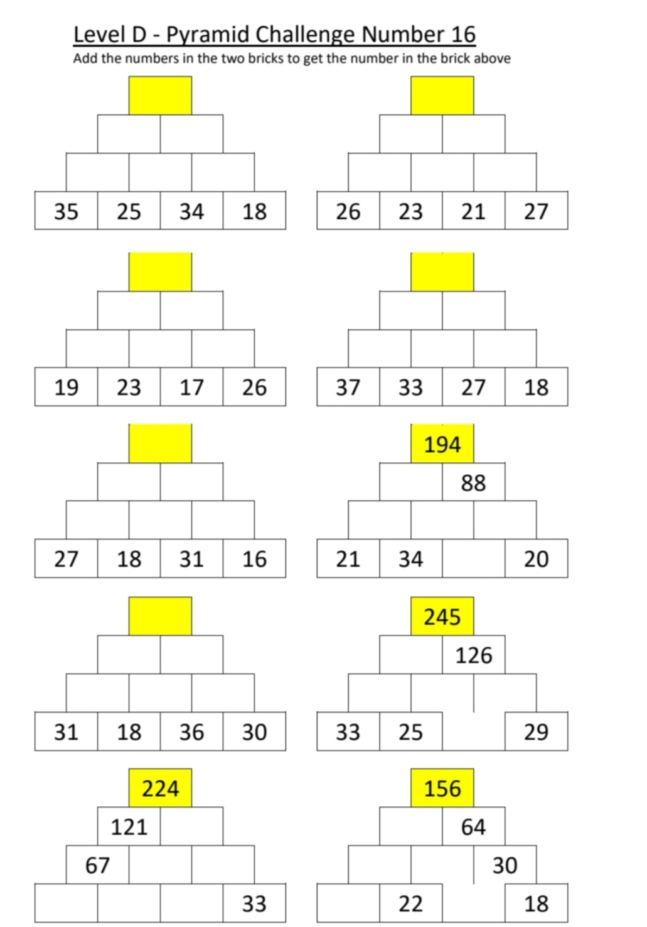
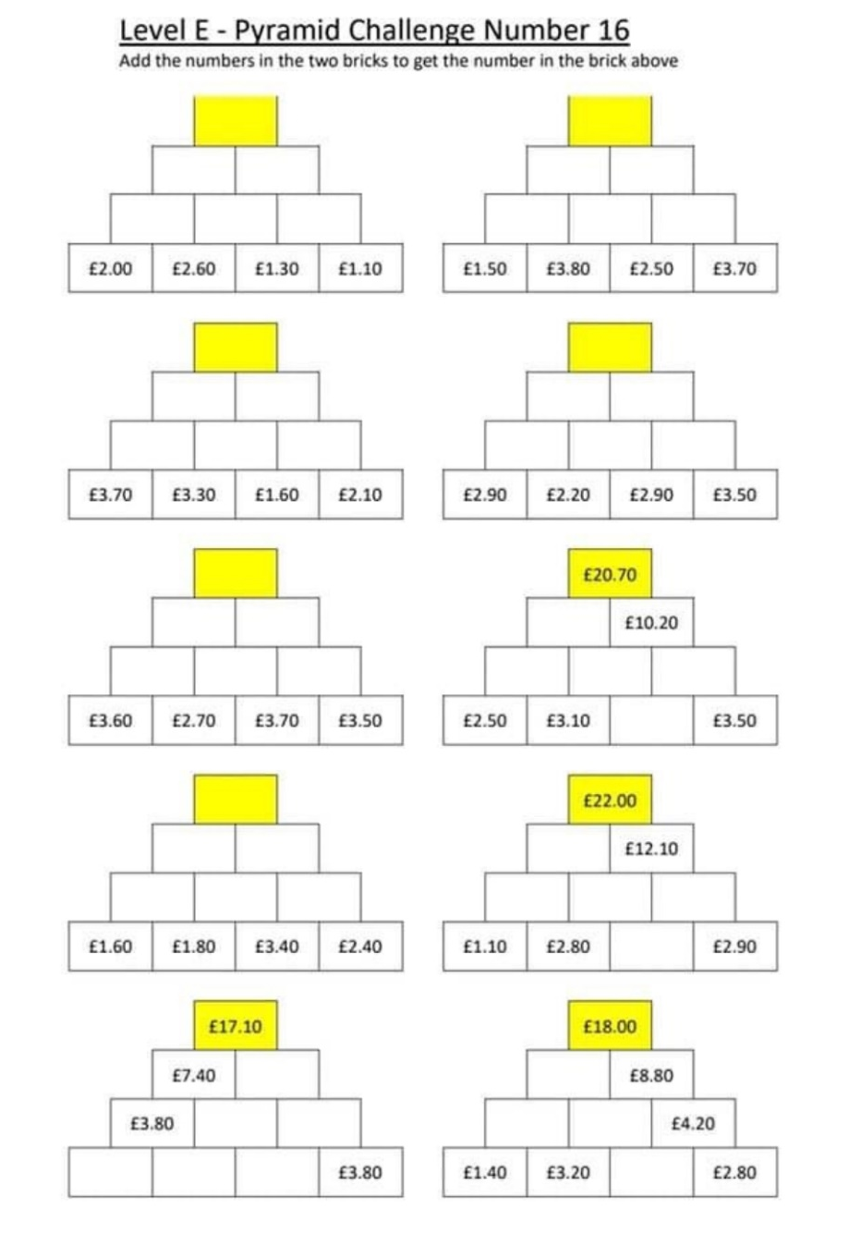

The Daily Rigour

Multiplying by 10, 100 and 1000 Questions

Multiplying by 10,100 and 1000- Answers

The Outdoor Daily Walk Challenge

CAN YOU HANDLE THE SPICE PRIMARY 7?

Rules:
- You want to try earn as many peri points as you can (Let me know how many points you earn)
- You can’t do the same level of spice twice in a row
- You need to do a minimum of at least 10 exercises on the grid

If you are unsure about any exercises please ask me or look them up online.
35 BURPEES | 25 SQUAT JUMPS | 30 ALTERNATING JUMPING LUNGES | 30 BUTTERFLY FIT UPS | 3 MINUTES OF HIGH KNEES | 2 MINUTE WALL SIT | 30 AB CRUNCHES | 20 IN AND OUT JUMP SQUATS
15 IN OUT SQUAT | 20 SECOND SQUAT HOLD | 2 MINUTE PLANK | 25 FORWARD LUNGES | 20 GLUTE BRIDGES | 15 FIRE HYDRANTS | 20 PUSH UPS | 20 RENEGADE ROWS
1 MINUTE OF HEEL KICKS | 1 MINUTE PLANK | 15 BURPEES | 10 RUSSIAN TWIST | 15 SQUATS | 15 FORWARD LUNGES | 15 BACKWARDS LUNGES | 10 GLUTE BRIDGES
30 SECONDS OF HIGH KNEES | 10  BURPEES | 30  SECOND PLANK | 10  SQUATS | 10 FORWARD LUNGES | 15  PUSH UPS | 10  MOUNTAIN CLIMBERS | 10 JUMPING JACKS

How many peri points did you manage?

Sunday’s Gospel
Gospel: John 10:1-10
Jesus said, “I am telling you the truth: the man who does not enter the sheepfold by the gate, but climbs in some other way, is a thief and a robber. The man who goes in through the gate is the shepherd of the sheep. The gatekeeper opens the gate for him; the sheep hear his voice as he calls his own sheep by name, and he leads them out. When he has brought them out, he goes ahead of them, and the sheep follow him, because they know his voice. They will not follow someone else; instead, they will run away from such a person, because they do not know his voice.”

Jesus told them this parable, but they did not understand what he meant.

So Jesus said again, “I am telling you the truth: I am the gate for the sheep. All others who came before me are thieves and robbers, but the sheep did not listen to them. I am the gate. Whoever comes in by me will be saved; they will come in and go out and find pasture. The thief comes only in order to steal, kill, and destroy. I have come in order that you might have life — life in all its fullness.

Gospel Reflection
- In today’s reading Jesus tells us a parable in which he is the gate which takes us to God. But can you remember what Jesus says, right at the end of today’s gospel?
- Jesus says, “I have come so that you might have life – life in all its fullness.” What do you think it means to have life in all its fullness?
Living life to the full doesn’t mean having all the latest toys or the most fashionable clothes or the biggest house. And it doesn’t even mean just having all the things we need in life, like enough food and somewhere safe to live, although this is a really important part of living life to the full. It also means being the best person that we can be, living our lives well and having the chance to use all our gifts and talents for the good of all.
- What gifts and talents do you have? What are you good at?
- Do you always make the most of the gifts that you have? Do you always try to be the best person you can be?

How to pray the Rosary

