Rounding Pairs

Step 1 – Cut out 12 small squares of paper (any colour).

Step 2 – Write the following numbers on a square of paper each.

|  |  |  |  |  |  |
| --- | --- | --- | --- | --- | --- |
| 70 | 55 | 60 | 20 | 89 | 50 |
| 90 | 12 | 53 | 17 | 72 | 10 |

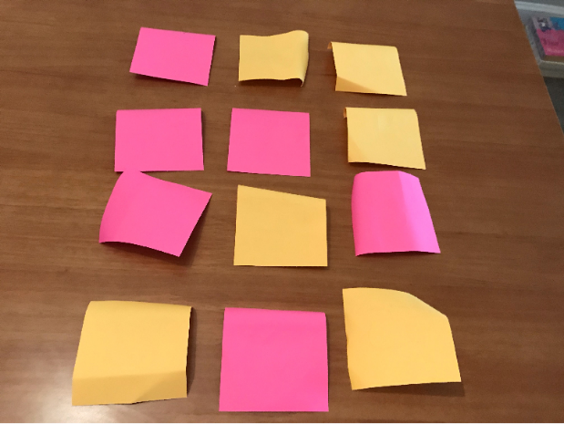Step 3 – Face your cards down on the table like the picture.

*The Game*

Turn over 2 cards at a time and look at the numbers.

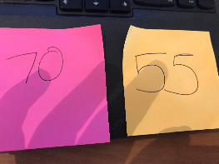On my first go I chose 70 and 55. As 55 rounded to the nearest 10 is not 70 I have to put my cards back.

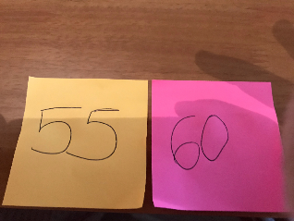On my next turn I chose 55 and 60. As 55 rounded to the nearest 10 is 60 I get to keep those cards.

The aim of the game is to see how quickly you can pair up your cards. If you choose 2 multiples of 10 or 2 numbers that are not a multiple of 10 you must also return these cards.

**Challenge 1** – To challenge yourself you could change the numbers to 3 digit numbers and play again.

**Challenge 2** – You can try to play again with rounding to the nearest 100.