[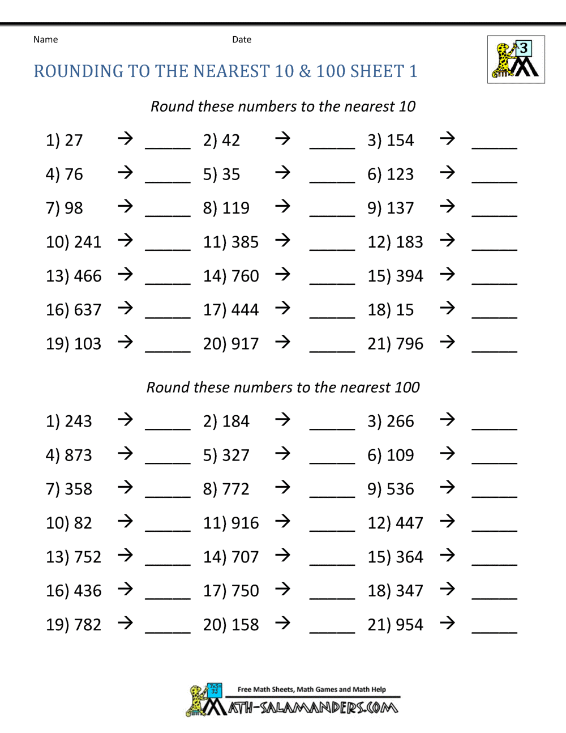](https://www.google.co.uk/url?sa=i&url=https%3A%2F%2Fwww.math-salamanders.com%2Frounding-numbers-worksheets.html&psig=AOvVaw3Nw7ydH1rb2z6M4kKWrrk9&ust=1588294027733000&source=images&cd=vfe&ved=0CAIQjRxqFwoTCNi34bz2jukCFQAAAAAdAAAAABAQ)