**St Barbara’s Primary School**

|  |  |
| --- | --- |
| **Curricular Areas** | **Primary 7 Suggested Daily Learning Activities**  **Thursday 30th April** |
| **Literacy** | 1. **Today we will continue to explore suffixes that mean a ‘state of being’- ness, sion and tion. Spend some time revising the focus suffix words that I set yesterday. Can you come up with 3 additional words (or more if you would like) for each prefix? Write your new words out 3 times each in your jotter, choose 2 words from each suffix and use them to write interesting sentences. For a little bit of fun why not create a word search using a mixture of the focus suffix words and the suffix words that you have selected? When you have created the word search give it to someone in your house to complete, remember the trickier the better. I have attached a word search template to the Primary 7 GLOW homepage.** 2. **For today’s writing activity I would like you to write a letter to your friend to fill them in on what you have been doing during lockdown. I have included an overview of different things that you might like to include in your letter and a little reminder about the format of writing a letter. I think I will do this task today also and write a letter to my good friend, Miss McEleney** [Thumbs Up Emoji [Free Download IOS Emojis] | Emoji Island](https://www.google.co.uk/url?sa=i&url=https%3A%2F%2Femojiisland.com%2Fproducts%2Fthumbs-up-sign-iphone-emoji-jpg&psig=AOvVaw0Oz5VvkVmjL7ZJL15dKQ54&ust=1588169309717000&source=images&cd=vfe&ved=0CAIQjRxqFwoTCNiDwu6li-kCFQAAAAAdAAAAABAN)**.** |
| **Numeracy** | 1. **Complete the maths starter below. Remember you can only use each of the numbers once and they must add up to the stated total. Copy the diagram into your jotter and give it a go! Remember you can email me your answers.** 2. **Complete the final task on your 2nd level April maths calendar. Today’s activity is all about finding the volume of a shape, remember to read the question carefully. I will post the answers to April’s calendar tomorrow morning and I will also post a new monthly maths calendar.** 3. **Clink on the link below to take part in a Countdown number challenge. Use the numbers you are given to get the target number. You can play this as many times as you like.**   [**http://www.maths-resources.com/countdown/practise.html#numbers**](http://www.maths-resources.com/countdown/practise.html#numbers)   1. **Today we are going to focus on dividing decimals by a single digit. I have included a refresher clip for you below from Rigour Maths, this is a great step by step tutorial on how to tackle these types of sums. You should then complete the bronze questions in your maths jotter.**   **Bronze refresher clip**  [**https://www.youtube.com/watch?v=F4VcXa_qSdo&feature=youtu.be**](https://www.youtube.com/watch?v=F4VcXa_qSdo&feature=youtu.be)  **It is important that you follow the process that we always use when dividing numbers, try not to let the decimal point confuse you. A secure knowledge of all of your times tables will really help.**  **Tomorrow I will be posting a little check up on all 4 outcomes that we have explored this week.** |
| **TIOF** | **BBC Bitesize are doing daily lessons on various curricular areas. Today there is a nice World Religions lesson that explores the story of Rama and Sita. This story is connected with Diwali - the annual festival of light held every autumn. It is about Rama rescuing Sita from a demon King Ravana with the help of Hanuman and his monkey army. I would like you to go on and watch the video clips for this lesson and then, if possible, complete the activities that go along with it. It is important that we learn about all the different World Religions to help expand our knowledge.** |
| **Spanish** | ¡**Hola Primary 7! Today I would like you to do a little bit of Spanish revision. Below are some of the activities that you could do to practise your Spanish.**   1. **Revise days of the week and months of the year in Spanish. I have attached some resources on the Primary 7 GLOW homepage to help support you.** 2. **What is the highest number you can count to in Spanish? Can you get to 100? Watch the clip below to help you to count to 100.**   [**https://www.youtube.com/watch?v=qwnjyAC9uc8&vl=en**](https://www.youtube.com/watch?v=qwnjyAC9uc8&vl=en)   1. **To learn a little bit more about Spanish culture I would like you to choose a Spanish city, research it and record 5 interesting facts about it. Do this in your jotter and include a drawing or picture of the city you chose.** |
| **Additional Tasks** | **If you wish to complete more tasks please select one or two tasks from your Second level grid for April.** |

**Daily Maths Starter**

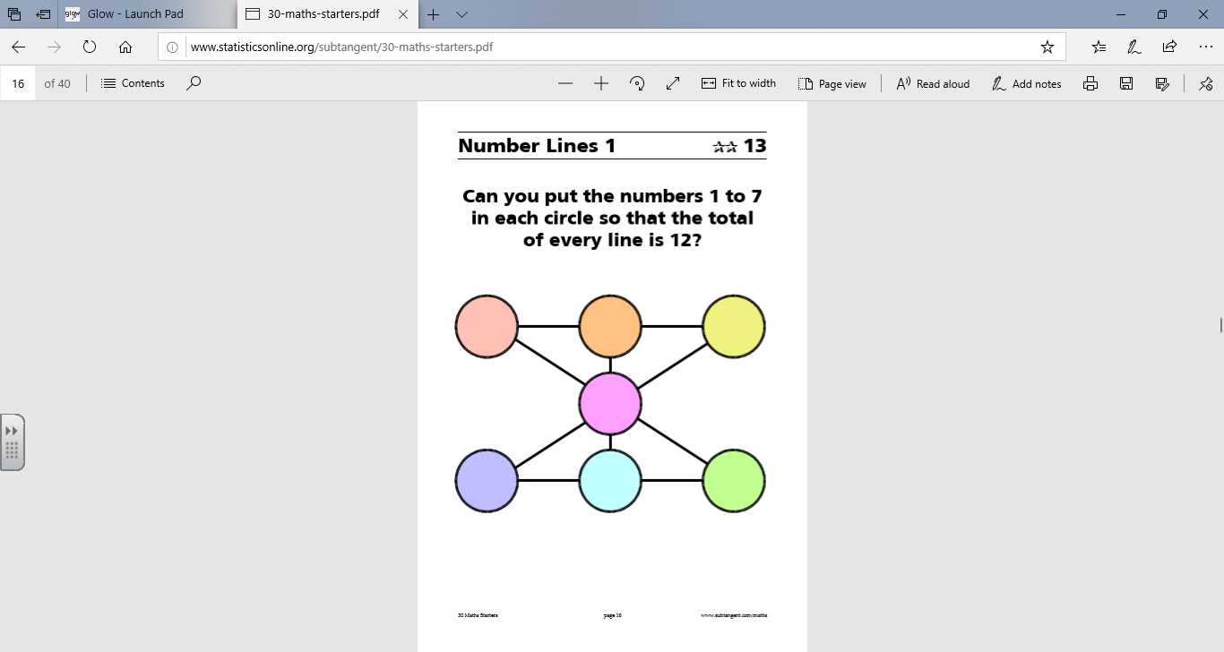

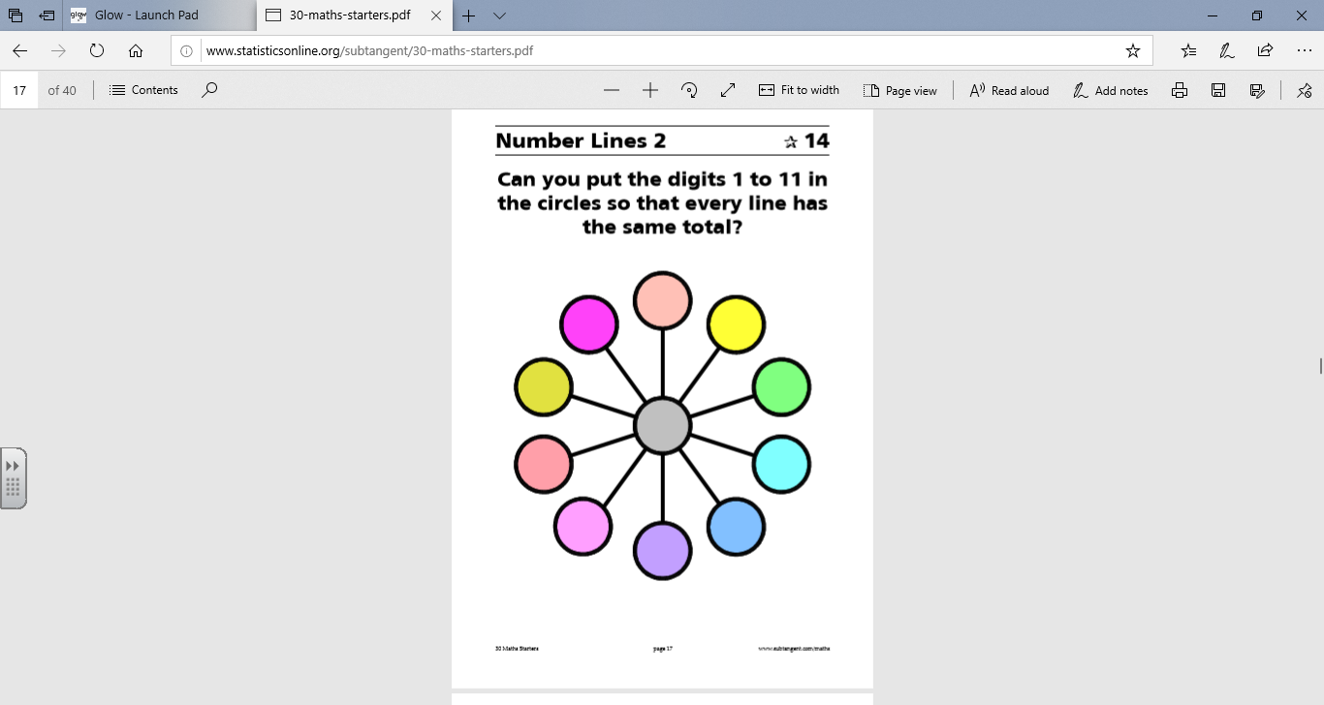

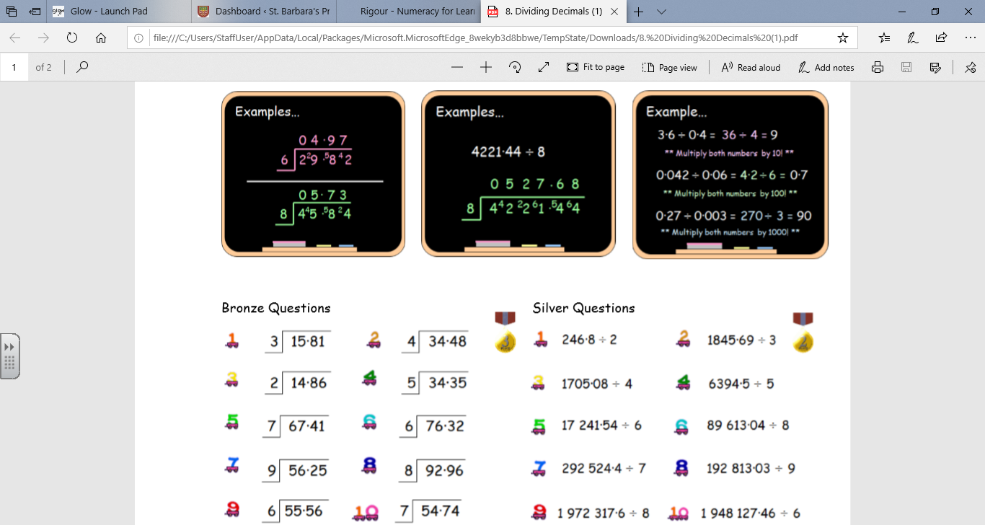**Dividing Decimals Task**

**Dividing Decimals- Answers**

