**St Barbara’s Primary School**

|  |  |
| --- | --- |
| **Curricular Areas** | **Primary 7 Suggested Daily Learning Activities**  **Wednesday 29th April** |
| **Literacy** | 1. **Choose 10 prefix words from the list that I set you or the words that you have selected on your own. Using the values of the scrabble tiles that I have attached below calculate the total value of each of the selected prefix words, record these in your jotter. If you have access to scrabble tiles it might be a fun idea to spell your words out using the scrabble tiles and then work out the value of your words.** 2. **For reading today explore the First News newspaper article, Feline Lonely. When you have finished reading the article, read the questions and then skim and scan the text before attempting to answer any of the questions. Answer the questions in your jotter and remember to use the question to help you structure your answer. The answers are in the text so always refer back to the article to help support you. I have attached a link to today’s article, questions and answers on the Primary 7 GLOW homepage. Remember no peeking at the answers before you give the questions a go!** 3. **Today we will explore some suffixes. Remember a suffix is a letter or group of letters added to the end of a root word to make a new word. Over the next few days we will focus on suffixes that mean a ‘state of being’- ness, sion and tion.**   **Here is a little video clip to remind us what a suffix is-**  [**https://www.bbc.co.uk/bitesize/topics/z8mxrwx/articles/zwgbcwx**](https://www.bbc.co.uk/bitesize/topics/z8mxrwx/articles/zwgbcwx)  **I have attached our focus words for the next few days below. Can you write a definition for each of our focus words?** |
| **Numeracy** | 1. **To get our brains going in maths today I would like you to complete the BBC Bitesize lesson on identifying common factors, multiples and prime numbers. Click on the link below, watch the tutorials and complete the follow up activities.** 2. **Today we are going to focus on multiplying decimals by a single digit. I have included a refresher clip for you below from Rigour Maths, this is a great step by step tutorial on how to tackle these types of sums. You should then complete the bronze questions in your maths jotter.**   **Bronze refresher clip**  [**https://www.youtube.com/watch?v=yAOlbPlqEq8&feature=youtu.be**](https://www.youtube.com/watch?v=yAOlbPlqEq8&feature=youtu.be)  **It is important that you follow the process that we always use when multiplying numbers, try not to let the decimal point confuse you. A secure knowledge of all of your times tables will really help.** |
| **Health and Wellbeing** | **Yoga has many benefits for children so today we are going to take part in a yoga session. Yoga teaches stress and relaxation techniques and explores breathing techniques. These skills might help you find some calm during these uncertain times. I have been doing some yoga sessions at home and I have really been enjoying it**[Thumbs Up Emoji [Free Download IOS Emojis] | Emoji Island](https://www.google.co.uk/url?sa=i&url=https%3A%2F%2Femojiisland.com%2Fproducts%2Fthumbs-up-sign-iphone-emoji-jpg&psig=AOvVaw0Oz5VvkVmjL7ZJL15dKQ54&ust=1588169309717000&source=images&cd=vfe&ved=0CAIQjRxqFwoTCNiDwu6li-kCFQAAAAAdAAAAABAN)**.**  **I have attached a video link on the Primary 7 GLOW homepage, this will take you to today’s yoga session.** |
| **Science** | **As you know BBC Bitesize are doing daily lessons on various curricular areas. Today there is a fabulous lesson on mixing, dissolving and separation. I would like you to go on and watch the video clips for this lesson and then, if possible, complete the activities that go along with it.**  **Why not give this little experiment a go at home, if you have the available resources? This lesson asks you to dissolve different substances in hot and cold water to see which substance dissolves better and if the water temperature has an impact. I have attached the overview for this experiment below. Why not take a snap of yourself doing this experiment and share it on our Twitter page?** |
| **Additional Tasks** | **If you wish to complete more tasks please select one or two tasks from your Second level grid for April.** |

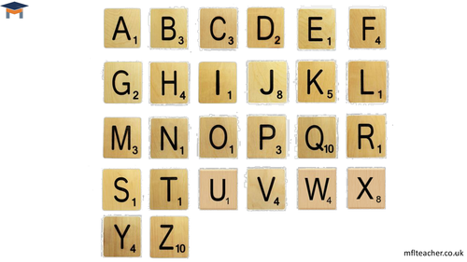**Scrabble Tile Values**

**Suffix Focus Words**

**ness**

happiness

forgiveness

greatness

**sion**

exclusion

precision

cohesion

**tion**

promotion

affection

reflection

**Multiplying Decimals by a Single Digit**

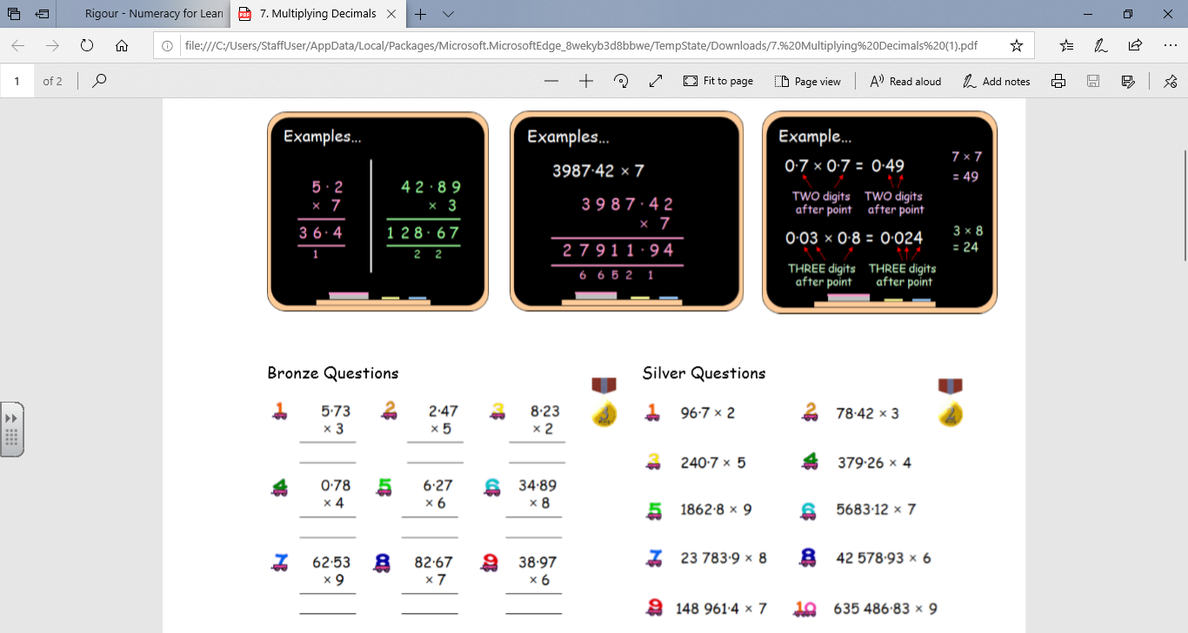

**Multiplying Decimals by a Single Digit- Answers**

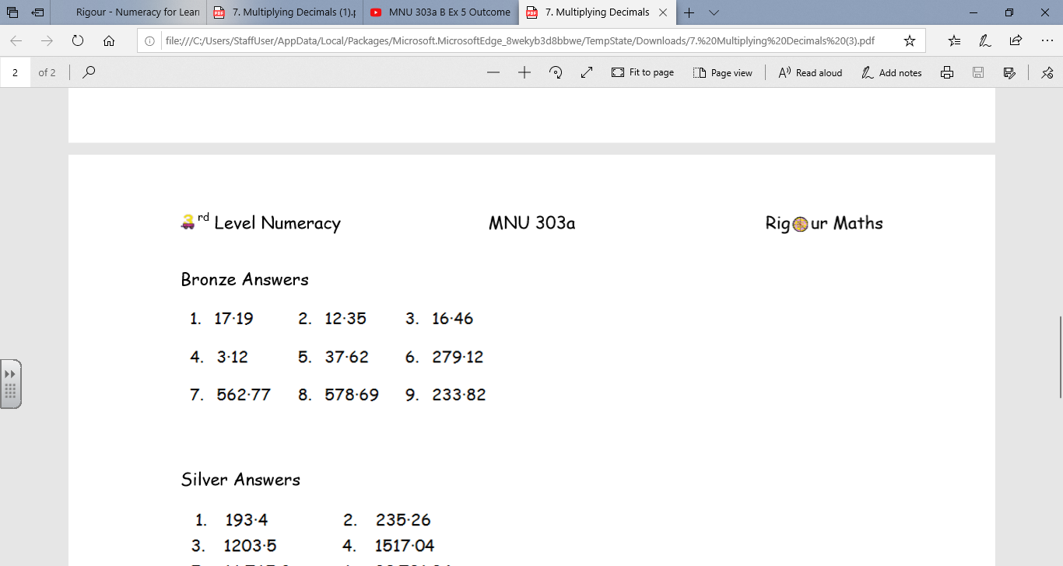

**Dissolving Science Experiment**

