Wednesday 29th- please begin with your morning prayer, thanking God for looking over us and keeping us safe.
Literacy | Reading Task- We are going to continue to use this resource > https://www.oxfordowl.co.uk/  Simply log in to this website by clicking- the pink ‘my class login’ button at the top right hand side.  Enter the username- miss shreenan p2 & password- books  Your child should know what reading group they are in but if you are unsure what group your child is in please email me and I can let you know.  Apples- I would like you to search for ‘What was it like?’  Listen to the audio before having a go at reading it yourself.  Once you have read the book I would like you to play Activity 1 and Activity 2.  Bananas- I would like you search for ‘Paris Adventure’. Listen to the audio before having a go at reading it yourself. Once you have read the book I would like you to play Activity 1 and 2.  Strawberries- I would like you to search ‘Kipper and the Trolls’. Listen to the audio before having a go at reading it yourself. Once you have read the book I would like you to play Activity 1 and 2.  After this I would like you to select one of the reading tasks from the grid below. We have completed all of these tasks in before in class..  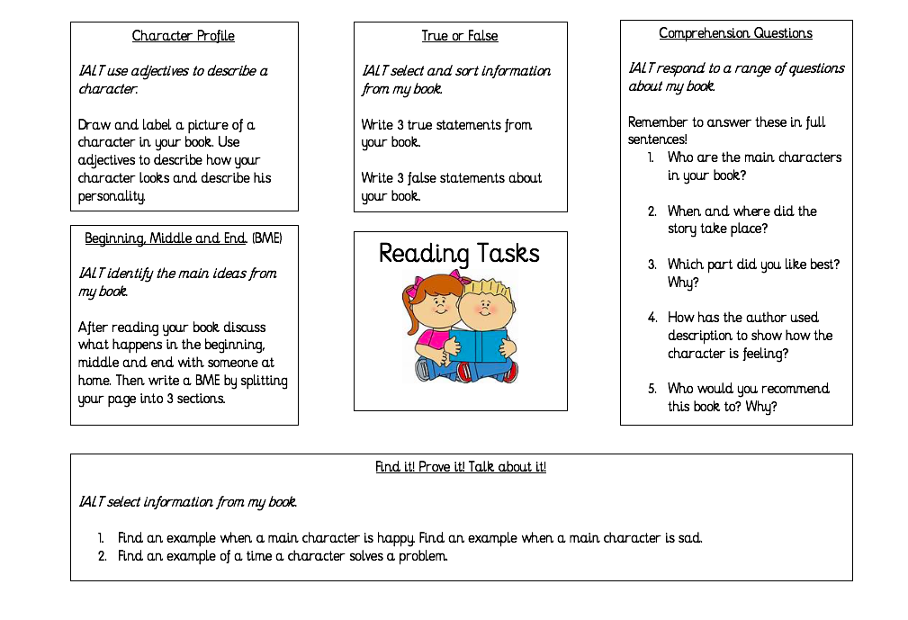
Numeracy  IALT round whole numbers. | Warm up- Youtube >Jack Hartmann Kids Music Channel > Count to 100 https://www.youtube.com/watch?v=0TgLtF3PMOc  Complete this worksheet. What ten is it closer to? Remember the rules about rounding. If the number ends in 1-4 round down, if the number ends 5-9 then round up!  1 2 3 4 5 6 7 8 9  round down round up  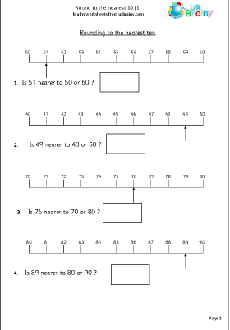
HWB  IALT improve my fitness. | Select one of these to complete to ensure you stay active today.  - Jumpstart Jonny dance and work outs @ 9:00am  - Oti Mabuse Strictly Come Dancing live dance class @11:30  - Go noodle on youtube.
IDL topic  IALT design and construct models. | Our next step in our journey this week is to think about HOW we are going to get on holiday. Below is a link to a video which will give us a tour of the Riverside Museum in Glasgow.  Give it a watch and see if you can identify 5 different modes of transport we could use to go on holiday!  https://www.youtube.com/watch?v=GO3cCtSFoP4&fbclid=IwAR2i0xg0Szw2QeyqyXGlHIcG7jnOJOy7y8B41ebzC5KKC9t6k72dU893Z8s  Next I would like you to make your own aeroplane. You will need an old toilet toll tube for this, I have put a picture below showing an example. Be creative and make sure to send me pictures of you and your new plane!  Example-  