Tuesday 28th- Let’s begin by saying our morning prayer and saying a special ‘Hail Mary’ for all the people who are sick in our world and for those caring for them.
Literacy  IALT decode words using phonemes. | Phonics Task- consolidation  Starter- Alphabet name and sounds- My name is A, my sound is a… (orally)  Warm-up- read through the phonics cards- see how many you know! (sh for shop, ch for chest…)  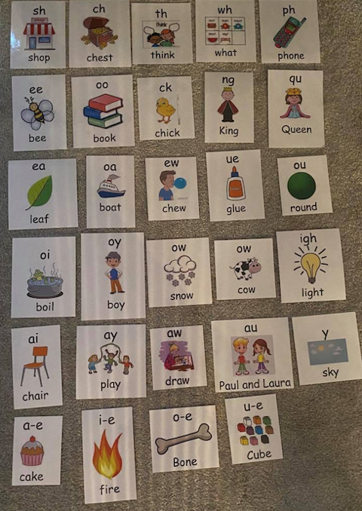  Capital letters group- ai, ee, igh, oa  Watch > https://www.youtube.com/watch?v=0QwrkowksKk  Complete this task-  Can you think of 2 words for each of your phonemes. Write them down and draw a picture next to each word.  Eg, light  Full stops group- oa  Watch > https://www.youtube.com/watch?v=DJV_uQcbUxk  Complete this task-  Can you think of 6 words for the phoneme ‘oa’. Write the words down and draw a picture next to each word.  Eg, boat
Numeracy  IALT round whole numbers | We are going to continue with rounding to the nearest 10. I would like you to complete this rounding worksheet.  Remember the rules of rounding from yesterday.  Before you complete this W/S, let’s warm up by counting in 10’s from 0-100- forwards and backwards.  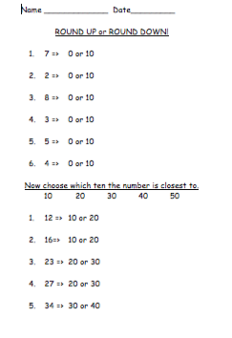
HWB  IALT improve my fitness. | Select one of these to complete to ensure you stay active today.  - Joe Wicks on YouTube @ 9:00am  - Jumpstart Jonny dance and work outs @ 9:00am  - Cosmic Yoga on YouTube.
T.I.O.F  IALA the resurrection of Jesus. | Last week, we were learning about Saint Thomas and how he was known as ‘doubting Thomas’. Following on from this, I would like you to watch and listen to this story. Today’s story is about discovering the tomb is empty.  https://www.youtube.com/watch?v=7BwgVqBQBsU&fbclid=IwAR2O7BTmhjWmwc9wlfk6O4UOnrQ-o-yMgT2ZlU_MQ9T--BT_Ejh-2rq5sVw  Once you have watched this story, I would like you to act out the scene to someone at home to show them what you have learned.  (This could be done using your toys or you can act out in person).
IDL topic  IALT use my imagination to solve design problems. | Yesterday we made our passports. Next, we need to pack in our suitcases. Talk to someone at home about what kind of things we take on holiday with us? Have a think about:  What do we wear on holiday?  What other things might we need?  Do you have a favourite teddy or toy you couldn’t leave behind?  Don’t forget toiletries too!  Now I would like you to draw and label what you would pack in your suitcase. You can use this template to help you.  