St Barbara’s Primary School
Curricular Areas | Primary 7 Suggested Daily Learning Activities  Tuesday 28^{h} April
Literacy | - Can you use the following letters to create as many words as possible- d, l, v, o, e, p, e, m, a and t? Try to challenge yourself by creating words using as many letters as possible. Remember you can only use the letters that are given to you.  - Today we will continue to explore prefixes that negate the meaning of words- non, in and un. Spend some time revising the focus prefix words that I set yesterday. Can you come up with 3 additional words (or more if you would like) for each prefix? Write your new words out 3 times each in your jotter, choose 2 words from each prefix and use them to write interesting sentences.  - I know that none of you have completed the novels that I have set for you on Scholastic so today I would like you to continue to read these novels. Try to read a few chapters today and perhaps you could take some notes about the main events that take place in each chapter that you read.
Numeracy | - To get our brains into maths mode please complete a Top Marks Daily 10 challenge, this will revise our rounding work from last week. Select Level 5, Rounding and Decimals to 1dp. If you would like a challenge complete the Daily 10 challenge below which revises rounding decimals to 2dp.  - Remember to complete today’s task on your 2nd level maths April calendar. Today’s question explores co-ordinates. I have attached the calendar below in case anyone needs a copy of it however remember you can also access it on Twitter #alittlebitofmathseverday. Only a few days left before a new monthly calendar will be published. On Friday morning I will post the answers to this month’s maths calendar.  - Today we are going to focus on subtracting decimals. I have included a refresher clip for you below from Rigour Maths, this is a great step by step tutorial on how to tackle these types of sums. You can choose to complete either the bronze or silver questions or if you would like to do both then go ahead.  Bronze refresher clip  https://www.youtube.com/watch?v=Yq42_VVDk6M&feature=youtu.be  Silver refresher clip  https://www.youtube.com/watch?v=EUjRF0rs_DI&feature=youtu.be
Health and Wellbeing | Today we are going to continue to explore our transition from primary school to high school. I am sure lots of you will be wondering how different high school is going to be so today I thought we could complete a little activity to get you thinking about the differences between primary and secondary. If you have an older sibling already at high school try to complete this task without their help. When you have completed the activity maybe you could discuss your answers with them and see if they agree with you. I would like you to read the statements in the worksheet that I have attached to the Primary 7 GLOW homepage. When you have read all of the statements I would like you to circle the statements that you think are the same as primary in red and the ones that you think are different from primary in blue. If you would like to record what you think in a different way maybe you could put them in a table under different headings.
TIOF | The 23rd April marked the beginning of Ramadan. Do you know what Ramadan is? During the month of Ramadan, Muslims won't eat or drink during the hours of daylight. This is called fasting. Children are not expected to fast. Ramadan remembers the month the Qur'an (the Muslim holy book) was first revealed to the Prophet Muhammad. The actual night that the Qur'an was revealed is a night known as Lailut ul-Qadr ('The Night of Power'). I have attached a PowerPoint to the Primary 7 GLOW homepage that will give you more information about Ramadan. Here is a little video clip to help explain Ramadan in more detail,  https://www.bbc.co.uk/bitesize/topics/zpdtsbk/articles/zjc2bdm  After you have learned a bit more about Ramadan why not see if you can share your new knowledge with a member of your family?
Additional Tasks | If you wish to complete more tasks please select one or two tasks from your Second level grid for April.

Daily 10 Challenge- Rounding to 2 Decimal Places
Round the numbers below to 2 decimal places. You have 20 seconds to complete each question.
- 16.954 2. 70.697 3. 306.413
- 2.379 5. 18.212 6. 9.745
7. 100.393 8. 67.685 9. 1.3456
10. 4.1462

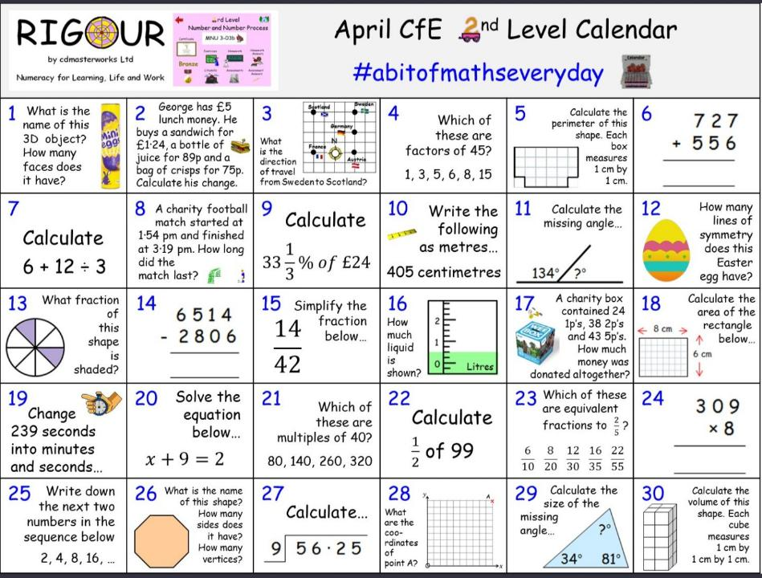
April 2nd Level Maths Calendar
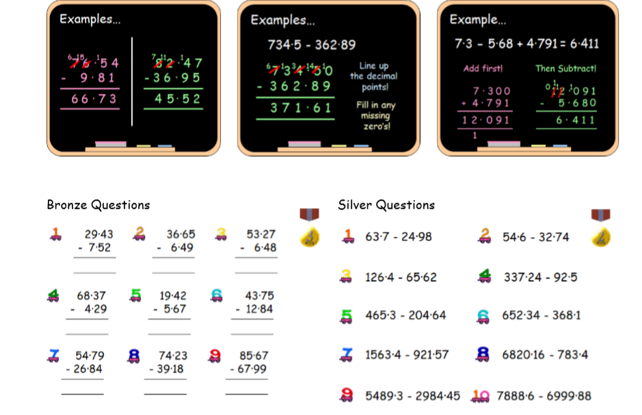
Subtracting Decimals

