Monday 27th- It is a new week so let’s begin our day with a morning prayer, keeping those who are sick in our thoughts and thanking God for being healthy and keeping us safe.
Literacy  IALT use a range of strategies to help me spell. | For today’s literacy task, we are going to begin with our ‘all about today’ news. Start off by singing your days of the week and months of the year song. After being asked these questions I would like you to complete the task below.  If yesterday was Sunday, Today is?  Yesterday was the 20th, what date is it today?  Last month was March, so this month is?  Can you look outside and describe the weather?  April is the season of new beginnings- what season is it?  Can you name all 4 seasons?  Complete the following-  Today is ____the ___ of ____ It is ____ outside. April is the season of _____.  Draw a picture below to represent today.  When you have finished that I would like you to complete this spelling task. This week is our consolidation week.  Read and copy your words out 3 times using rainbow spelling.  Select 3 of the words to create 3 super sentences.  Don’t forget super sentences need- capital letters, full stops, finger spaces.  Challenge- try add in a connective to your sentence- and/but/so/because.  ‘Capital letters’ spelling words- Mrs. School home two right ‘Full stops’ spelling words- Like, made, could, said, down
Numeracy  IALT round whole numbers. | We are going to focus on rounding to the nearest 10 this week.  Warm up- counting in 10’s- https://www.youtube.com/watch?v=7stosHbZZZg  Remember the rounding rules we learned in class-  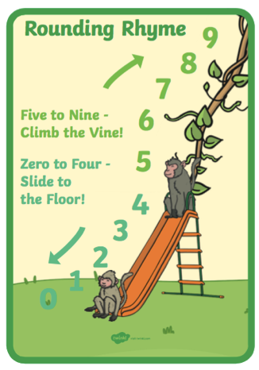  Watch this video > Rounding to the nearest 10 > https://www.youtube.com/watch?v=CMdck80SHnw  Complete this worksheet below- remember we look at the ones column to see whether we move up or down. Is 11 closer to 10 or 20? Well let’s look at the ones column- 11 ends in a 1, 1 is 1 jump away from 10 but 9 jumps away from 20, which means we round down to 10.  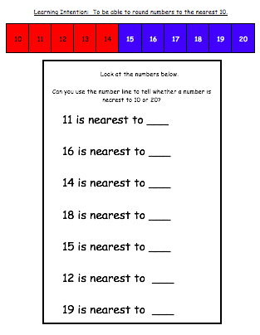
HWB  IALT improve my fitness. | Select one of these to complete to ensure you stay active today.  - Joe Wicks on YouTube @ 9:00am  - Jumpstart Jonny dance and work outs @ 9:00am  - Oti Mabuse Strictly Come Dancing live dance class @11:30
IDL topic  IALT use a range of media to create images and objects. | Today we are going to start our brand new topic! Our topic this term is called:  Around the World in 7 weeks  We are stuck at home just now but that doesn’t mean we can’t learn about new places all over the world. We will be learning all about countries including France, Spain and America.  This week we are going to prepare for our journey and first we need to create our own passports.  Use this template to create your own passport. You can add a photo or draw a picture.  