St Barbara’s Primary School
Curricular Areas | Primary 7 Suggested Daily Learning Activities  Friday 24th April
Literacy | - Select 5 words from the soft ‘c’ spelling rule word list and 5 words from the soft ‘g’ spelling rule word list and use the spelling fitness challenge grid to revise your chosen words.  - I hope you are all enjoying the novels that I have set for you on the Scholastic website. I would like you to complete an activity on either the novel that has been set for you or indeed your personal reader. You may choose from one of the following options:  - Choose a character from your novel and create a detailed visualiser for them using the descriptive vocabulary from the text.  - Summarise what you have explored in the novel so far. Remember a summary means only including information about key or main events in the story.  - Use the metalinguistic strategy to explore any tricky or unfamiliar vocabulary that has jumped out at you whilst reading your novel.  Remember there are some quizzes attached to some of the Scholastic books that I have set for you. These are a great way to test your comprehension of the text.  - I have created a spelling challenge on Sum Dog that tests your knowledge of the soft ‘c’ and soft ‘g’ spelling rules. This challenge opens at 9:00am today and will close at 2:30pm. I will go on and check your progress at the end of the day. Good luck and remember to follow our spelling rules for accuracy.
Numeracy | - Try the problem solving activity that I have attached below. This task requires a trial and error approach. Making the number cards and turning this into a practical learning opportunity might help support you when getting the answer.  - Complete a Place Value written activity that I have included below. There are mild, spicy and hot options, choose the questions that challenge you the most. Record the answers in your jotter, you may choose to do more than one set of questions. Remember you can send me your completed task to see how you got on.  - To continue developing your mental maths skills you should sign up for Maths with Carol Vorderman. The website is www.themathsfactor.com. This is a great free resource and a fun way to do your number work.
TIOF | Today I would like you to focus on saying your prayers. Say our morning prayer before you begin your work and before and after lunch. It might be nice to end our first week of term 4 with a little prayer thanking God for keeping us safe and guiding us during these difficult times.  Remember Father Campbell is streaming live mass every Sunday on St Barbara’s Parish Facebook page. It would be nice if you could join in with this. On Monday we will be exploring this weeks’ Gospel message.
Health and Wellbeing | I understand that this is not the way we had planned to spend our final term before heading off to high school however I thought it might be nice to do some activities to prepare us for this big change. For today I would like you to do a bit of research about the high school that you are going to. Each school will have its own website that will give you lots of information to help with your research. You can record the information that you find in your jotter in any format you want. You might like to do a mind map or even an information leaflet. Some areas that you might like to research include;  - What is the name of your new Head Teacher?  - Where is the school based?  - When was the school built?  - How many teachers are there at the school?  - What subjects can you study at the school?  Tune in to BBC Bitesize today as they are doing a special lesson all about going to high school. Click on the link below to access it.  https://www.bbc.co.uk/bitesize/articles/zj2grj6
Additional tasks | If you wish to complete more tasks please select one or two tasks from your new Second level grid for April.

Spelling Fitness Grid
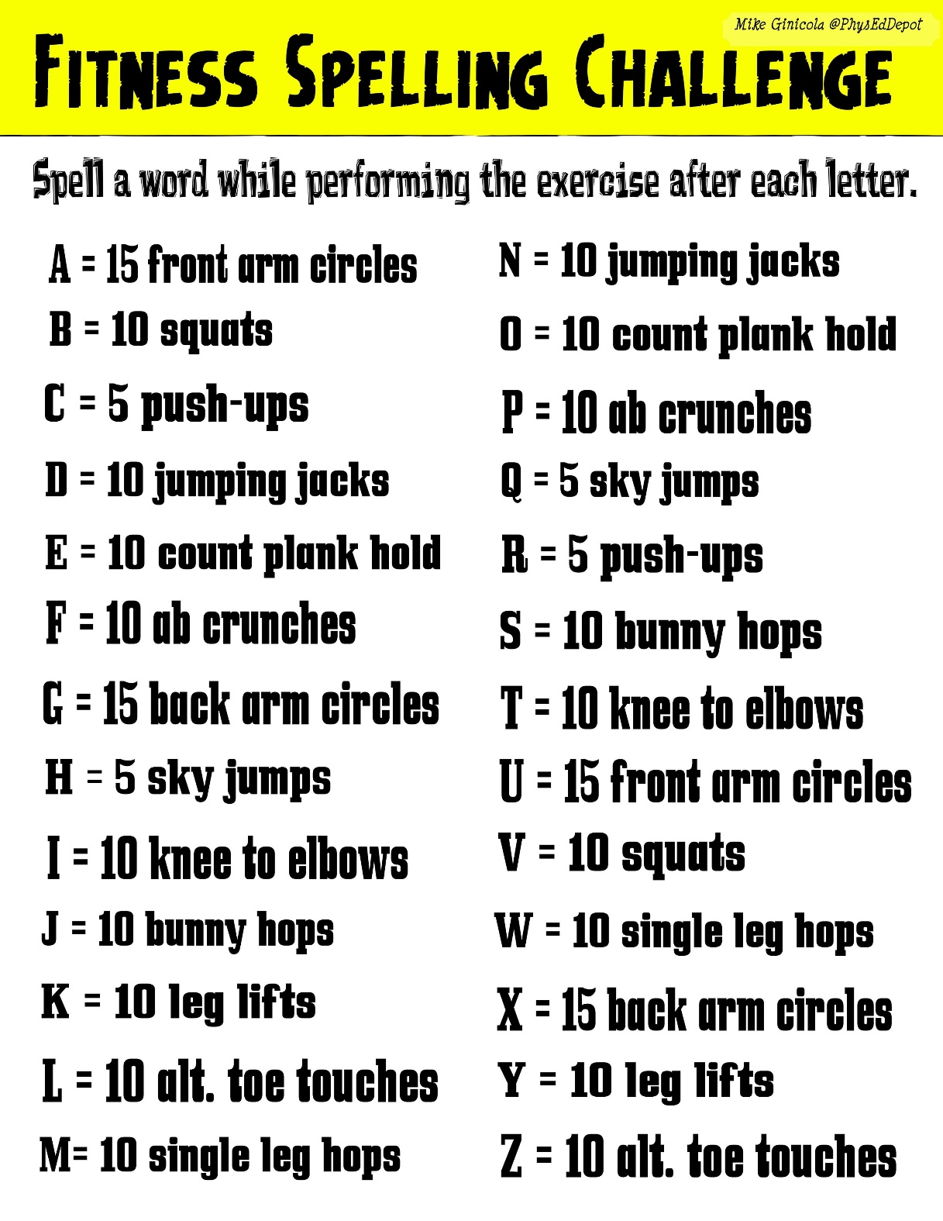

Problem Solving Activity

Place Value Revision
Mild Chilli Questions
- Complete the statements below:
5367 = 5 thousands + _____ hundreds + _____ tens + 7 ones
4193 = ____ ones + 1 hundreds + _____ tens + 4 thousands
7504 = ____ tens + ______ thousands + ____ ones + ____ hundreds

- Write the value of the underlined digit
3462 = _______
5124 = _______
4027 = _______
2740 = ______
- Can you order these numbers from smallest to greatest?
4672, 3623,4762, 3980, 4038, 3632

- Round these numbers to the nearest 10
- 37 b. 21 c. 185 d. 3,522

- Round these numbers to the nearest 100
- 107 b. 462 c. 2,985 d. 9,463

Spicy Chilli Questions
1.Find the difference between the following numbers:
a) 345 to 395 | b) 4726 to 9726
c) 57821 to 52821 | d) 209481 to 279481
d) 63237 to 23237 | e) 3687693 to 9687693

2.Write the following figures in words:
a) 143948 | b) 3395
c) 9350124 | d) 28902841
e) 23842 | f) 4003482

3.Complete the following:
a) decrease 194753 by two thousand
b) increase 2384598 by six million
c) decrease 9809821 by sixty thousand
d) increase 2049342 by three hundred thousand

4. Round to the nearest 1000
a) 549
b) 284
c) 2719
d) 6475
e) 17,591
f) 42,806
g) 85,467
h) 124,846
i) 345,217
j) 438,108
Hot Chilli Questions
1. Write the following numbers in words:
a) 4567.5
b) 34289.43
c) 457329.43
d) 1657389.32
e) 3246781.21

2. Write these amounts in digits:

- Two thousand and thirty four point seven, six
- Twelve thousand, two hundred and eight point six, seven, nine
- One hundred and twelve thousand, six hundred and forty five point nine, five.
- Seven million thirty four thousand and seven tenths, four hundredths.
- Six million, seven hundred and twenty two thousand, four hundred and three point zero, two, five

3. Round these numbers to the nearest 10,000
a) 45,895
b) 68,109
c) 74,548
d) 547,313
e) 671,194
f) 358, 427
4. Round these numbers to 1 decimal place
a) 23.48
b) 47.17
c) 582.439
d) 156.67
e) 258.471
f) 349.50

