Friday 24th- Morning Prayer
Literacy  IALT select, read and listen to texts I enjoy. | Spelling Test-  Today I would like you to practice your spelling words by doing speed writing. Set a 60 second timer and see how many times you can write your spelling word out correctly. Do this with each of your spelling words.  When you are finished, get someone at home to test you on this week’s spelling words.  Reading-  Today I would like you to read something you enjoy. You might have a book in the house you love or you could have a look on epic! to see if there is an audio book you are interested in. This is perfect to go along with the literacy activity on your grid-  Choose a short book or a chapter of a book and read it out loud for a member of your family to enjoy.  Remember to use expression and make eye contact!
Numeracy  IALA how numbers are constructed. | I would like you to complete this place value worksheet today. This can be completed on the worksheet or in your jotter.  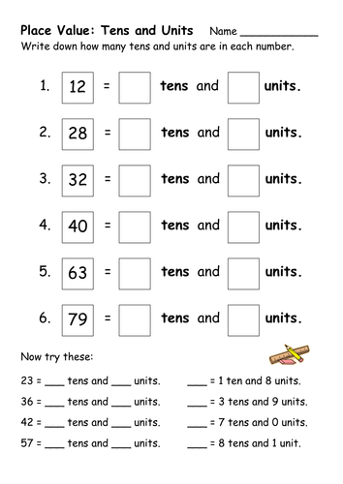
HWB  IALT improve my fitness. | Select one of these to complete to ensure you stay active today.  - Joe Wicks on YouTube @ 9:00am  - Jumpstart Jonny dance and work outs @ 9:00am  - Oti Mabuse Strictly Come Dancing live dance class @11:30
T.I.O.F | One of the choices on your new grid is to follow Holy Mass which is being streamed through Facebook (supervised by an adult) by Fr. Campbell each week day at 10am.
Golden Time | Well done! We made it to Friday!  Do something you enjoy this afternoon. I hope you are all getting a chance to go out and enjoy the sunshine, play with your toys and have fun!  If you can, post some photos of you having fun on our Twitter.  Have a wonderful weekend everyone!  Take care,  Miss Shreenan

