Wednesday 22nd- Let’s begin with our morning prayer and continue to thank God for keeping us all safe.
Literacy | Reading- I have set our class up to oxford owls, this is a great resource to help us continue our reading. https://www.oxfordowl.co.uk/  Simply log in to this website by clicking- the pink ‘my class login’ button at the top right hand side.  Enter the username- miss shreenan p2 & password- books  Your child should know what reading group they are in but if you are unsure what group your child is in please email me and I can let you know.  Apples- I would like you to search for ‘Dinosaur Safari’.  Listen to the audio before having a go at reading it yourself.  Once you have read the book I would like you to play Activity 1 and Activity 2.  Bananas- I would like you search for ‘The Frog Prince’. Listen to the audio before having a go at reading it yourself. Once you have read the book I would like you to play Activity 1 and 2.  Strawberries- I would like you to search ‘The Orchid Theif’. Listen to the audio before having a go at reading it yourself. Once you have read the book I would like you to play Activity 1 and 2.
Numeracy  IALA how numbers are constructed. | Warm up- Youtube >Jack Hartmann Kids Music Channel > Count to 100 https://www.youtube.com/watch?v=0TgLtF3PMOc  Complete these worksheets in your jotters.  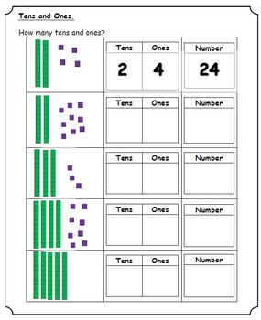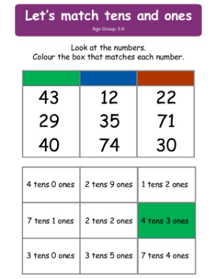
HWB  IALT improve my fitness. | Select one of these to complete to ensure you stay active today.  - Jumpstart Jonny dance and work outs @ 9:00am  - Oti Mabuse Strictly Come Dancing live dance class @11:30  - Go noodle on youtube.
Other | We have been learning all about colours in Spanish so this would be the perfect activity to select from you grid to help consolidate our learning.  Google ’Calico Colores’ song for kids (YouTube).  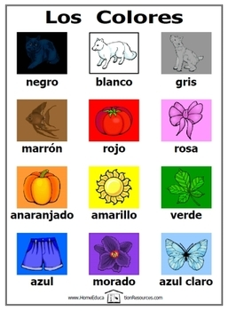  Listen a few times and try to sing

