**St Barbara’s Primary School**

|  |  |
| --- | --- |
| **Curricular Areas** | **Primary 7 Suggested Daily Learning Activities**  **Wednesday 22nd April** |
| **Literacy** | 1. **Today’s starter task is another Boggle word game. Can you use the following letters to create as many words as possible- p, o, a, i, m, l, c, n, t and r? Try to challenge yourself by creating words using as many letters as possible.** 2. **Reading- Scholastic learning zone. Our school is using a new digital education resource published by Scholastic online. I will be assigning some novels for you to read over the next few weeks. Every pupil in our class has been assigned their own login details. Please send me an email and I will be able to give you your username and password so that you can access your novel. For today I would like you to login and read some of the novel that I have assigned to you. At the end of the week you will be asked to complete the quiz that goes along with the novel that you have been reading and I will also set you a little comprehension task.** 3. **Another spelling rule that we will be revising this week is soft ‘g’. Today I would like you to come up with a list of 10 words that follow this rule, try to challenge yourself when choosing your words. When you have created this word list I would like you to check the spelling of your chosen words using a dictionary and then use look, say, cover, write and check to test yourself on these words.** 4. **Scrabble tiles- Using the values of the scrabble tiles that I have attached below calculate the total value of each of the soft ‘g’ spelling words that you have chosen. If you have access to scrabble tiles it might be a fun idea to spell your words out using the scrabble tiles and then work out the value of your words.** |
| **Numeracy** | 1. **Choose a times table that you feel the least confident with and spend some time practising it. I have attached a copy of our race car track that you could use to help you practise your chosen times table. After you feel a bit more confident with it I want you to chant it out loud using the clapping technique that we use in class and time yourself writing the full times table out in your jotter. Remember to choose a times table that you find tricky as we all know how important our times tables are at supporting us with our numeracy work.** 2. **BBC Bitesize has launched some excellent home learning sessions. Today we will revise how to round decimals to the nearest whole number using examples like money and weight. Click on to the link below, watch the 3 tutorials and complete the follow up activities.**   [**https://www.bbc.co.uk/bitesize/articles/z6g8d6f**](https://www.bbc.co.uk/bitesize/articles/z6g8d6f) |
| **Health and Wellbeing** | **It’s time to get out in the sunshine and complete a mini boot camp session! I have attached below what I would like you to do for today’s session, you have to repeat this 3 times if you can. You may need a water break between each circuit. You can put on some catchy music whilst completing this activity to help get you moving. Have fun and stay safe!** |
| **Expressive Arts Art and Design** | **I would like you to get in touch with your creative sides and recreate Vincent Van Gogh’s sunflower portrait. Firstly, I would like you to research a little bit about Van Gogh and record your findings in your jotter. I have attached a PowerPoint to the Primary 7 GLOW homepage that will give you some information about the artist, Vincent Van Gogh. The website below also gives some great information about the artist’s life.**  [**https://www.ducksters.com/biography/artists/vincent_van_gogh.php**](https://www.ducksters.com/biography/artists/vincent_van_gogh.php)  **When you have completed your research you may use the image below to help recreate Van Gogh’s sunflower portrait. You can use whatever materials you have available to add colour to your portrait. It might be nice to find a sunny spot in your garden to do this art activity.** |
| **Additional Tasks** | **If you wish to complete more tasks please select one or two tasks from your new Second level grid for April.** |

**Scrabble Tile Values**

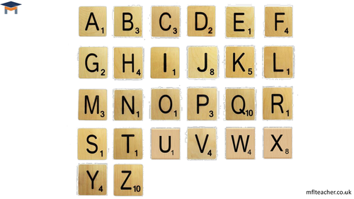

**Race Car Track**

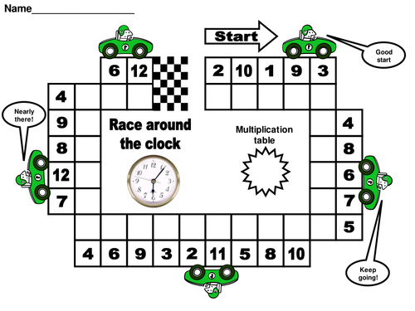

**Boot Camp Session**

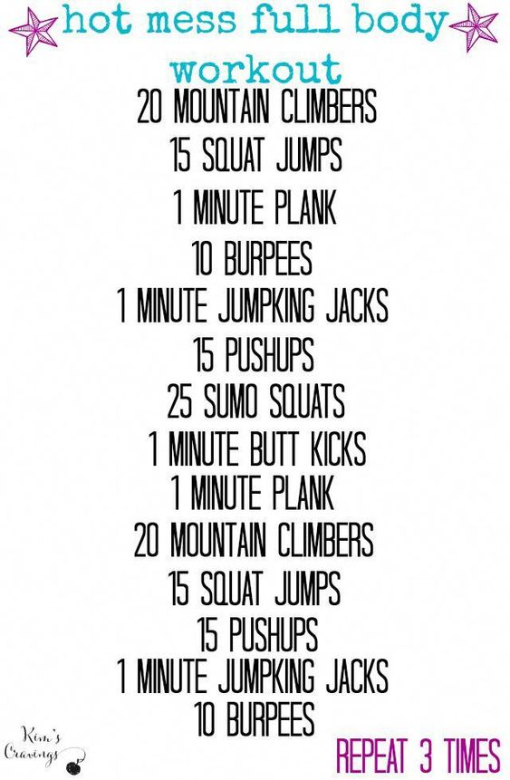

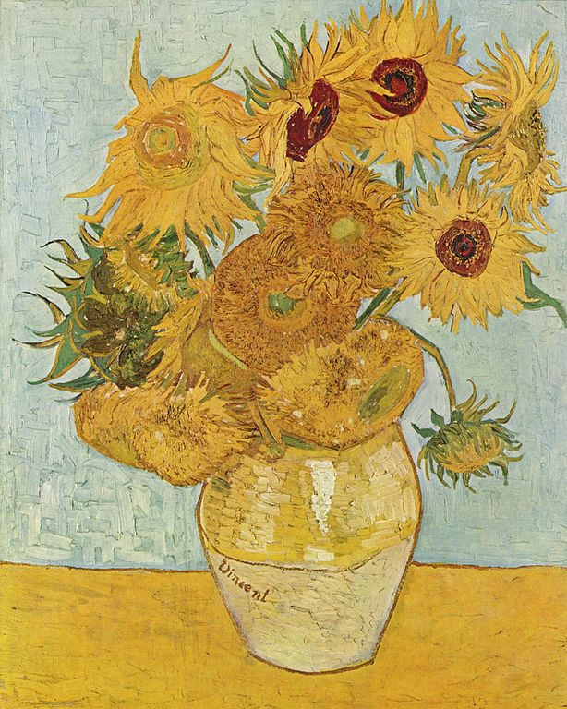**Vincent Van Gogh- Sunflowers (1888)**