Art - [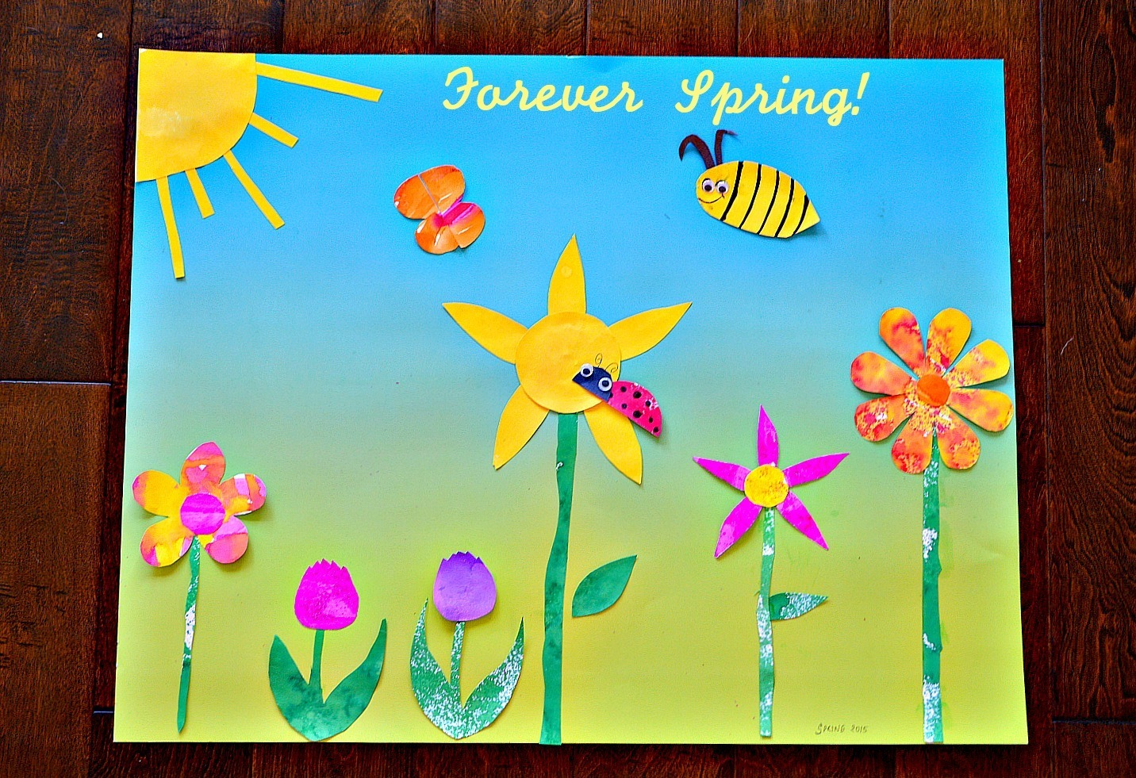](https://www.google.co.uk/url?sa=i&url=https%3A%2F%2Fwww.funlittles.com%2Fspring-art-for-kids-spring-themed-diy-wall-art%2F&psig=AOvVaw3Nq--O6s9BauIgzbkRSIKp&ust=1587477484682000&source=images&cd=vfe&ved=0CAIQjRxqFwoTCIib3M6U9-gCFQAAAAAdAAAAABAE)