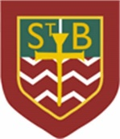**St Barbara’s Primary School**

**Suggested Learning – Tuesday 21st April**

Numeracy:

Number Talks – Please choose a question to complete. You may do it in your head or in your jotter. Think about what strategy you have used. I will post solutions and suggested strategies to these questions at 3:00pm.

Red – 34 + 10 =

Yellow – 67 + 22 =

Green – 56 + 25 =

Main lesson – As you know we are revising our place value skills this week. Yesterday we looked at identifying tens and ones in a 2 digit number. Today, if you can manage, we are going to look at 3 digit numbers.

Take a look at this place value chart like the one we use in class.

|  |  |  |
| --- | --- | --- |
| Hundreds (H) | Tens (T) | Ones (O) |
|  |  |  |

What number is represented on the chart?

Can you draw your own chart for the number 572?

Activity – When you have completed your warm up please choose one of the Maths activities below. You may wish to work with 3 digit numbers or there is a 2 digit number option if you feel you need a little extra practice.

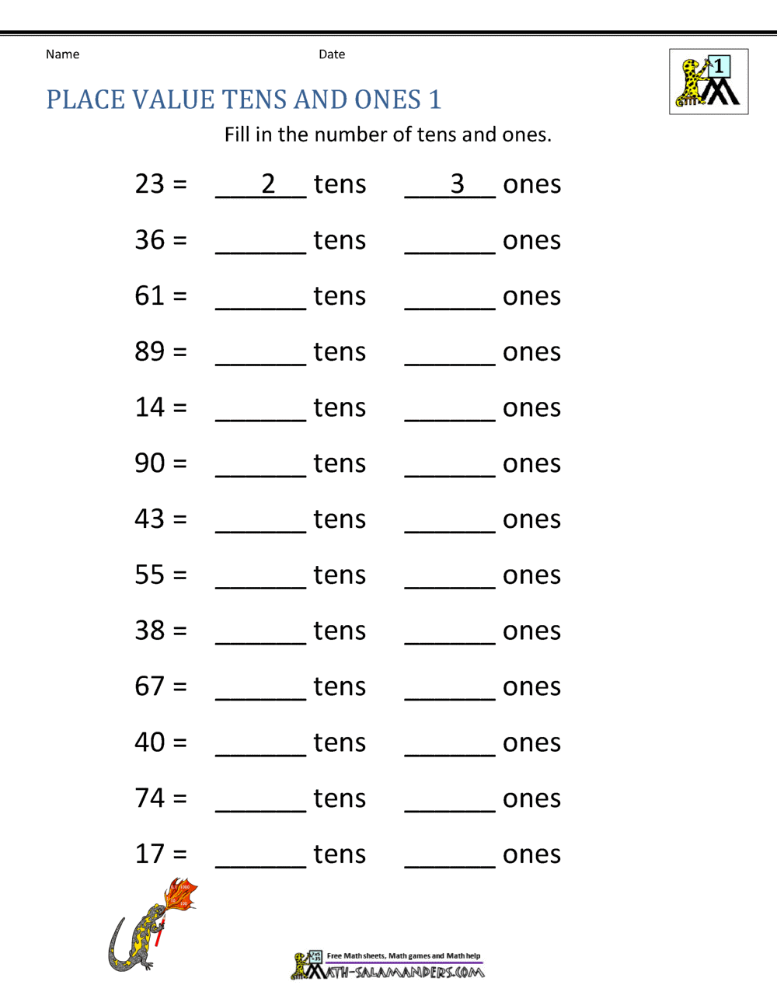[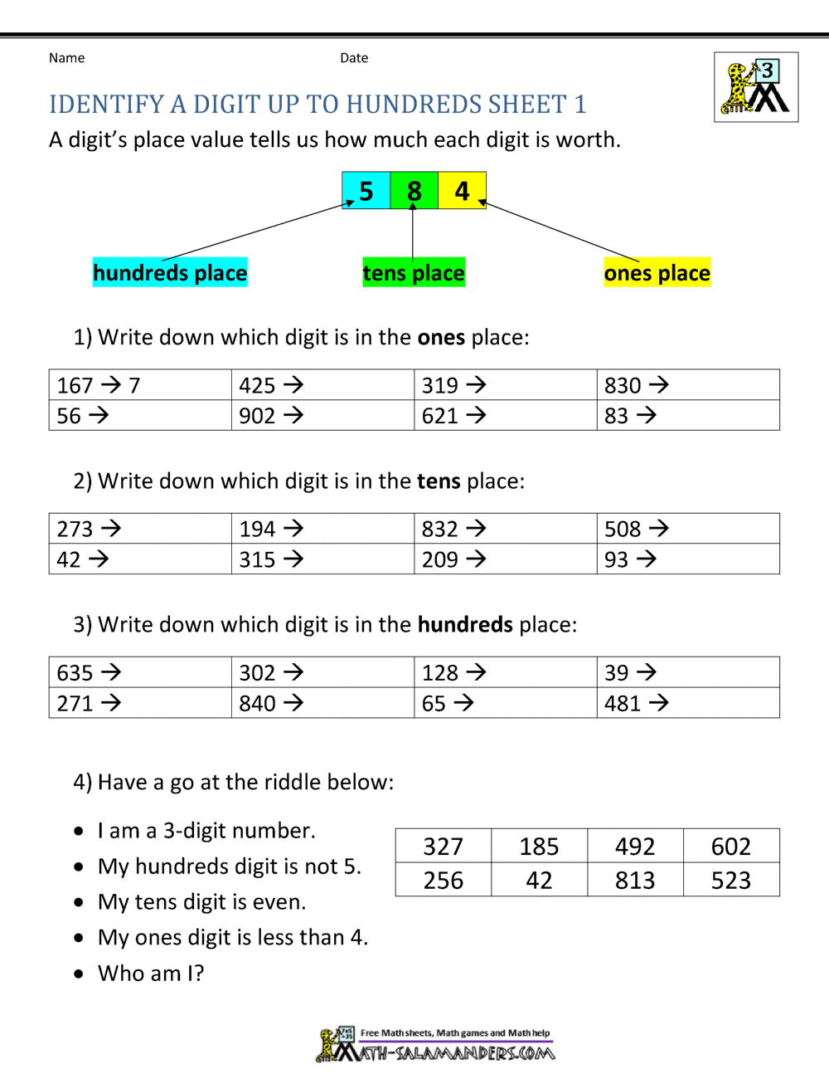](https://www.google.co.uk/url?sa=i&url=https%3A%2F%2Fwww.math-salamanders.com%2Fsecond-grade-place-value.html&psig=AOvVaw38YtYFZcT997ukUpus-dVL&ust=1587540671037000&source=images&cd=vfe&ved=0CAIQjRxqFwoTCIjtiICA-egCFQAAAAAdAAAAABAU)