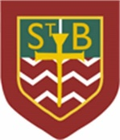St Barbara’s Primary School
Curricular Areas | Primary 7 Suggested Daily Learning Activities  Tuesday 21st April
Literacy | - Today’s starter task is a Boggle word game. Can you use the following letters to create as many words as possible- n, f, i, c, t, a, e, f, o and s? Try to challenge yourself by creating words using as many letters as possible. Remember you can only use the letters that are given to you.  - For reading today explore the First News newspaper article, HAIR-LARIOUS HAIRDO. When you have finished reading the article, read the questions and then skim and scan the text before attempting to answer any of the questions. Answer the questions in your jotter and remember to use the question to help you structure your answer. The answers are in the text so always refer back to the article to help support you. I have attached a link to today’s article and questions on the Primary 7 GLOW homepage.  - I have created a variation of word lists that follow this weeks focus spelling rule, soft ‘c’. Select a set of words that will challenge you and write each of the words out three times each in your jotter and then select 5 of the words to write interesting sentences.
Numeracy | - For today’s numeracy starter task complete the maths challenge from the 2nd level April calendar. Go to #abitofmathseveryday on Twitter to access this calendar.  - Today we will continue with Place Value- rounding. I have attached some rounding activities that you can do in your jotter and check your answers when you are finished. You may choose to complete a mild, spicy or hot chilli challenge, remember you can do more than one if you want.  - If you feel like doing some extra maths work today go on and complete this interactive maths challenge, it really is a lot of fun.  https://www.sporcle.com/games/Answer/speed-math-2
TIOF | Today I would like you to spend a little bit of extra time praying. Say a little prayer to thank God for all of his wonderful creations. You may choose to have one or more of your prayer sessions outside today whilst soaking up the sunshine and getting the opportunity to really appreciate the natural beauty of our surroundings.  If you would like you could choose to write down your prayer in your jotter and decorate it with a nice border or illustration.
Health and Wellbeing | During lockdown it is important that we exercise and remember to choose healthy options when snacking. Today I would like you to explore some of the food labels on a snack of your choice. Use the traffic light system guide provided to help decide if this is a healthy snack and provide reasons for your answer. You can record your answers your jotter.

Soft ‘c’ spelling rule word lists
List A
cylinder, circus, centre, juice, peace, December, niece and city
List B
distance, certainly, advanced, difference, science, democracy, bicycle and exercise
List C
celebrate, medicine, citizen, commercial, received, circumference, criticism and transparency

Rounding challenge
Mild Chilli Challenge
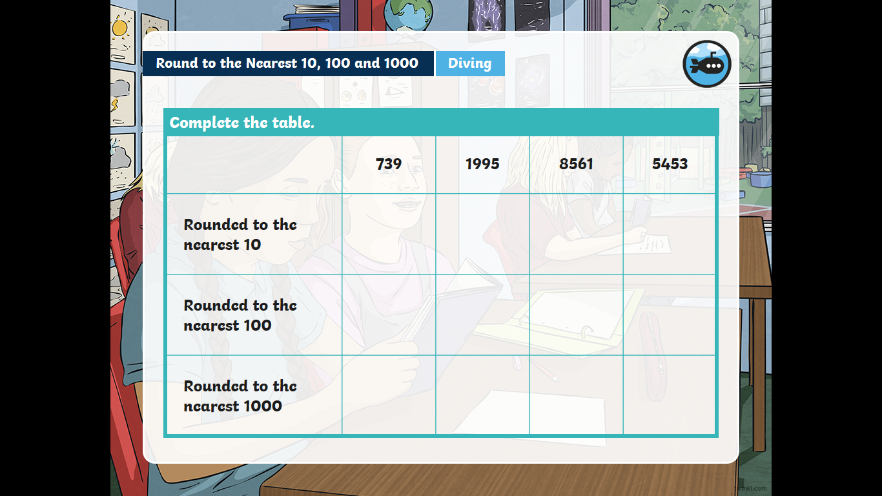
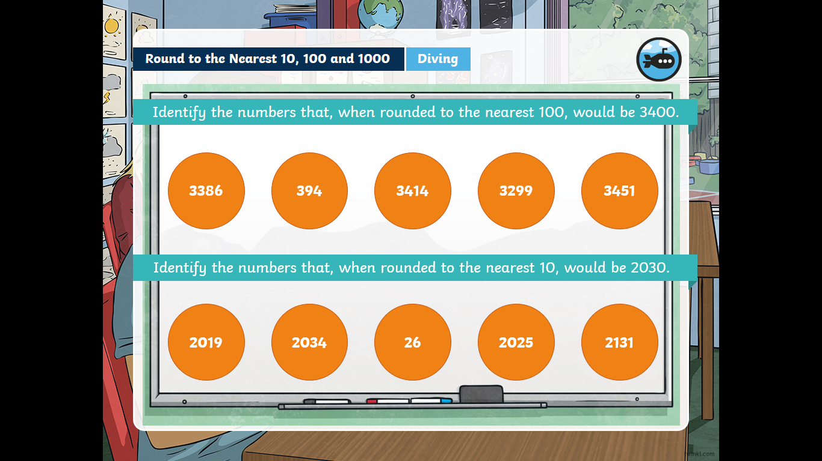
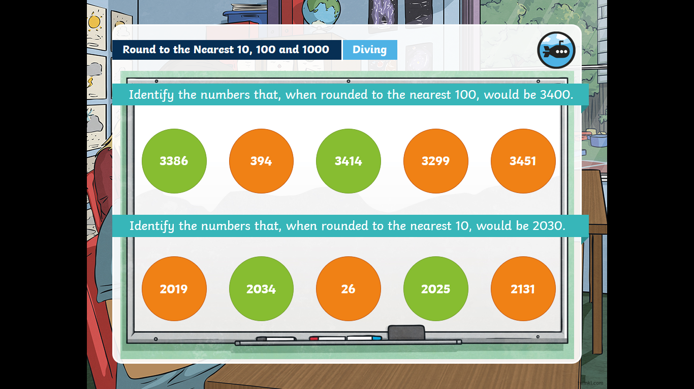
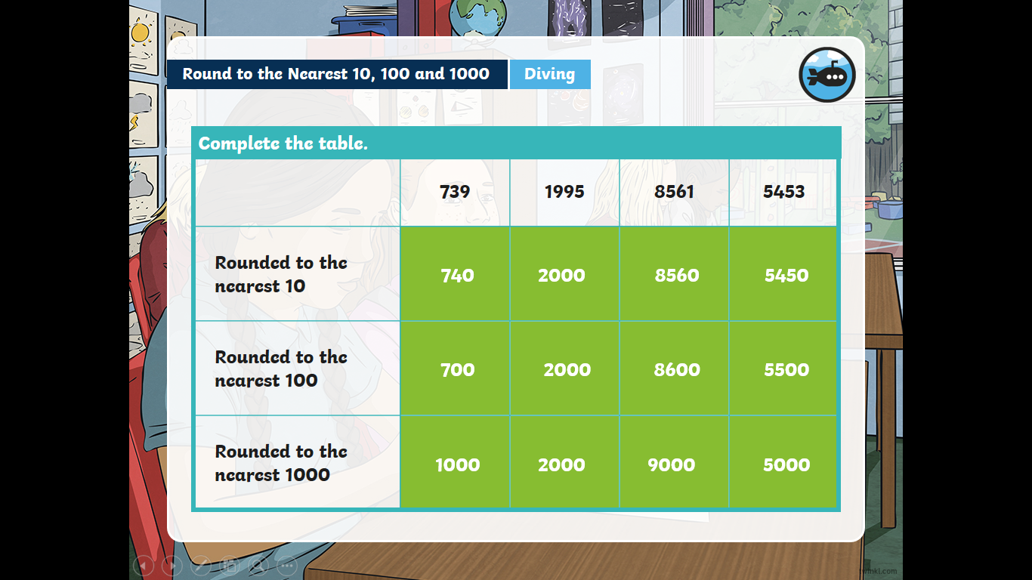
Mild Chilli Challenge Answers

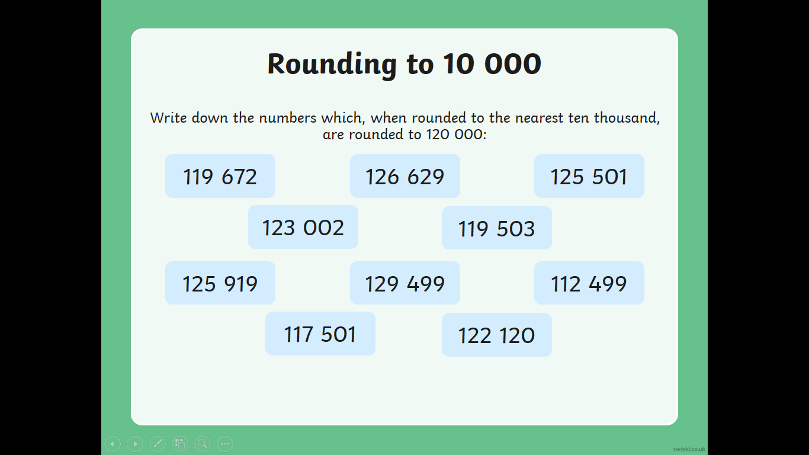
Spicy Chilli Challenge
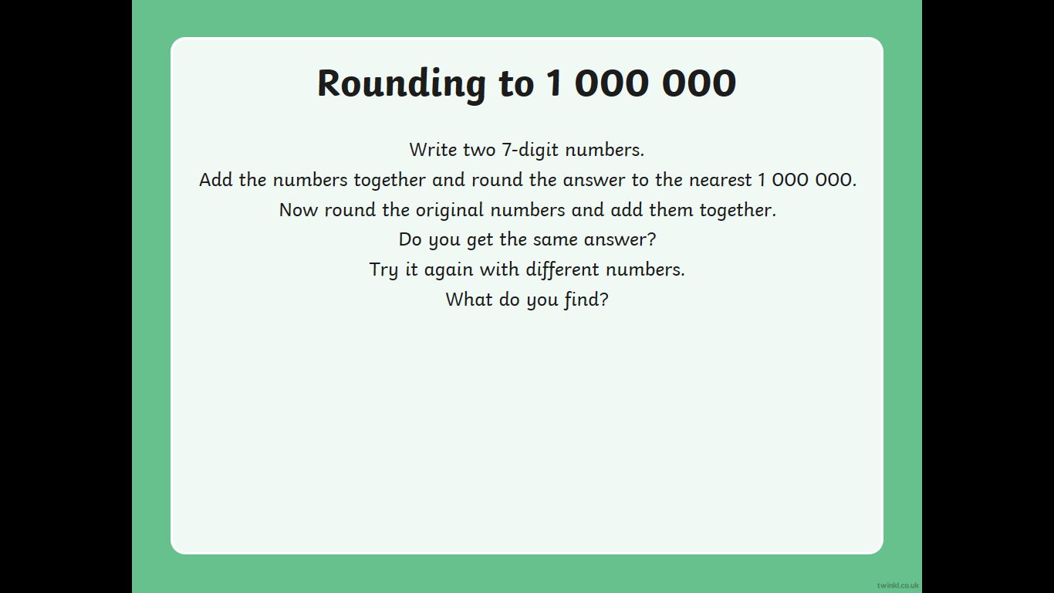

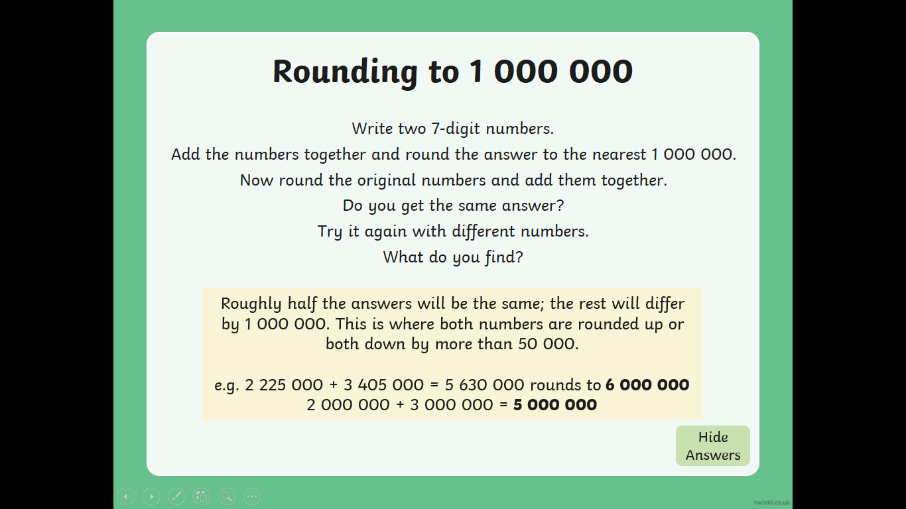
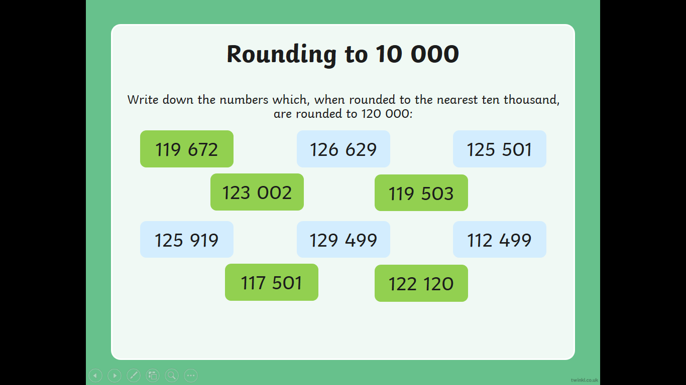
Spicy Chilli Challenge Answers

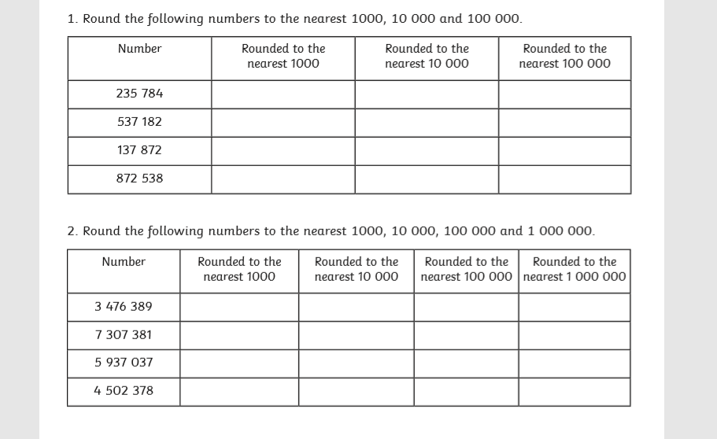
Hot Chilli Challenge

Hot Chilli Challenge Answers

Food Labels task

