Tuesday 21st- Morning Prayer
Literacy  IALT decode words using phonemes. | Phonics Task- consolidation  Capital letters sp group- split diagraphs (i-e/u-e/o-e/a-e)  Watch https://www.youtube.com/watch?v=L7faYbILI1s  Complete this worksheet  .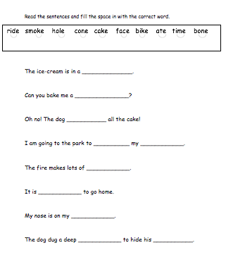  Full stops sp group- oy  Watch https://www.youtube.com/watch?v=g_FDezjoPMw  Complete this ‘oy’ worksheet  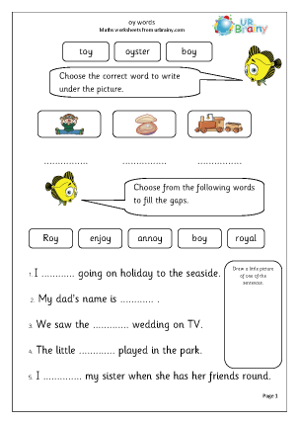
Numeracy  IALA how numbers are constructed. | Watch the place value video before completing this place value worksheet.  Place Value-  https://www.youtube.com/watch?v=1F3AycEDksY  Complete this worksheet- you can use objects at home to help you count visually.  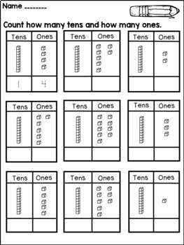  I know you all enjoyed playing this place value game so why not give it a go once you have completed your W/S.  https://www.topmarks.co.uk/learning-to-count/place-value-basketball
HWB  IALT improve my fitness. | Select one of these to complete to ensure you stay active today.  - Joe Wicks on YouTube @ 9:00am  - Jumpstart Jonny dance and work outs @ 9:00am  - Cosmic Yoga on YouTube.
T.I.O.F | St Thomas is one of the Apostle. He is often called “Doubting Thomas”.  Watch this video and find out why. After this, explain to an adult why and if you think it is fair that he has been given this title.  https://www.youtube.com/watch?v=vgk1BCvdV64
Other | We have been focusing on healthy eating in class so why not select the healthy menu task to complete today off your grid.  Healthy Menu  Using the Eatwell Guide, create a healthy menu which should include food from all food groups.  Eatwell Guide - Food and nutrition | NHS inform  www.nhsinform.scot › healthy-living › food-and-nutrition › eating-well

