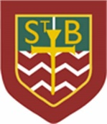St Barbara’s Primary School
Curricular Areas | Primary 7 Suggested Daily Learning Activities  Monday 20th April
Literacy | - Normally on the first day of a new term we spend some time sharing stories about what we did during our time off. I would still like to hear what you did over the holidays so I would like you to write a short recount about your Easter break. Remember to structure your writing in paragraphs, challenge yourself with your use of vocabulary and double check your spelling and punctuation.  - Personal reading- after reading a few chapters of your book identify 5 words that you are not sure of their meaning. Can you use your metalinguistics strategies to work out the meaning of these tricky words?  - One of the spelling rules that we will be revising this week is soft ‘c’. Today I would like you to come up with a list of 10 words that follow this rule. When you have created this word list remember to double check the spelling of these words using a dictionary. Tomorrow I will give you some focus words that follow this spelling rule that you will be tested on via Sum Dog at the end of the week.
Numeracy | - To get our brains back into maths mode please complete a Top Marks Daily 10 challenge. Select Level 6, Digit Values and up to the value of 999,999.  - The Daily Rigour is a great numeracy newspaper. I would like you to try and complete some of the activities from the articles, I have attached a copy of the newspaper underneath this table. This is a great way to develop your confidence when completing word problems.  - This week we will be revising some concepts from Place Value. Carefully listen to and watch the link below from Rigour Maths and complete the examples given. This great refresher clip.  https://www.youtube.com/watch?v=5D3gUWP3ffQ&feature=youtu.be  Have a go at the text book page that links with this lesson and write the answers in your jotter. There are bronze, silver and gold questions so try to complete the ones that challenge you the most. The answers are provided so once you have completed this activity you should self-assess your work, remember no cheating! I have attached the textbook work and answers underneath the table however if you have any questions please get in touch.
Health and Wellbeing | To help get us motivated and active complete a Joe Wicks workout. Go to the ‘P.E. with Joe’ section and let’s keep fit.
R.E. | After his death and resurrection, Jesus appears to his disciples, and wishes them peace. How did they feel when they saw Jesus alive again?  But one of the disciples wasn’t there when Jesus appeared. Can you remember who that was?  And what did Thomas say? Did he believe the others when they told him they had seen Jesus?  Thomas said he would not believe that Jesus was risen from the dead unless he saw it for himself. Thomas wanted to see the holes in Jesus’ hand, made by the nails on the cross.  We are all a bit like Thomas sometimes. Can you remember a time when you didn’t believe something someone told you, until you’d seen it for yourself?  In just the same way, it isn’t always easy for us to believe in God and Jesus. Even though we listen to the gospel, and hear about God’s love for us from people at church, home and school, it can be difficult to keep believing when things go wrong or when we are sad or afraid.  But what does Jesus to say to Thomas?  Jesus appears again to Thomas, shows Thomas the holes in his hands and wishes him peace. He tells Thomas to believe, and he proves that he is real. But he also says, “How happy are those who believe without seeing me!”  Can you remember the nickname that Thomas gets? Do you think this is a fair nickname? Write a justification for your answer in your jotter.
Additional Tasks | If you wish to complete more tasks please select one or two tasks from your new Second level grid for April.

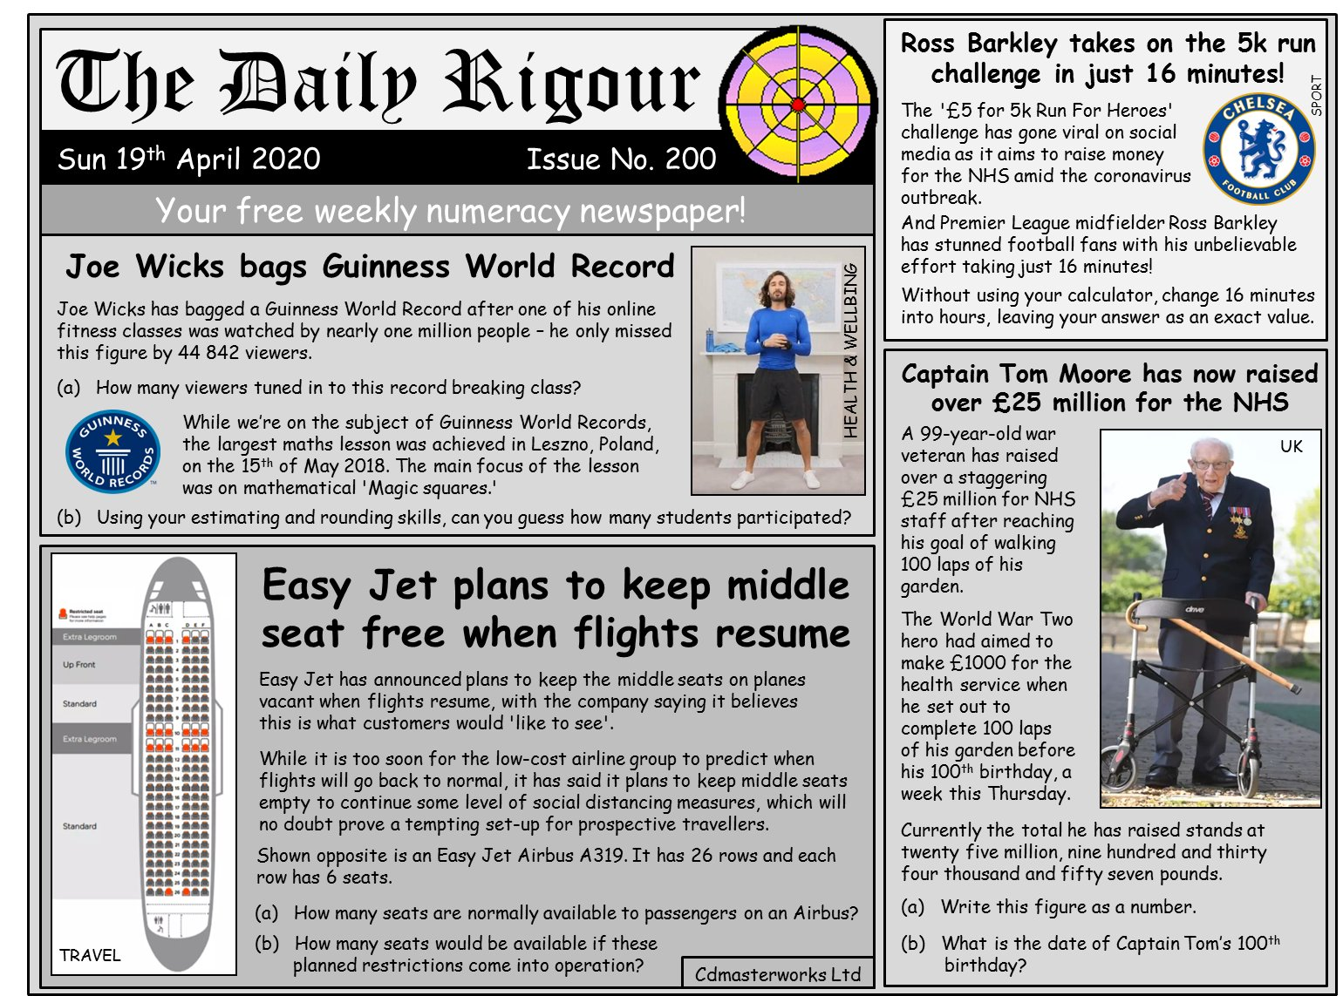
The Daily Rigour newspaper

Rigour maths textbook work
Rigour maths textbook answers
