Abraham
When Abraham was 75 years old, God appeared to him and spoke to him. God told Abraham to leave his country and travel with his family to a land where God would lead him. God promised that his name would be great and that he would be part of a great nation. Abraham did what God commanded and he took his wife Sarah and his brother Lot with him.
God promised a son to Abraham and Sarah but it wasn’t until Abraham was 100 years old that God blessed them with a son. Abraham definitely had his doubts over God’s promise of a son as they had waited for so many years. What faith Abraham had to trust that God would deliver a son to them. Sarah gave birth to a son and they named him Isaac.
Not long after this, God spoke to Abraham and asked him to take his only son Isaac to a high place and sacrifice him! After waiting all these years to have a son, God was asking Abraham to kill him!
In great faith and trust, Abraham took Isaac to the place God told him and lifted Isaac onto an altar.
Just as Abraham raised the knife to slay his son, the angel of the Lord called out to Abraham to stop and not harm the boy. God could see how great Abraham’s faith was and God provided an animal for Abraham to sacrifice instead (as was a normal custom of the time).
Abraham went from the sorrow of never being able to have children, to the joys of being blessed with a son. He then experiences sorrow again when he prepares to sacrifice Isaac at God’s request, only to feel joy again as God never intended him to go through with it and his son is spared.
Abraham’s life is a powerful message about trust. Abraham did have doubts, but he placed his trust in God and his life is an inspiration for many Christians.

Questions
- Write down what Abraham would have been feeling at the following moments in his life?
a) Abraham had been promised a son when God spoke to him (age 75) and 24 years later, he and his wife still had no child. b) At the birth of his son Isaac.
c) When God spoke to him and asked him to sacrifice Isaac.
- Do you think it was easy for Abraham to trust God?
- How does Abraham inspire you?

Moses
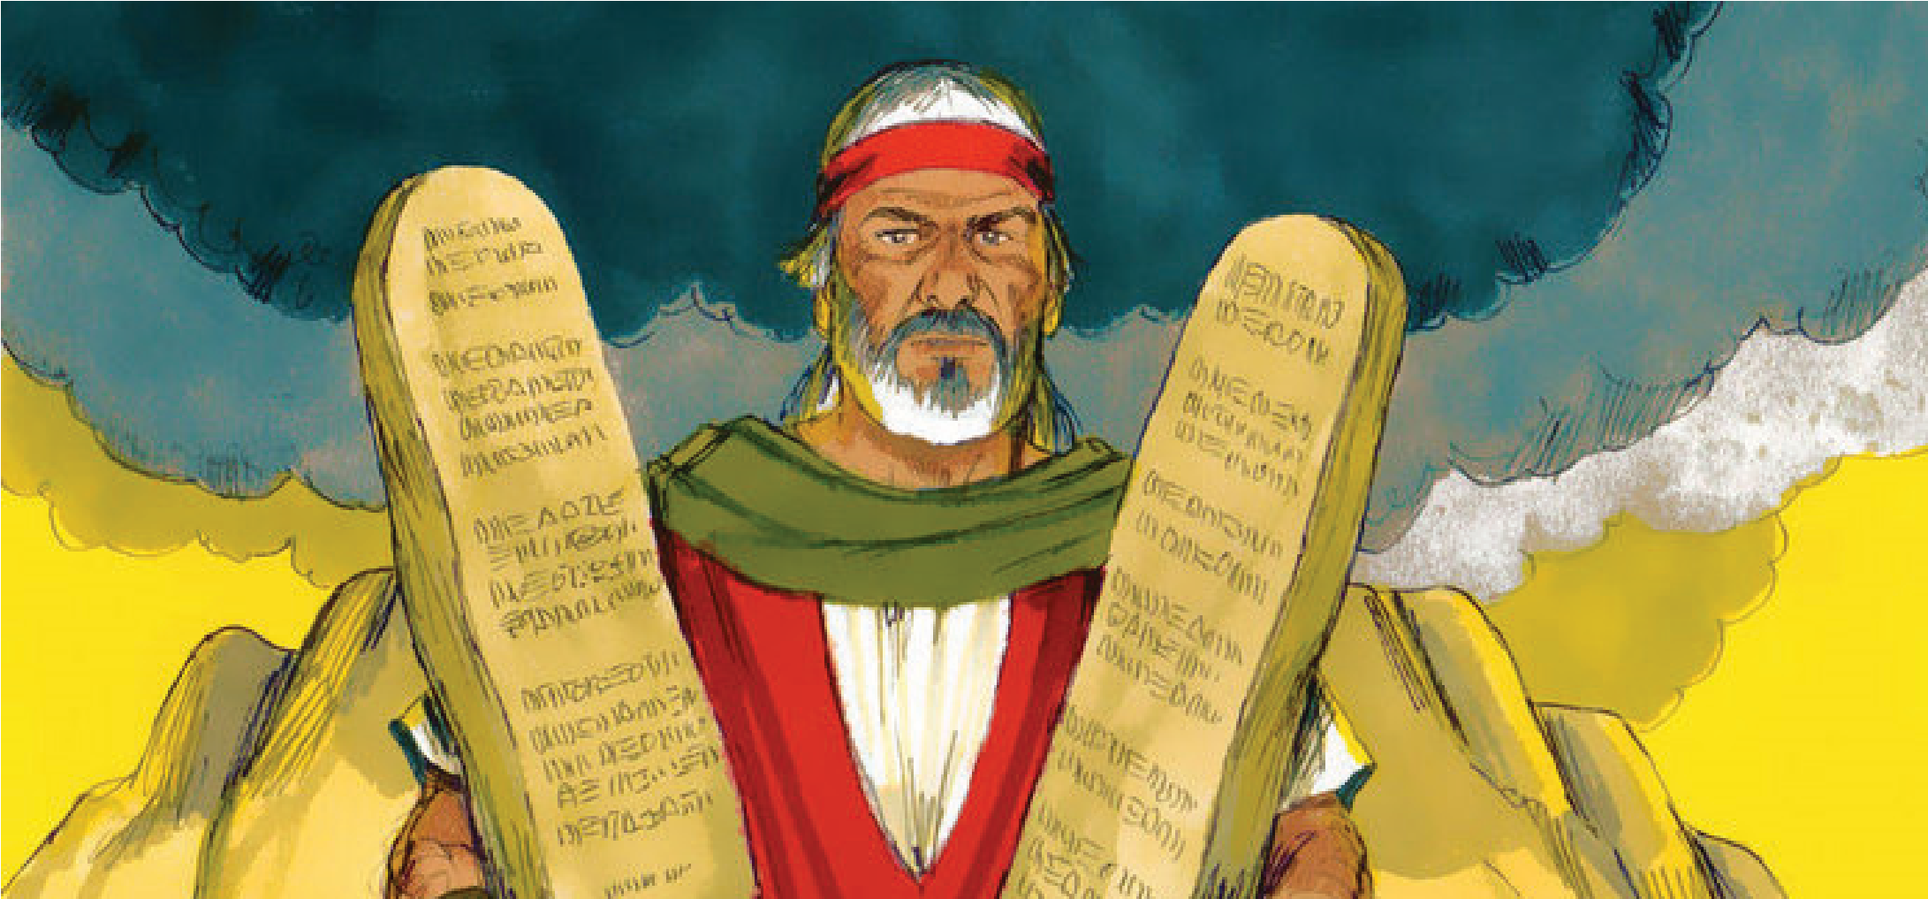
Joseph had a tough life! First of all he was one of 12 sons, (can you imagine the fighting?) and he wasn’t well liked by his brothers especially when Joseph told them that he had a dream when even the sun and moon were bowing down to him. They thought he was being big headed so they worked out a way to kill him! Fortunately they stopped at dumping him down a well where he was picked up and sold as a slave to an official in Pharaoh’s household.
Joseph was falsely thrown into prison but even in prison God was with him. He was put in charge of the other prisoners and continued to show that he was a special man.
God had given Joseph the ability to interpret dreams and this was recognised years later when Pharaoh had some dreams that he was struggling to understand. Joseph was brought before Pharaoh and Joseph told him what the dreams meant. Although Joseph had interpreted Pharaoh’s dream as a warning of famine, his abilities were clearly seen as amazing and he was put in charge of all of Egypt. From slave to master!
Because of Joseph’s ability to read dreams, the whole country stored up grain ready for when the famine would hit them. It was at this time when his brothers travelled to Egypt to buy food. Joseph set some tests for them and once when they returned, he revealed who he was (they had not recognised him before that point).
Joseph forgave his brothers for what they had done and invited them to come and live in the land of Egypt.
Joseph may have come across as big headed to his brothers, but what should be remembered about Joseph is how he came back from so many times in his life when he was so low. He was sold as a slave and thrown into prison but he fought his way to become ruler of Egypt, all the time fully relying on God.

Questions
- Write down what Joseph would have been feeling at the following moments in his life?
  - When he was attacked by his brothers
  - When he was thrown into prison
  - When he became ruler of Egypt
- How would you react to the things that Joseph went through?
- How does Joseph inspire you?

Ezekiel
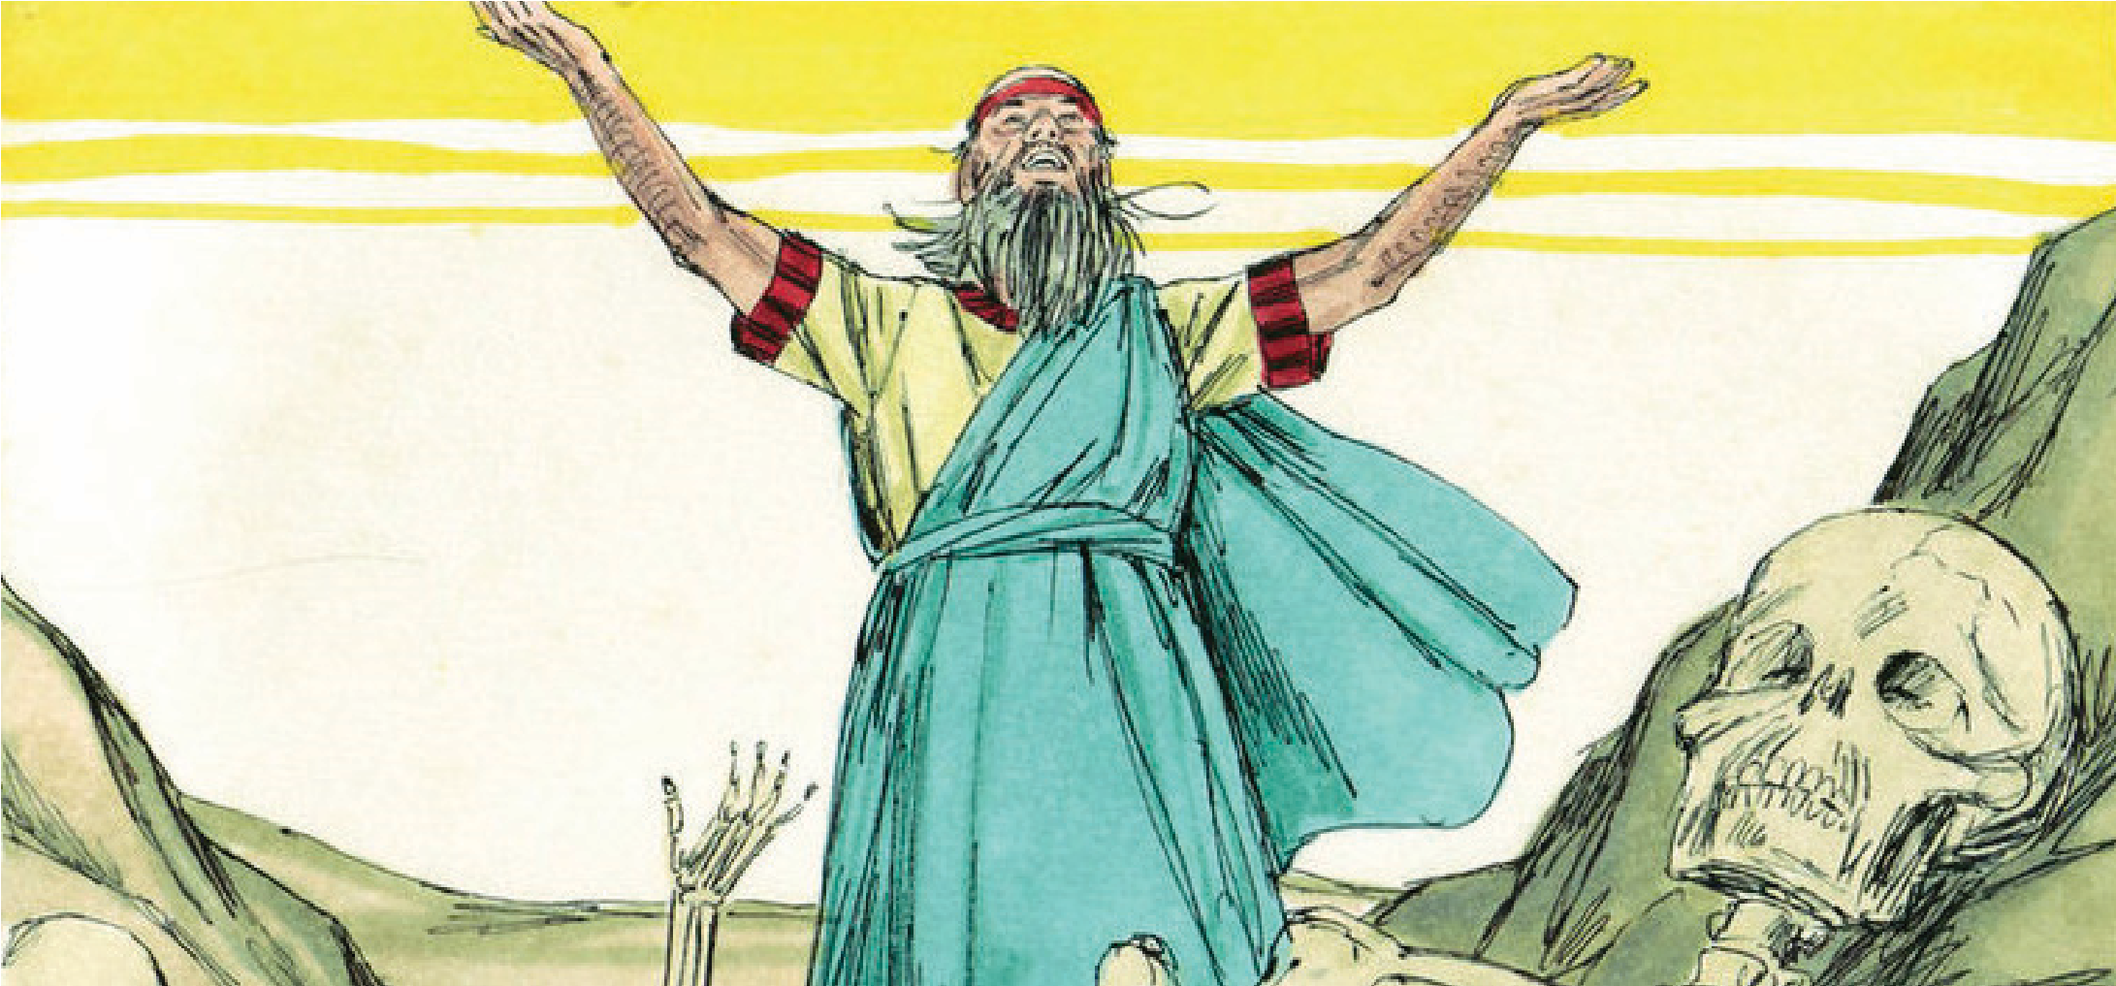
Ezekiel was among many Jewish people when they were taken captive by the Babylonians. Ezekiel is known as the man of visions as God appeared to him in many visions.
God asked a strange request of Ezekiel, to eat a scroll that God provided and to go and tell what was in it to people of Israel. He did this and the message was to not disobey God.
Ezekiel did other, what we would consider strange things that God had told him to do. He shaved of all his hair and burned a quarter of it to represent that a third of the Israelites would die of disease and famine when the city was attacked.
One third, he chopped up, representing that a third of them would be killed in battle. The final third of his hair was scattered in the wind but some was kept to show that God would save some and bring them back to the promise land.
God told Ezekiel that things would get worse for the people of Israel before they got better. You can tell that Ezekiel was not the most popular man in town!
God continued to give Ezekiel visions and one was more hopeful than the others. When a vision of dry bones came together and flesh and skin came upon them, this was a sign that the nation of Israel would be restored and they would come back to their land.

Questions
- What do you think Ezekiel was thinking when God was asking him to do the strange things?
- What would you have done?
- How can Ezekiel inspire you?

Isaiah
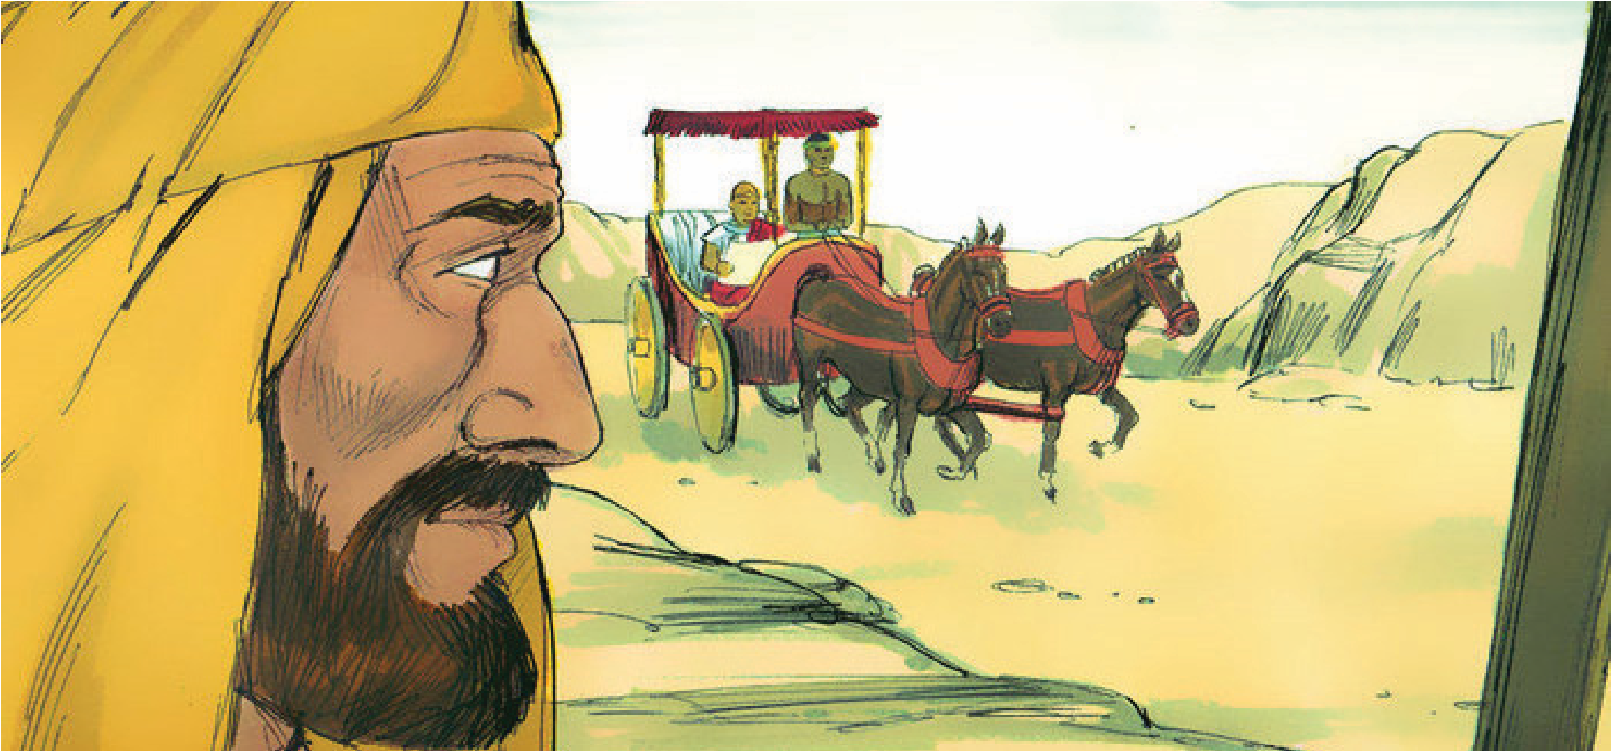
Isaiah was a prophet, which meant that he would hear from God messages to give to the people. Some-times the messages were not always what the people wanted to hear but Isaiah always delivered.
Isaiah brought messages from God to four different kings. It was not easy for him to stand before the kings and tell them off as some messages from God were asking them to stop doing bad things and turn to God again.
Isaiah gained respect from a king called Hezekiah and he was asked to pray for him about a battle that was coming his way. Isaiah delivered a message to King Hezekiah that he didn’t need to worry as God would bring him the victory. The enemy army left without fighting.
One time Isaiah had a vision (which is like a dream, without sleeping) in which he saw God in all His glory. Isaiah was asked by God ‘Who shall I send?’ and Isaiah replied ‘Here I am, send me’. God sent Isaiah to his own people to tell them that God was angry at them. Not the easiest message to take!
Isaiah also told his people about how a saviour would come and help them. This was of course going to be Jesus. All the things that Isaiah spoke about Jesus are written in his book.

Questions
- How would you feel standing before a king, telling him off?
- How do think Isaiah felt when God asked him to deliver the message about Jesus?
- How does Isaiah inspire you?

King David
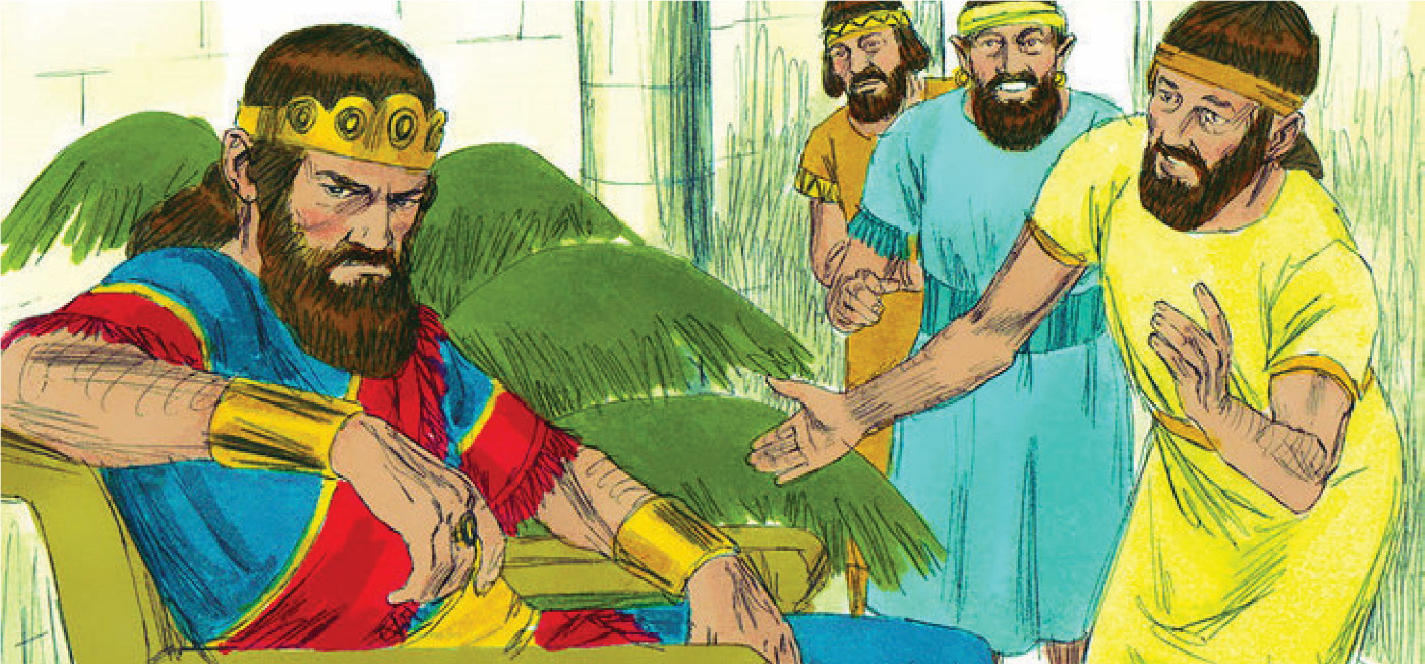
David was not always king, in fact he was nothing more than a shepherd boy when we first read about him in Scripture. He lived in the shadow of his older brothers who were soldiers fighting for the king. They teased him saying that he was not strong enough to fight against the Philistines (the king’s enemies). But when all the soldiers were too scared to fight Goliath (a Philistine giant), David the young shepherd boy, stepped forward and defeated him with a slingshot and a stone.
This amazing victory made him famous throughout the land. He was maybe too famous as he was admired more than the present King who then tried to kill him several times.
David became King of Israel and reigned for 40 years
Although David did not live a perfect life, he continued to trust God and God himself gave the title of ‘A man after God’s own heart’ to David.
He was a mighty warrior defeating many of Israel’s enemies.
He became friends, like brothers, with King Saul’s son Jonathan, setting a model of friendship that everyone can learn from.
David was courageous, trusting in God for protection. He loved God his entire life.

Questions
- Where did David’s courage come from?
- How do you think David was feeling after he killed Goliath but then was chased by the present king in order to kill him?
- How does this story inspire you?

