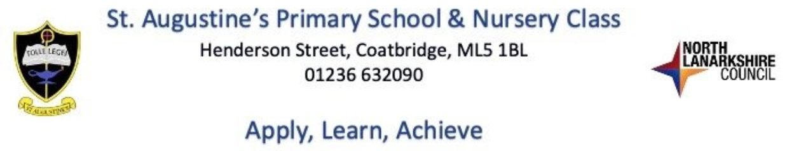

Dear Parent / Carer,

You are invited to attend an Open Afternoon in the school on **Wednesday 23rd October at 1.45pm.** A short presentation will take place in the school hall followed by an opportunity to visit your child’s class and to meet your child’s teacher at **2pm**.

Please note that this is not a parent meeting to discuss your child, rather an opportunity to view your child’s learning environment and for your child to share their learning.

Parent reporting sessions will take place on **Tues 12th Nov** and **Thurs 14th Nov**.

We look forward to welcoming you to the school.

Kind Regards

Mrs C Docherty

Head Teacher