How do I access Glow?
Go to the website https://sts.platform.rmunify.com/account/signin/glow or search for “Glow login” online. You will be taken to the following image: -
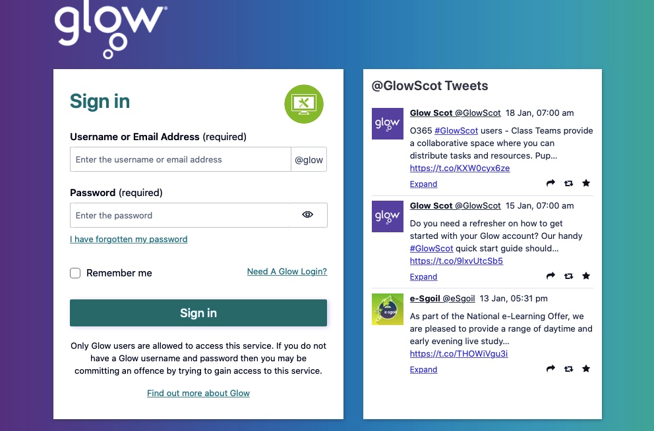
I have forgotten my password and login information; how do I find this out?
Please call the school on 01236 632090 or email HT@st-augustines.n-lanark.sch.uk stating your child’s name. We will call or email you back with this information as soon as we can.
What computer / device can I use to access Glow?
Any internet enabled device with a web browser. For example, a PC, Laptop, Tablet, iPad, or games console such as Xbox or PlayStation. We have uploaded a guide for X-box or PlayStation to the school blog.

What is the easiest way to access Teams?
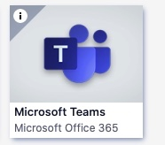
If you have a compatible device such as laptop or iPad downloading the free Teams app allows easier access and your login credentials can be remembered. Simply go to your device app store and search. You are looking for this icon.
I am on Teams, where do I see posts from my child’s teacher?
At the top of the screen, you will see “Posts” this is where messages from the teacher will be made. You can reply on a post by selecting ‘reply’.
You select at the bottom of a post for reply to come up.

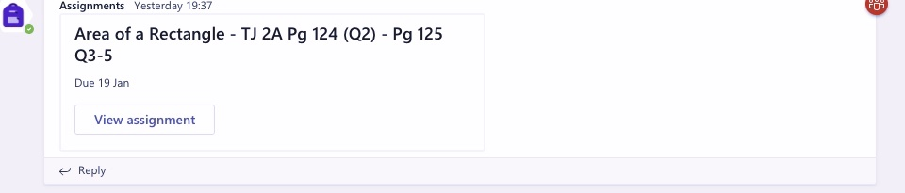

How can I attach a file to share with the teacher?
You can upload work completed either on assignments or on a post to the teacher by selecting the paperclip icon either on the post or in assignments. You can upload a document or a photograph of written work, depending on how the work was created. Your child’s teacher might give specific instructions on where they would prefer work to be submitted.
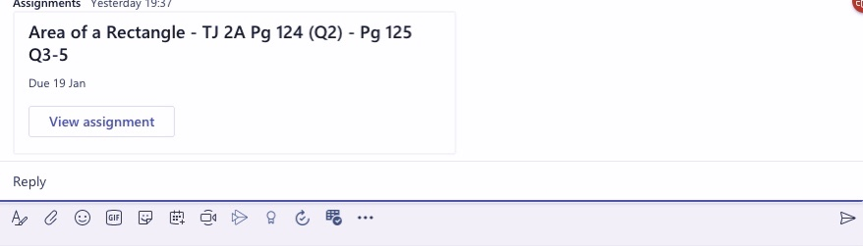
When you have finished typing your message and it is ready to send select the aeroplane image on the right to send.

We would like to type work to submit but don’t have Word on our device.
That’s ok. You can download Microsoft Office on up to 15 devices using your Glow id. Simply search for Office in App Library on Glow. You are looking for this image: -
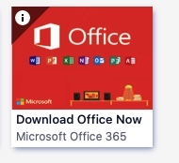
Once you select this tile you will be taken through the various stages to download the software onto your device. Just remember to log in with full Glow username and password to activate.

