** November - December 2020 **

**St. Augustine’s Primary**

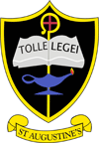**NEWSLETTER**

***Winner of NLC Sport Award – Primary School of the Year 2019***

Dear Parents/Carers,

The arrival of autumn tied in with the opening of our new campus nursery on the 23rd October. All building work was complete and we were delighted to welcome our wonderful new nursery and amazing nursery team to our learning community. We are thrilled to have such an addition to our campus. It is wonderful to both see and hear the children making great use of their new outdoor space. The nursery team are already working on ideas to make changes to the outdoor play area. It really is exciting stuff!! We hope you have kept well informed about all that has been going on in school by checking our blog on the school/nursery app and our tweets on twitter. The term that lies ahead is always a hectic one so please take note of dates to add to your diary.

Mrs.C.Docherty

, 

*Mrs. C. Docherty*



So, please, please park and stride and ensure the road around the school is free of parked cars.

learning about sources of energy and how to conserve energy.

 Parking

Our PTA kindly paid for parking banners last year. They had a notable impact at the time and reminded every parent of their responsibility to be considerate of others and park in a safe place. Our message remains the same with our JRSO (Junior Road Safety Officers) committee identifying ongoing parking issues that are putting children at risk and giving them cause for concern. Their campaign is already underway. Parking is available in the Time Capsule car park and St. Augustine’s Church.

Infra-structure Update

We are delighted that we have finally come to the last phase of building upgrades that have been ongoing for more than a year. The school now has a new heating system, is fully re-wired and has a new cabling system. However, there remains some outstanding painting work that we hope gets addressed as soon as possible. Likewise, we hope that issues with wi-fi connectivity at some points in the school are addressed to support our digital learning.

Social Distancing and Face Coverings

Many thanks to you all for following the clear guidelines around social distancing at the school fence and gates. Please note that Scottish Government advice is to wear a face covering at drop off and pick up times. Please try to drop off and leave in order to reduce the opportunity for virus transmission.

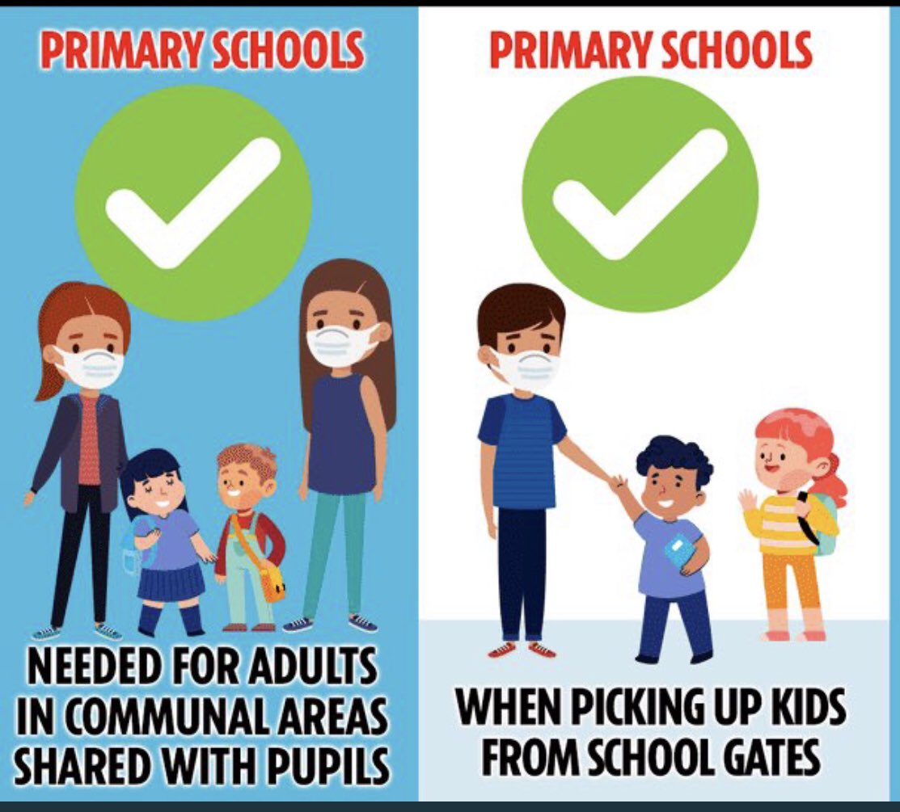

Pope Francis Faith Award Candidates

Our Pr. 6 and 7 pupils are already making entries in their faith journals and are looking for ways to put their faith into action and serve others. Please support your child at home to address their personal targets.

MASS

Pupils across the school view the First Friday Mass online as we can’t attend Mass as a school community. As a faith school we remain committed to the promotion of Gospel values and faith formation and look forward with earnest to the day we can return as a school to church.

PE.Days

Our P.E. kit is white polo shirt or white T-shirt, black shorts or black/grey jogging bottoms. Bright emblazoned T-shirts are not part of our uniform.

At present due to ongoing restrictions we remain delivering PE outside. We are currently reviewing our protocol to determine how we can effectively deliver a PE programme indoors after recent updated guidelines/advice. We will keep you posted.

Please note children will only be exempt from a P.E. session if a letter is sent to school stating the need for an exemption on **medical grounds**. PE is a core part of the curriculum and everyone is expected to take part.



Happy Birthday

to all our

October,

November

and

December

birthday

boys and girls.

Catholic Education Week

Catholic Education Week will take place in partnership with St.Ambrose High School and St.Augustine’s Church week beginning 16th November. This year’s theme is Jesus, the way, the truth and the life.

House Captains and Vice Captains

The school is delighted to announce that new House Captains and Vice Captains have been elected. They have already presented at two end of month virtual assemblies and are already accomplished presenters. As House Captains and Vice Captains they are expected to lead by example and so far are doing a wonderful job. They are becoming very professional in their role and have been a delight to work with. They have taken on a most important leadership role in school that will hopefully inspire other pupils to be responsible citizens, confident individuals and effective contributors.

Monklands

House Captain – Noora Sajith

Vice-Captain – Christopher Ho

West End

House Captain – Enya Doran

Vice-Captain - Declan Cassidy

Summerlee

House Captain- Daisy Linton

Vice-Captain- Melissa Wright

Drumpellier

House Captain- Florence Hagerty

Vice-Captain- Lucille King

We wish them continued success in their new roles.

School Improvement Priorities

This session we have three Improvement Priorities in our School Improvement Plan.

1. Improve outcomes for learners via the Recovery Programme for Literacy and Numeracy
2. Improve outcomes for learners via the Recovery Programme for HWB
3. Improve outcomes for learners via an established Digital Pedagogy across all stages

A copy of our Improvement Plan and School Improvement Report can be found on our school website.

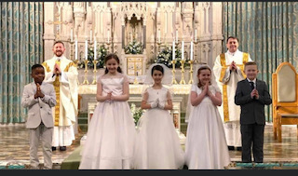

Gaelic Football News

Pupils from Room 7 and 8 (Pr. 6 and 7) attend weekly training sessions with Joe Bradley. Many of the pupils also attend a local club held several nights during the week. We are delighted that our Gaelic Football team won a recent tournament held at St Ambrose. They showed great teamwork, skill and determination to win. Well done team! A group of people standing on top of a grass covered field

.

First Communions

A huge congratulations to all our Pr. 5 pupils who finally got to celebrate their First Holy Communion. They waited a long time but finally got to celebrate their special day with friends and most importantly their family. Many thanks to Father Kane and Deacon David for their great support and for ensuring the children had a most memorable day.

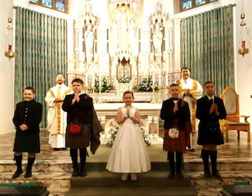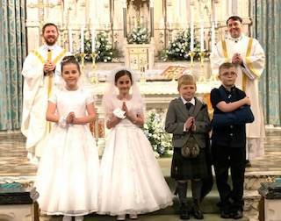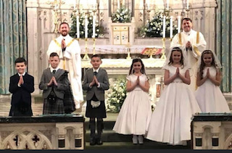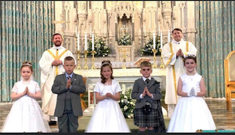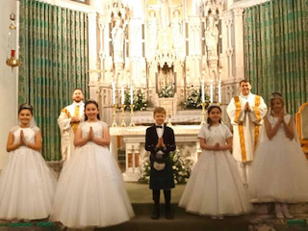

Afterschool Clubs



At present due to ongoing restrictions we do not have any clubs running at present. We understand this is a great loss to the school but hope that the children are finding fruitful ways of spending their free time. As soon as we are in a position to deliver clubs once again we will let you know.

Online Learning

Online learning is now playing an increasing role both in school and at home due to our changing world. During lockdown teachers had to find creative and inventive ways of ensuring children remained engaged in their learning and thanks to you, parents, this was achievable. This would not have been easy and we commend your great efforts. At school we have remained committed to maintaining an online platform for providing homework. All teachers are continuing to use teams to set homework and to engage with children who have had to self isolate this session. Never has parent partnership been so important as we work together to ensure that children are continuing to progress in their learning. Your child/children have already made great strides in their learning and are continuing to make progress. If you require any support in regard of how to use technology, access teams or you don’t have a device please contact the school and we will make arrangements to provide the necessary support. We are all in this together.

DECEMBER



FESTIVE FRIDAYS

Friday 4th December – Christmas Lunch

Please encourage your children to have a Christmas lunch that day. If it is not to their liking and you are providing a packed lunch please try to make it a bit festive that day so your child can join in with all the other pupils. Own clothes/Christmas t-shirts/jumpers can be worn that day.

Frid. 11th December – Christmas Party Day

Children arrive in school that day for their class party (party clothes). As we still have to follow strict guidelines around bubbles in order to continue mitigating risk all activities will take place in class. There will be a variety of Christmas themed activities in the morning and party food and Christmas movie in the afternoon. If guidelines change in any way we will notify all parents if there are to be changes to this arrangement.

Friday 18th Dec- Pantomime Afternoon

Children may wear their own clothes/Christmas Jumpers/ T-shirts for viewing the pantomime online. Sweets and juice will be provided for this fun afternoon.

School closes on Tuesday 22nd December at 2.30pm

School re-opens on Wednesday 6th January at 9.00am

Parent Council

Our Parent Council are committed to supporting the school on our ongoing improvement agenda. Next Meeting Wed. 25th Nov at 6.00pm. The meeting will take place virtually. Please check out the Parent Council twitter account for school and parent council news.

Parent Teacher Association

Next meeting – Wed. 25th Nov at 7.15pm. New members are warmly welcome to join us. We need your support. The meeting will take place virtually. Please check the PTA twitter account/facebook for details.

Christmas Card Project

Every year our PTA organise The Christmas Card Project that involves all pupils designing their own Christmas Cards. Designs can be completed in class or at home. Orders must be submitted via the PTA Facebook page – [www.facebook.com/StAugustinesPTA](http://www.facebook.com/StAugustinesPTA) or via e-mail pta.staugustine@gmail.com.



To support ongoing fundraising the PTA are also taking orders for Krispy Kreme donuts – a dozen glazed donuts for £10. Payments made online to PTA with doorstep delivery.

School Panto

Unfortunately this year due to ongoing restrictions we do not have our customary visit to Motherwell Theatre for the annual pantomime. However, please note that arrangements have been made for virtual pantomimes to take place in each class this year. It will still be a Christmas dress up day with reindeer antlers and santa hats all optional.

Celebrating Christmas

Please check our blog and twitter account for updates on class activities in the lead up to Christmas. Unfortunately, due to ongoing restrictions we can’t have our annual Christmas Nativity and Concert. However, we do aim to ensure the festive season is fully taking place at St.Augustine’s and that there is plenty going on in classes during this time of preparation.

**After School Clubs**

It has been wonderful to see that all after school clubs have been so well attended. This term our after school clubs are:

Monday – Badminton Room 2 and 3.

Tuesday – Art Club Room 1 and 2

Netball Primary 6/7

Wednesday – Fun Fitness Room 1 and 2

This after school club has just completed its 6 week block.

The Thursday football club will be restarting soon. Details to follow.

If you are interested in running an after school club please contact the school.

**Football Festival**

Some of our Primary 6/7 boys will visit Airdrie Academy on Friday 23rd March for a football festival.

Parental Comments/Feedback

The school greatly appreciates all feedback and comments from the wider parent body in regard of the school. Please feel free to complete the sheet and send into school if there is anything you wish to bring to our attention. Thank you.

Signed: Date: