When you open up Glow this is the screen you will see. Please input your username and password before clicking sign in.
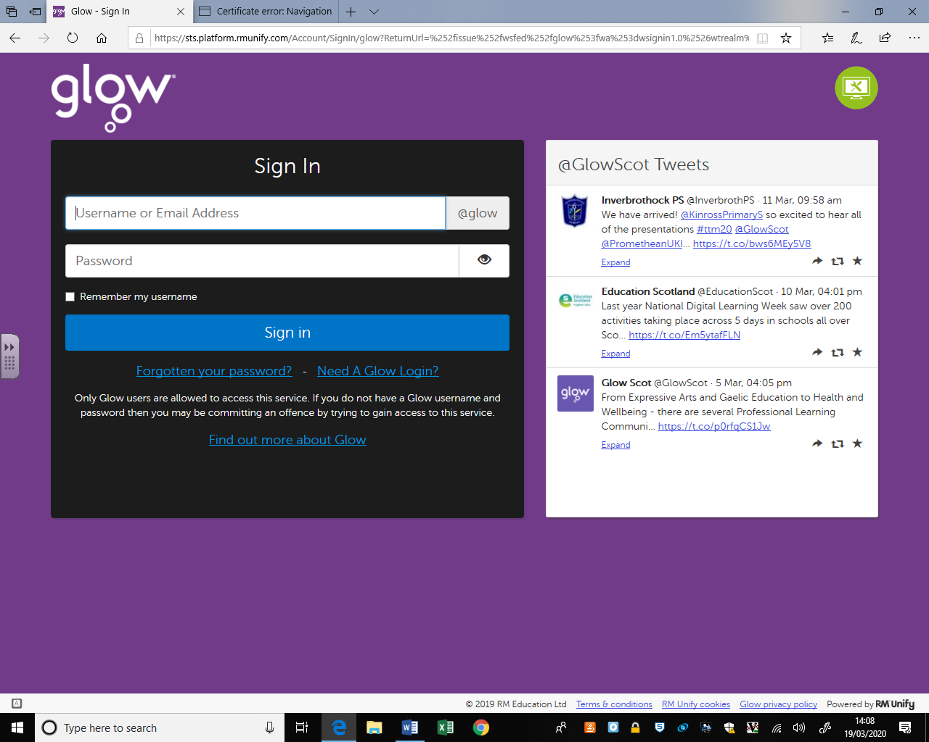

When you log in, you will see a page of ‘tiles’. Double click on SharePoint.
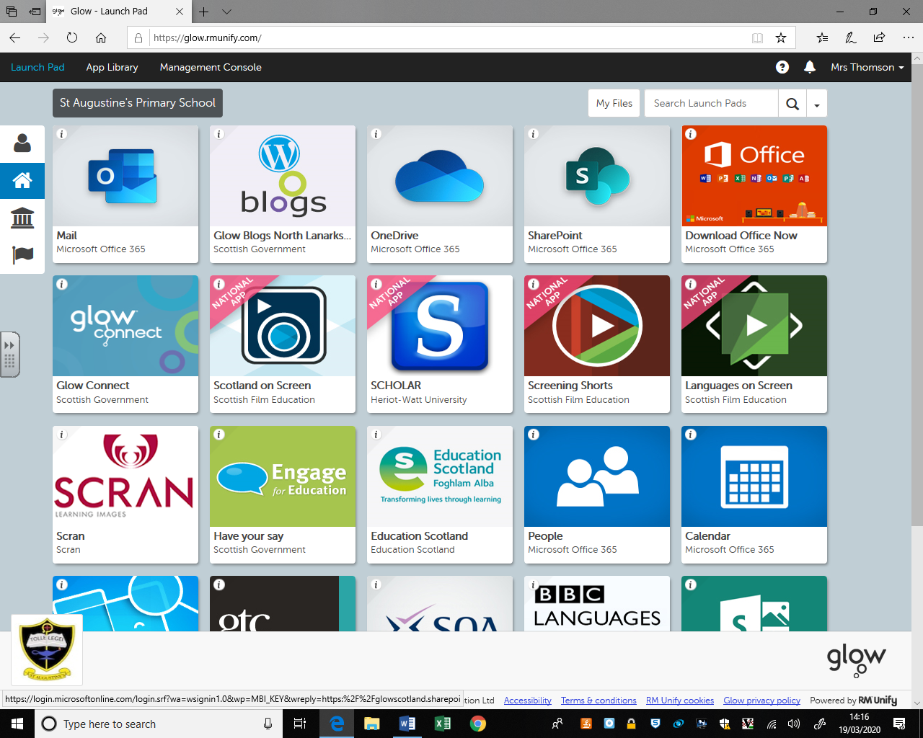

When you log into SharePoint this is what you will see. Double click on pupil area. 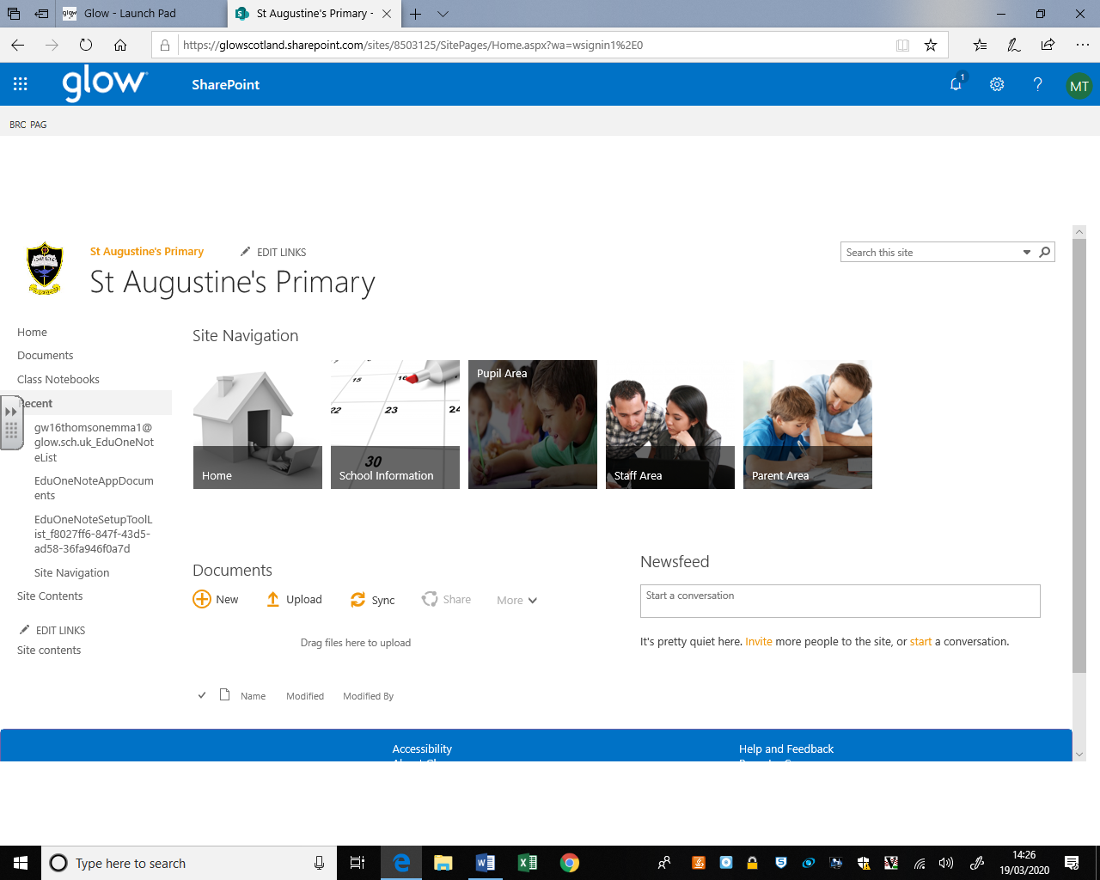

Double click on your year group. 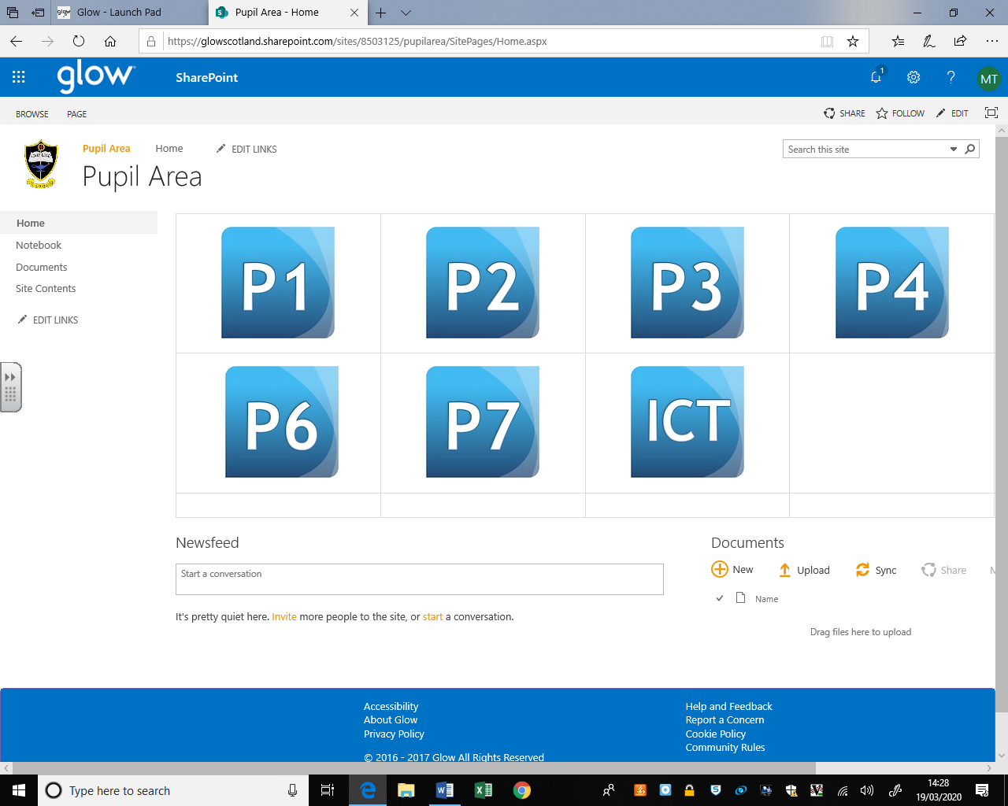

When you click on your year group this is the page you will see.
You will see documents to the right with learning tasks and correspondence for parents.
You will see curricular areas to the left and you can double click on these for more specific resources. Double click on the curricular area you are working on for example Literacy.

If you want to ask your teacher a question you can type it in the newsfeed.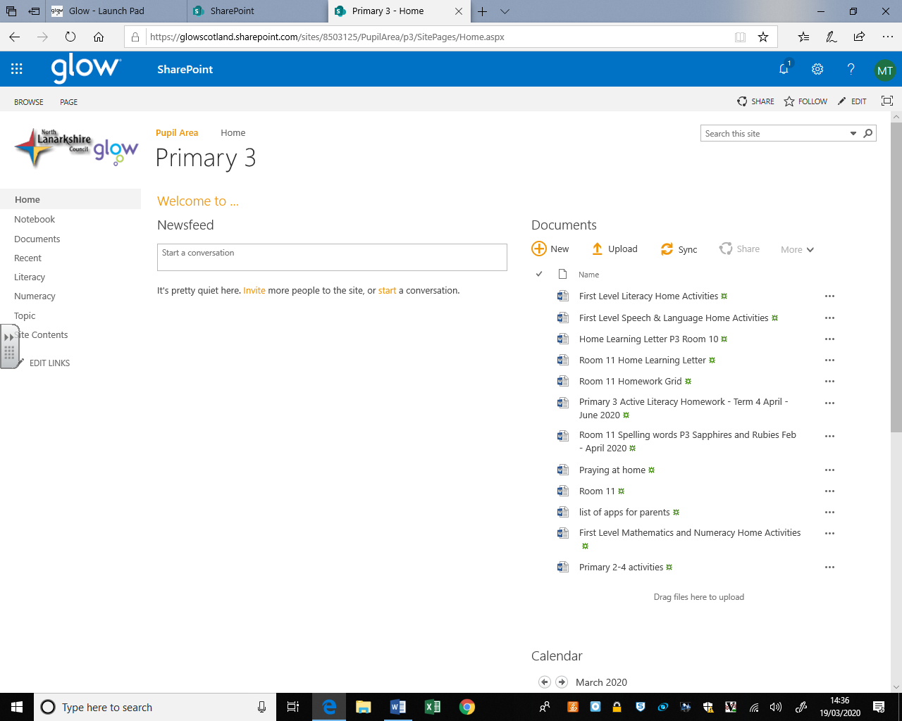

When you double click on the curricular area you will see resources for that subject for you to use. 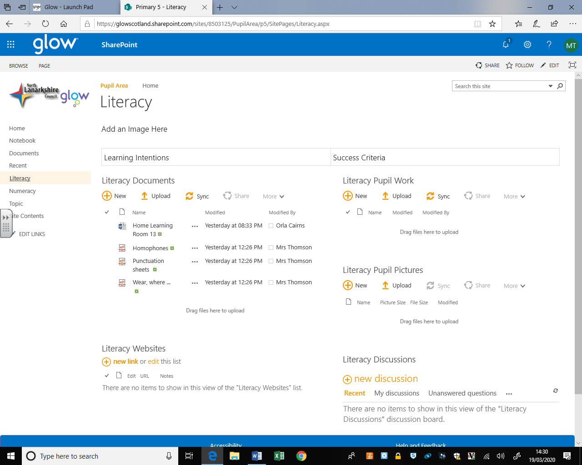

If you wish to upload work you can do this using the upload button at the left hand side.

