FANCY WINNING THIS ?

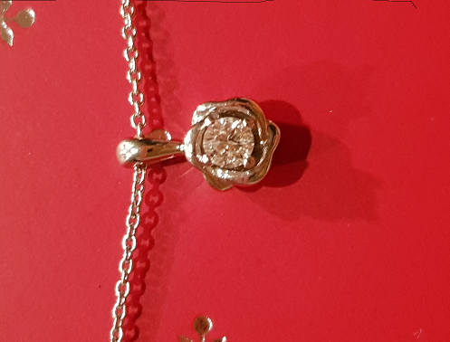

The Prize: A beautiful 0.1 carat white diamond, 18 carat white gold pendant. Retails for £750.
The Raffle: One entry per person. (Open to all School staff and those attending the Ladies night on Friday 17th November)
All proceeds go towards our school. Thank you & good luck!
The PTA

