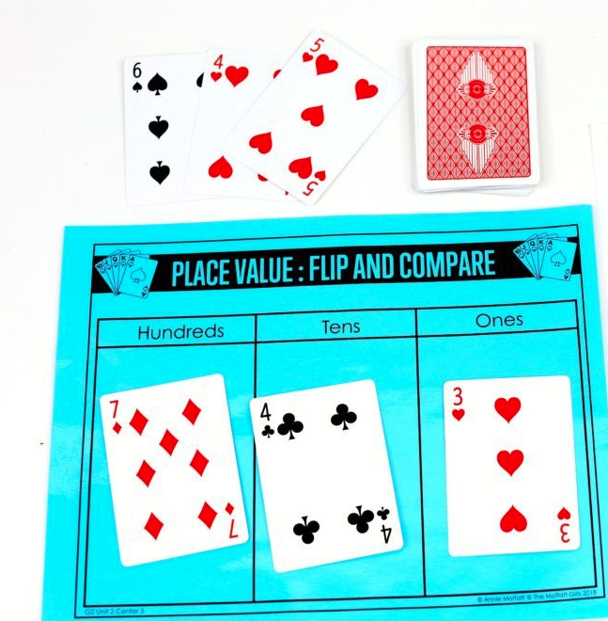
Name:______________________________ Date: __________________ M
L.O. I can explain what each number in a two- digit number (like 25) or three-digit number (like 325) represents.
Rules of the game: Once you have put a number card in any of the H, T or U column you cannot move it.
Remember the biggest number wins.

 | H | T | U
My numbers:

Tally the times you have won: _________________________________

Name:______________________________ Date: __________________ S
L.O. I can explain what each number in a two- digit number (like 25) represents.
Rules of the game: Once you have put a number card in any of the T or U column you cannot move it.
Remember the biggest number wins.

 | T | U
My numbers:

Tally the times you have won: _________________________________

Name:______________________________ Date: __________________ E

L.O. I can explain what each number in a two- digit number (like 25) or three-digit number (like 325) represents.
Rules of the game: Once you have put a number card in any of the H, T or U column you cannot move it.
Remember the biggest number wins.

 | H | T | U
My numbers:

Tally the times you have won: _________________________________
Now order all the numbers you made starting with the biggest:
__________________________________________________________________________________________
Name:______________________________ Date: __________________ E

L.O. I can explain what each number in a two- digit number (like 25) or three-digit number (like 325) represents.
Rules of the game: Once you have put a number card in any of the H, T or U column you cannot move it.
Remember the biggest number wins.

 | Th | H | T | U
My numbers:

Tally the times you have won: _________________________________
Now order all the numbers you made starting with the biggest:
_____________________________________________________________________

