Saint Andrew’s Primary School

Focus on Learning
P3 of Primary 2/3
Dear Parents,
Welcome back to the 1st term of 2018. I hope you had a lovely Christmas and a Happy New Year. This will be another busy term, the Primary 3 are looking forward to making the Sacrament of Reconciliation and we are all very excited about our class trip to Edinburgh Zoo.
Please find below the focus of learning in each area.

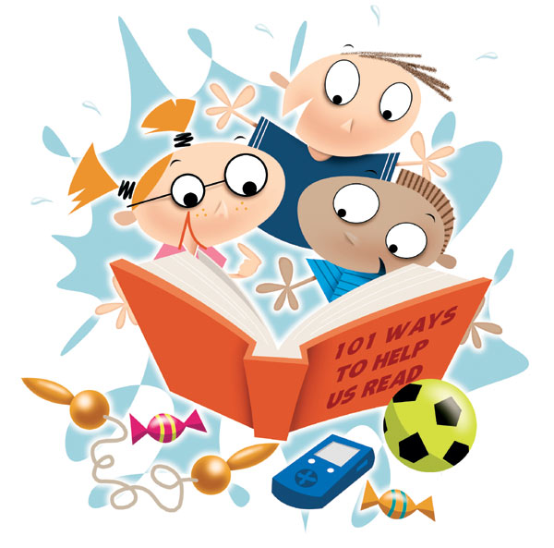
Literacy
This term the children will continue to learn their common words and phonemes. Please encourage your child to ready daily and return reading books each day for class tasks. We will focus more this term on sentence openers, using interesting vocabulary, a variety of connectives and punctuation in writing.
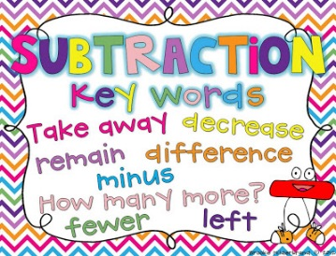
Numeracy
We will continue focusing on mental math strategies. This term the children will be working on 2D/3D shapes, symmetry, time and will develop their skills in multiplication and division.

Health and Wellbeing
This term the children will develop their skills in gymnastics and develop fitness levels through circuits outdoors.
P.E. Kits
Please encourage your child to remember their PE kit for PE on Mondays (outdoor) and Tuesdays (indoor). Children should wear a shirt and tie each day and bring a change of clothes on their gym days. Children should bring appropriate outdoor clothing for all weather conditions on a Monday. It is helpful if all items of clothing are labelled so that they don’t go missing. Please also ensure your child is not wearing jewellery on these days as it cannot be worn during any physical education lessons.

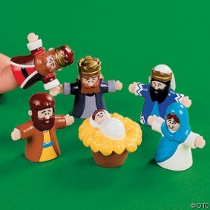
Topic
Our first topic this term will be a short topic ‘Our Own Shop’ The class will set up a shop and through this, will explore and begin to understand the different jobs involved in setting up a business enterprise. The following topic is ‘Toys from the Past’ This will be linked to Science, looking at forces.
I.C.T.
In ICT the children will continue to use digital technology to enhance their learning.

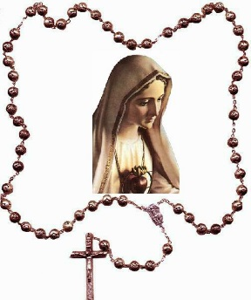
R.E.
This term the children will be preparing for their Sacrament of Reconciliation. This is a very important and special time for the children. Learning taken place in class will be followed with home sessions found in their workbook. Please ensure your child returns their workbook each day for class lessons. More information about the dates for the meetings and the Reconciliation dates will be sent out.
If you require any further information or have concerns, please do not hesitate to contact the school.
Thank you for your continued support.
Regards,
Mrs. Murray
Class Teacher

