Snow Pack
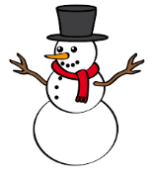
Primary 5

Primary 5 Adverse Weather Pack

In the case of adverse weather conditions and you are unable to attend school, the following Adverse Weather Pack has been prepared for you.

If this situation occurs, please complete as many activities as you feel possible. Please do not complete in any other circumstance.

Remember to keep yourself warm and KEEP ACTIVE! Try building a snowman, have fun sledging in the snow and take lots of photographs.

Literacy Activities
Reading
  - Choose a personal novel that you can read at home and read for at least 20 minutes a day.
Comprehension Tasks
  - Word building - make a list of new and interesting vocabulary from your novel.
  - Look up the meaning of these new words in a dictionary.
  - Write about your favourite character.
  - Write a book review including why you would recommend this book to others.
Spelling
Revise the following phonemes and make up wordlists for each.
  - oi (oy, oi)
  - k ( c,k,ck,ch)
  - j ( j,g,dge)
  - sh ( sh,ti,ch )
  - Jan – ch ( ch, tch,t)
  - Feb – sh ( s, ss, c, se, ce )
  - Pick personal spelling words and practise writing in the snow.

Writing
  - Take a photograph of yourself in the snow and write a recount of your experience in the snow.
  - Keep a diary about your exciting time off school.
  - Write an imaginative story about a winter miracle.
  - Write instructions on how to build a snowman.
  - Write a winter poem.
  - Write a summary about a Christmas movie.

Numeracy Activities

- Use Mental Maths booklet and complete a range of mental questions.
- Practise your times tables
- Write 4 digit addition and subtraction sums and complete.
- Use https://www.topmarks.co.uk/maths-games/7-11-years/ordering-and-sequencing-numbers to practise different skills.
- Write a shopping list and use a catalogue to calculate the price of items.
- Practise telling the time using o’clock, half past, quarter past and quarter to.

Topic
Research facts about our current topic
November/December – Scotland and a comparison with China and Spain.
January – The Romans

Science
Investigate the effect of temperature on water.
Make a snow Volcano
http://www.science-sparks.com/2013/01/21/snow-volcano/

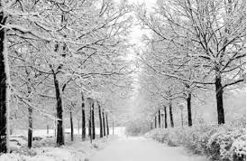
Art
Draw winter pictures using a range of materials.

Religious Education
Practise saying prayers from prayer booklet.
Reflect on weekly Gospel and how it impacts on our life.
December- Research important information about Advent and retell the Nativity story.

Most importantly have lots of fun!
Thank you
Mrs Alawoya

