Saint Andrew’s Primary School
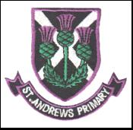

Focus on Learning
Primary 7 – Term 3

Happy new year to you all and welcome back to the new term in primary seven. The children are excited to be back and are already working hard across the curricular areas. I would like to take this opportunity to thank you all for the lovely cards and gifts I received from you all over Christmas. It was very kind and very much appreciated.
Below is an outline of what we will be covering in term three in primary seven.

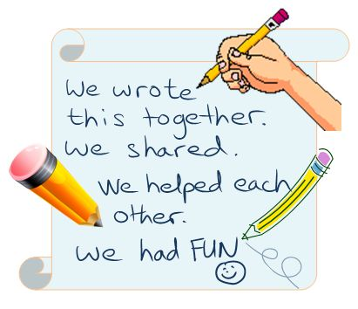
Literacy
The pupils will be continuing with their novel studies and developing the literacy strategies. They will be asked to complete tasks relating to the novel for homework so please look out for these tasks and support the children by encouraging them to complete these. We will also be continuing with the spelling programme as we work through the common words and spelling rules. A lot of our literacy this term will be accessed through the topic, where the children will have the opportunity to look at script writing, tools of film and character studies.

Maths
This term sees us covering a wide variety of maths concepts. We have already begun the term with measure and will be shortly moving on to data handling. The biggest maths topic this term will be the multiplication and division topic and again you will see examples of this sent home as homework for additional reinforcement and practise.

Health and Wellbeing
Lots of our learning this term is linked to our topic and we will be looking at the issue of racism as we discuss different cultures and compare them to our own. P.E. days remain the same this term:
- P7 indoor P.E on Wednesday and outdoor P.E on Thursday
- P6 and P6/7 indoor P.E on Tuesday and outdoor P.E on Thursday
Just to remind you, that all pupils should come to school on a Wednesday wearing P.E. kit for aerobics and must also have their uniform with them to change into after this. Please can I ask that you ensure your child has the appropriate kit on the associated days?

R.E.
The R.E. topic this term will be God’s Loving Plan and we will ensure that you are kept informed about what is being taught within the class through separate letters.

Interdisciplinary Topic
The three senior classes are already excited about this terms big topic which will be ‘The Lion King’ (Africa). As you are all aware, we will be putting on the performance of The Lion King Show in April and lots of our drama, music and art will be covered in our preparations for this as we learn scripts, songs and prepare scenery. The class will also have the opportunity to experience African foods in our Focus on Food topic. There will be lots of Social Study and Science lessons throughout the topic as we look at Africa as a country, its situation in the world and its sustainability.

As a class we are looking forward to a busy term. If you feel the need to get in touch and speak to me before parents’ night, please do not hesitate to do so through the school office.

Many thanks
Miss O’Halloran

