Saint Andrew’s Primary School

Focus on Learning
P5
Welcome back to the first term of 2017. I hope you had a lovely Christmas and thank you so much for all the lovely cards and gifts received.
Please find below the focus on learning in each area.

Literacy
In Literacy we will be continuing to work on our active literacy strategies within spelling and reading. The children are now beginning to apply their strategies more independently to their group novels. During this month the children will focus on developing their writing skills within the genre of information and report writing ,through the topic of the Victorians. They will also examine Scots language through Robert Burns.

Maths/Numeracy
In our maths lessons this term we will cover time, fractions, decimals, multiplication, percentages, division and symmetry. We will continue to build on our problem solving strategies and mental agility skills. The children will make use of ICT to enhance their mental strategies and speed.

Health and Wellbeing
During PE lessons the children have been developing football, netball skills, and swimming. In March, the pupils will move on to circuit training to develop their strength and flexibility skills.

Science
This term we are studying a science topic called the ‘Material World’ and children will develop their knowledge and understanding of fair testing by carrying out a variety of experiments and investigations.
During our topic, the Victorians, pupils will learn about major developments in science during this era. Subsequently we will focus on experiments developing their knowledge and understanding of fair testing related to ‘Light’.

I.C.T.
During ICT, the children are using a variety of interactive games to enhance their learning within numeracy. These can easily be used at home too and is an important skill to acquire as the children progress through their education.

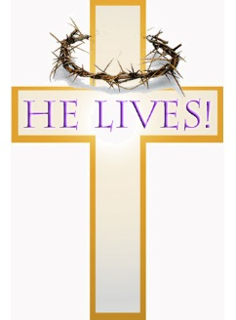
R.E.
In religious education the children will further develop their knowledge and understand of their personal faith through the exploration of The Passion, Death and Resurrection of Jesus. During the season of Lent pupils will participate in the celebration of Mass and know that the mass is at the heart of our Catholic community.

Kind Regards,
Mrs. Hone
Class Teacher

