Saint Andrew’s Primary School

Focus on Learning
P 4 - 5

Dear Parents/Carers,
Welcome back to the 1st term of 2017. Hope you has a lovely Christmas and a Happy New Year. Thank you for all the lovely cards and gifts I received.
Please find below the focus of learning in each area.

Literacy
In Literacy we will be continuing to work on our active literacy strategies within spelling and reading. The children are now beginning to apply their strategies more independently to their group novels. During this month the children will focus on developing their writing skills within the genre of information and report writing through the contexts of the Victorians and Robert Burns.

Maths and Numeracy
In our maths lessons this term we will cover time, fractions, decimals, percentages, angles and symmetry. We will continue to build on our problem solving strategies and mental agility skills. The children will make use of ICT to enhance their mental strategies and speed.

Health and Wellbeing
During PE lessons the children have been developing their flexibility, strength, and balance and sequencing skills through the context of gymnastics. They are also developing their abilities to recognise and appreciate their own quantities and those of others.
Primary 5 have been developing their swimming, football and netball skills, whilst Primary 4 have been developing their hockey skill. During the term we will move on to Circuit training to develop their fitness, strength and flexibility skills.

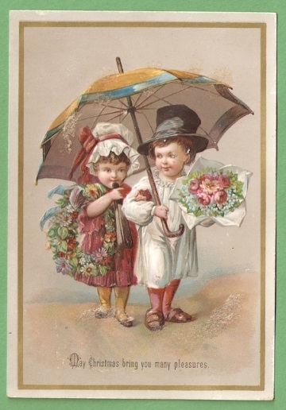
Topic
This term we are studying ‘The Victorians’ and pupils will learn about major developments in science during this era. Subsequently we will develop their knowledge and understanding of fair testing by carrying out a variety of experiments and investigations on ‘light’.

I.C.T.
During ICT, the children are using a variety of interactive games to enhance their learning within numeracy.

R.E.
In RE the children will further develop their knowledge and understanding of their personal faith through the events of The Passion, Death and Resurrection of Jesus and during the season of Lent the pupils will have an opportunity to attend Mass. P4 children will prepare for the Sacrament of First Holy Communion through a series of class lessons followed with home/parental studies.

Kind Regards,
Mrs. Frobisher
Class Teacher

