Saint Andrew’s Primary School
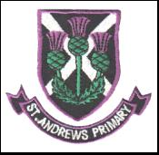

Focus on Learning
P3 – Term 3

Literacy
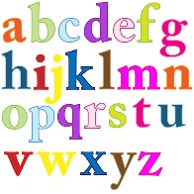
In Literacy the pupils will be continuing on the active literacy programme and further develop their spelling and reading strategies.
In writing, our man focus will be on Information and report writing. This will be enhanced through our topic – Ancient Egyptians. This will allow the children to explore, research and report back on this fantastic time in history.

Numeracy & Maths
In Maths, the children will be learning all about fractions, time, symmetry and angles. In class we have been developing mental agility and problem solving strategies. Therefore, please continue to support your child in these areas.

Health & Well being
This term pupils will have opportunities to develop flexibility, strength and balance through gymnastics. Please ensure your child has the appropriate gym kit for Tuesday (Indoor) and Thursday (outdoor). In outdoor PE the children will continue to develop skills needed for team games and will continue with the daily mile.

Topic
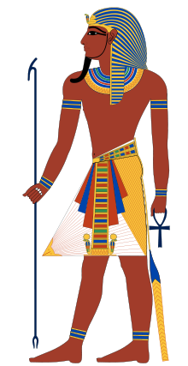
This term we will be going back in time to explore the ‘Ancient Egyptians’. The children have already shown a great deal of excitement and a big thank you to all who have sent in resources. Our topic table looks fantastic! The children will be learning all about this fascinating time in history, we will focus on Egyptian life, Mummification, hieroglyphic writing and some important pharaoh’s like Tutankhamun.

ICT
During our ICT time the children will be working with a partner collecting research to create notes for our Egyptian topic. The children have also been exploring GLOW and Sumdog. Usernames and passwords are at the front of your child’s diary. Both sits allow the children to play games linked to learning that takes place in class.

RE
This term the children will be preparing for their sacrament of reconciliation. This is a very important and special time for the children. Learning taken place in class will be followed with home sessions found in their workbook. Please ensure your child returns their workbook each day for class lessons.
Reconciliation dates
Holy Cross Parish – Monday 13th March – 7pm
Sacred Heart Parish – Tuesday 21st March – 7pm

Kind Regards,
Miss Smart.

