Saint Andrew’s Primary School
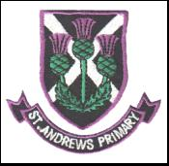

Focus on Learning
P3/4 – Term 3
Welcome back to our first term of 2017. I hope you had a lovely Christmas and New Year. Thank you for all the lovely cards and kind gifts I received.
Please find below the focus on learning across the curriculum.

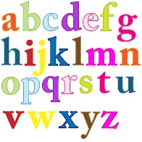
Literacy
In Literacy we will be continuing on our Active Literacy strategies within reading and spelling. The children are now beginning to apply their strategies more independently to their group novels. Please encourage your child to read more at home to develop their fluency and comprehension. The writing genre we will focus on is information report writing related to our topic. After this we will be learning to write recounts of personal experiences.

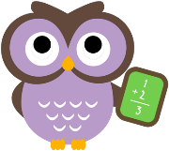
Numeracy/Maths
This term your child will be learning about fractions, time, symmetry and angles. In class we will continue to work on mental maths and problem solving related to these areas. Please continue to work on times tables and mental maths with your child.
Health and Wellbeing
During PE the children have been developing their flexibility, strength, balance, floor and vault skills through the context of gymnastics. They will also continue team games and the daily mile in outdoor P.E.

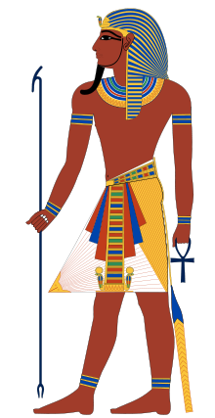
Topic
This term we are studying the Ancient Egyptians. The children are very excited about this topic and have already brought in many resources and items for our display which is wonderful. We will be learning about Egyptian life, mummification, hieroglyphic writing, Pharaoh’s life (Tutankhamun). The children will also work with their partner to create a 3D model of anything related to their topic.

I.C.T.
During ICT time the children will work with a partner to research the Ancient Egyptians. The children will take notes each week on a new area of Ancient Egyptian Life. The children will be expected to use their notes to create an information report in story writing.

R.E.
Within Religious Education the children will further develop their knowledge and understanding of their personal faith through the events of the Passion, Death and Ressurection of Jesus and reflect on this.
Primary 3 children will prepare for the Sacrament of Reconciliation and through a series of class lessons followed with home/parental studies.
Please ensure your child returns their workbook each day for class lessons.
Regards
Miss McCluskey
Class Teacher

