Saint Andrew’s Primary School
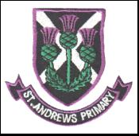

Focus on Learning
Primary 1 – Term 3
This term we will be learning across the curriculum. Please find below the focus of learning in each area.
Language
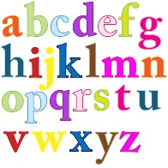
This term children will revise all initial sounds and will be introduced to phonemes sh, th, ch, ng and wh. A phoneme is two sounds that come together to make one sound. The children will be making, blending, reading and writing using their sounds and phonemes. We will continue to introduce three common words per week. During our daily writing children will begin to use joining words and, but and because to extend their sentences. Another focus will be on using capital letters and full stops.
The children will continue to have one taught book and will now have an additional home reader. The additional reader is a book to encourage more reading at home to allow children to practise applying their reading strategies independently. This will not be introduced in school. It is very important that these books are returned to school on a Friday.

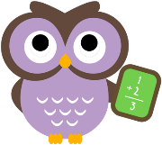
Maths
During this term children will be introduced to:
Addition
- Addition within 10
- Use cubes/number lines
- Vocabularly associated with addition e.g. add/altogether/ equal
- Identify number bonds within 10
- Complete simple addition sums mentally
Time
- Sequence daily routine
- Order days of the week/months of the year
- Identify features of the seasons
- Read and show o’clock times on an analogue and digital clock

Measurement
- Use non-standard units (hand span, feet, cups, cubes, etc) to find weight, height, length and capacity of objects.
- Vocabularly associated e.g. long, short, heavy, light etc.

Health and Wellbeing
P.E.
Children will develop their coordination and movement skills through Gymnastics. Children will have the opportunity to practise moving their body in different ways, e.g. jumping, balancing, and rolling. They will have opportunities to work independently and with a partner. Children will have the experience of using a range of gymnastic equipment and learn to do so safely.
Topic
Children will develop their literacy, science and expressive art skills through our Fairyland topic. They will be working on a range of traditional fairy tales and will be taking part in exciting activities to transform their classroom.
R.E.
This term children will learn about Jesus’ life, listening to related Bible stories and reflecting on their own family life. Children will think about how they can show the qualities of kindness, love and forgiveness in their daily life. Later in the term we will explore Lent and Easter, looking at key symbols and important feast days.

Homework
Homework will continue to be given out on a Monday and should be returned on a Friday however reading books should be brought to school every day.

Regards,
Miss Mooney and Mrs Murray
Class Teachers

