
Dear Parents,
Welcome to the February edition of the Saint Andrew’s Primary newsletter. This newsletter aims is to keep all parents up to date with the many things that are going on in the school this term.


Gymnastics
Congratulations to our cross stage gymnastics group who recently competed at the North Lanarkshire games and all of them doing extremely well. Special Congratulations to the level 2 team who were Niamh O’Rourke, Beth Docherty, Emmy Docherty and Lucy Morrison who won a bronze level award for their floor and vault routines. Thank you to Miss McCluskey,
Ms. Hone and Niamh O’Rourke for all their hard work in practising with the girls. Well done to all!
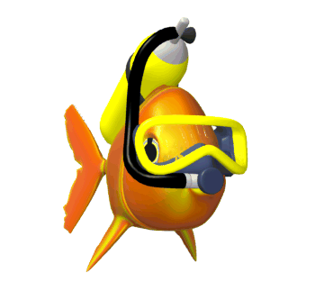
Swimming
Big Congratulations to our swimming star Callum O’Reilly who took part in the recent Scottish Swimming championships coming 8th in Scotland which only confirms what we already suspected Callum is obviously part fish!

Football
The Primary 6 footballers have also been in action at a tournament at Hamilton Palace on Wednesday this week. Congratulations to them as they played and won four games, which means they are through to the next round. We will let you know the details nearer the time.


Primary 6 Our lady’s High School visit
The Primary 6 children will by spending a day at OLHS on Thursday 9th February. The children will travel to and from the venue by coach, at no charge to the children. This outing is to give the children a taster of what will be in store for them once they transfer and hopefully will help ease any of their anxieties about this.


Holidays
Monday 13th February and Tuesday 14th February are mid-term breaks and the school is closed for the teachers and children. On Wednesday 15th February the school is also closed for children, but is an in-service day for staff.

CIO Visit
Our link continuous improvement officer, Robert Dalziel will be visiting
the school on Thursday 16th February. This is a follow up to the validation visit made last December. He will be visiting some classes, talking to some children and having discussion with staff in order to ascertain the progress of the school. We will let you know his findings once we have them.


Rotary Quiz
This will be held in Baird Memorial on Thursday 16th February our competitors will be:-

Niamh O’Rourke – Harris Carberry,
Olivia Akindele - Erin Devlin. Good Luck Guys!


Our Lady’s High School
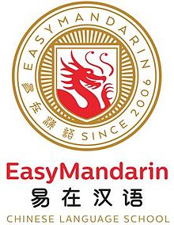
The Primary 6 and the Primary 7 children will begin a Spanish rotation with Language Specialists from the high school on 21st February.

A Mandarin rotation will also begin with all classes benefitting from working with the Chinese teachers.

Ash Wednesday
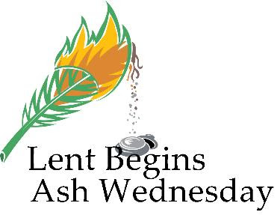
There will be a service for Ashes on Wednesday 1st March at 1:30pm in school. Lenten Masses will run every Monday from March 6th – 27th at 9:15am. Our R.E. co-ordinators will work with the pastoral care team to prepare these.

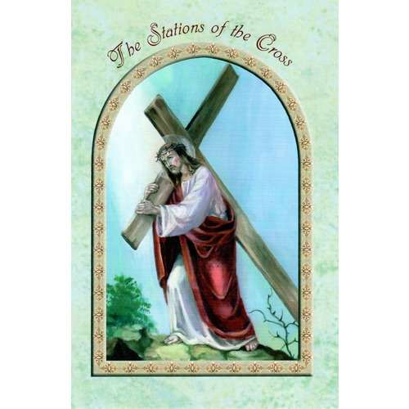
Pope Francis Faith Award
Pope Francis Faith Award children are invited to take part in ‘Stations of the Cross’ on the Saturdays of 4th March, 11th, 18th, 25th March at 10:25am at Holy Cross Church.

National Society for the Prevention of Cruelty to Children
Following a successful joint workshop for parents the NSPCC have agreed to hold another workshop during school time for parents with child care issues. The workshop will be held at 2:00pm on 14th March in the hall.
All parents are welcome.


P7 Maths Challenge
This takes place on Wednesday 15th March our entrants this year are:-
Harris Carberry - Charlie Phillips
Niamh O’Rourke - Megan Welsh Rennie

Parent’s Night
Parent’s night is on Wednesday 22nd March between 3:30pm – 8:00pm. Letters for appointments will be with you soon.


The Daffodil Tea this year will take place on Monday 27th and
Tuesday 28th March. Further details will follow nearer the time.

Kilbowie meeting
There will be a short meeting for parents of Primary 7 pupils who will be attending Kilbowie this year. It will be on Wednesday 29th March at 7:00pm.


Dancemania
The Dancemania qualifier will take place on Thursday 30th March in Cumbernauld Academy. We can only enter one team and at the moment we have two teams working hard with Miss O’Halloran for the distinction of competing in this competition. Once Miss O’Halloran has decided on her team we will let you know.
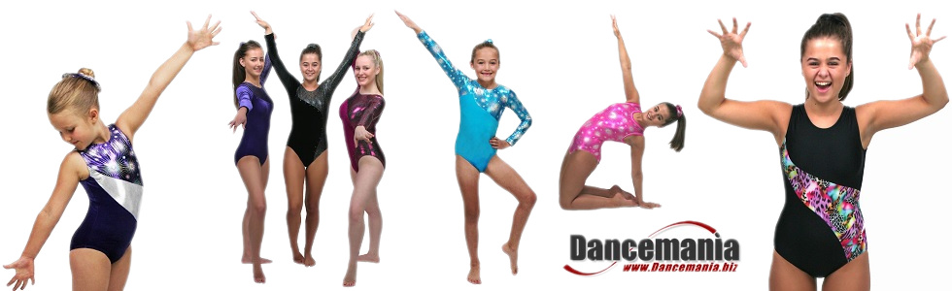

P7 High School Transition

The Transition to High School is underway with teachers from the Secondary English department already having paid a visit. They will work with the Primary 7 for four weeks and then the maths department will work for another four.

Extra staff in Our Lady’s High School has also allowed
for English teachers to pay an extra visit per week to work with small groups.

After Easter a full scale transition topic will begin involving all cluster primaries being involved in a ‘Safe use of Social media’ campaign. This
will involve paired working between primaries and visits to the City of Glasgow College to support the project. A showcase event is planned for all parents in Our Lady’s High School in June. Further details will follow.


Eco Garden
Thanks to Mr. Elaho of ‘Cummings Diesel’ our
Eco garden and ‘Piggy garden’ will shortly be undergoing a makeover. Mr. Elaho and his company have been working closely with children and staff from both schools to ensure a pleasing outcome. It all sounds very exciting and we hope all children and classes will benefit from this revamp.

Budget Cuts

As you will be aware due to further budget cuts by NLC our office hours have been cut. This means that Mrs. Harris has been redeployed to another school. We are all very sorry to see her go and we wish her well in her new promoted position within St. Joseph’s Primary, Cardowan.

School Budget
As we near the end of the financial year, here is a quick summary of the things we have purchased this year for the children’s education.

- Further play equipment for the playroom in the infant department.
- New projectors in Primary 3 room and P1/2 to replace out of date models.
- A kitchen, cooker, dishwasher to create a designated cooking area, shared between both schools.
- Subscription to Expresso (I.T. programmes for use on Smartboards.)

This is in addition to all school jotters, photocopying, art materials,
library books and other supplies.

STEM experience
Mrs. McLoone has been undertaking class assemblies on a Monday which have a science, technology, engineering and mathematics (STEM) theme.
This has involved the children working within their mixed stage house groups on various practical tasks e.g. making towers out of post-its and structures out of cocktail sticks.

Stage 6 pupils from Our Lady's High School have also visited to help the children out, including many former pupils. So far this has been a great experience for the children and is very innovative. Please look out for our display of photos on parent’s night.



Mock Court
The Primary 6 and Primary 7 children who were involved in the Mock Court programme will travel to Central Hall in Edinburgh for the final of the experience on Monday 27th February. Even though we were beaten on points our children did extremely well and may be in line for a special award. Mrs. Gamson has also agreed to serve as ‘Black Rod’ for the occasion and all parents of Primary 6 or Primary 7 pupils are welcome to attend.

Wow launched

How WoW works
The purpose of WoW is to encourage pupils, parents and carers to walk to school at least once a week. Children record when they walk to school using the Travel Tracker. Each month, children who have walked, or travelled actively, at least once every week throughout the month receive a collectable badge. The threshold for collecting a badge can be raised as the scheme progresses. Different badge designs are awarded each month based around a theme.

Pupils are currently designing a poster to promote WoW, these will be entered into the NLC WoW competition.

WoW aims to get more children walking (cycling and scootering) to school and the Travel tracker helps you to keep an accurate tally of this and reward children who use Active modes of travel.

Kind Regards
M.C. Fiddler
Head Teacher

