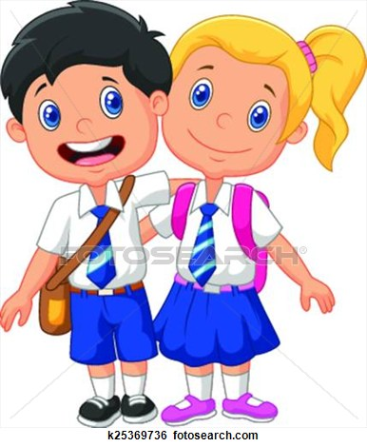
St. Andrew’s Primary
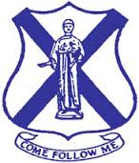
Learning Overview
Mrs McMillan Primary 2/3 April – June 2017
Literacy | Maths
P2 Will further develop knowledge and understanding of reading, talking and listening by completing fiction and non-fiction texts appropriate to their level.  P3 Will continue to read fiction and non-fiction texts and Novels.  Continue to develop their knowledge and understanding of phonics and NLC active spelling strategies,  Will be writing regularly for different purposes with focus on information texts and revision of all previous taught genres. | P2. Will continue to consolidate their understanding of multiplication using 2 and 10 times table and division through equal sharing and grouping and link to fractions. Will further develop knowledge of time o’clock and half-past. Revision of money.  P3 Will continue to develop understanding of multiplication using 2,4,5 and 10 times table and division linking to fractions ¼ ½ and tenths. Will further develop knowledge of time using quarter past and quarter to. Revision of money.
Health & Well Being | Physical Education
The children will focus on the importance of team work communication, responsibility and participation.  They will participate in co-operative learning activities such as problem solving to encourage and support group and individual learning to become successful learners. | Will further develop game and ball skills and abilities in the Better Movers and Thinkers program, working individually and co-operatively.  To encourage daily fitness and exercise the class will continue “Fit Fifteen”
Science | Social Subjects
The children will continue to develop understanding of the need for setting a hypothesis, designing a fair test, and how to record results in a variety of ways. During this term, the children will be involved in experimenting with motion. | As the country is involved in both local and general elections the children will take part in a variety of learning activities to introduce them to local and U.K. governments. They will find out how they are formed, what they do and how as citizens we can become involved in the democratic process.
Technology | Music
The children will have regular opportunity to use technology to support their learning in all curricular areas. They will use computers and ipads and develop skills in using a variety of programs for word processing, painting, and research. They will have regular opportunity to use a camera and video. How to stay safe online will be reinforced. | The children will follow the ABC interactive music program. They will continue to use a variety of untuned and tuned percussion instruments.  They will learn hymns for school mass.
Drama | Art
The children will experience a variety of drama conventions through a selection of cross curricular activities. They will develop their knowledge of improvisation and using their voice and movement in a variety of role play situations. | The children will be given the opportunity to use a variety of digital programs to develop their growing skill and control when using technology for art. The children will be encouraged to look closely at a variety of objects and use materials to construct a model.
Religious and Moral Education | Homework Projects
The children will reflect on the events of Easter. The children will listen to and respond to a variety of bible stories from both the old and new testament. All children will learn about Mary our Mother during the month of May and will regularly recite a decade of the rosary. | Using any materials available make an election rosette and identify an idea that would benefit the local community.
Please find brief details of what your child will be covering in class this term. Take time to ask them about their learning. We know children attain better when a parent or carer at home discusses their learning with them. Like you, we want all our children attaining and achieving to their maximum potential.

