St Ambrose High School

Higher Chemistry

Unit 1 Chemical Changes and Structure

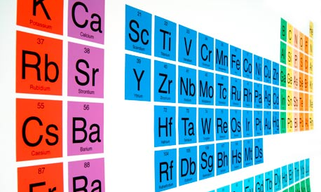
Name :

Teacher:

1. Periodicity
1.1 The First Twenty Elements
The Periodic Table lists all known elements in order of increasing atomic number. The elements are organised into groups and periods. Elements in the same group have similar chemical properties as a result of having the same number of outer electrons.
Use the Royal Society of Chemistry Website http://www.rsc.org/periodic-table to explore the Periodic Table.
You need to be able to categorise the first 20 elements according to their bonding and structure. The main types of bonding in elements are metallic and covalent. There are also forces that exist between the molecules and the atoms of the Noble Gases called London dispersion forces.
The First Twenty Elements
http://www.educationscotland.gov.uk/highersciences/chemistry/animations/bondingstructure.asp
1 | 2 |  | 3 | 4 | 5 | 6 | 7 | 0
H |  |  |  |  |  |  |  | He
Li | Be |  | B | C | N | O | F | Ne
Na | Mg |  | Al | Si | P | S | Cl | Ar
K | Ca

Colour the elements in the table above that show the bonding and structures shown:
Metallic lattice
Covalent network
Covalent molecular diatomic gases
Covalent molecular solids
Monatomic gases
The metals only have metallic bonding.
The monatomic gases only have London dispersion forces.
The covalent networks only have covalent bonding.
The covalent molecular elements have covalent bonding inside the molecules and London dispersion forces between molecules.

  - Trends in the Periodic Table
The elements show trends in properties as we go across periods and down groups. The properties considered in this section are covalent radii, ionisation energy and electronegativity.

1.2.1 Covalent Radii
The covalent radius is a measure of the size of an atom. It is defined as half the distance between the nuclei of two covalently-bonded atoms of an element.
Radius = d / 2
The covalent radius shows a periodic trend.
Using information in the data booklet, draw a graph of covalent radius (vertical axis) against atomic number (horizontal axis) for the element 3 to 20.
(Use a dotted line between atomic numbers 9 and 11 and 17 and 19)

Describe the trend going across a period:

__________________________________________________________________________
Describe the trend going down a group:

__________________________________________________________________________
Why are there no values given for the noble gases?

__________________________________________________________________________
Explaining the Trends
Across a Period - the atoms get smaller as we go across a period (ignore the Noble gases as they do not form bonds).
As we move from left right, we add a proton to the nucleus and an electron to the outer electron level. E.g. from lithium to fluorine:
3+
-
-
-
-
-
-
-
-
9+

Lithium atom Fluorine Atom
The electrons are added to the same electron level. The nuclear charge is increasing and as a result, the electron are pulled in closer to the nucleus.
-
-
-
-
-
-
-
3+
-
9+

Lithium = 134 pm Fluorine = 74 pm

Going Down A Group Look at the electron arrangements of the elements in group 1.
As you go down the group, another full electron shell is added. The outer electron becomes further and further away from the nucleus.
As well as the physical distance, the outer electron is shielded or screened from the pull of the nucleus by the full electron shells in between.
Group 1 Metal | Electron Arrangement | Covalent Radius / pm
Lithium | 2, 1 | 134
Sodium | 2, 8, 1 | 154
Potassium | 2, 8, 8, 1 | 196
Rubidium | 2, 8, 18, 18, 1 | 216
Caesium | 2, 8, 18, 18, 8, 1 | 235

Ionic radii can be measured in the same way as covalent radii.
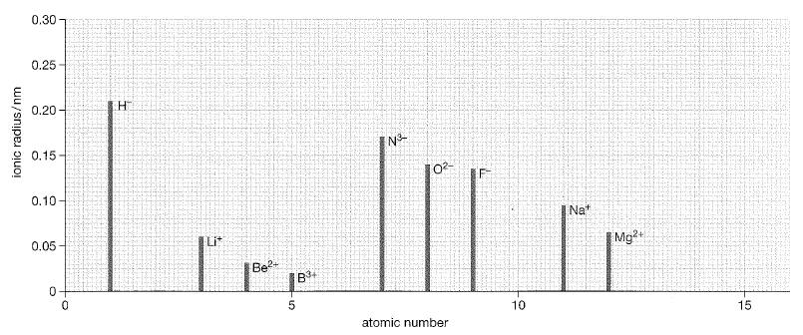
- Complete the graph above showing the ion sizes of elements with atomic number 13 and 15.
- The value quoted for hydrogen is for the hydride ion, H⁻.
- Why is there no value quoted for the H⁺ ion?

_______________________________________________________________
- Why is the H⁻ ion larger than the Li⁺ ion?

_______________________________________________________________
- Why is there a large increase in ion size from boron to nitrogen?

1.2.2 Ionisation Energy
The first ionisation energy is the energy required to remove one electron from each atom in one mole of gaseous atoms of the element.
This process is represented by the equation: E_{(g)} → E⁺_{(g)} + e⁻
Where E is any element.
A list of ionisation energies can be found in the data booklet.
Is ionisation energy exothermic or endothermic? _________________________
Using information in the data booklet, draw a graph of first ionisation energy against atomic number for the first twenty elements
(Use a dotted line between the noble gases and the elements in group 1)

Using information in the data booklet, draw a graph of covalent radius (vertical axis) against atomic number (horizontal axis) for the element 3 to 20.
Going across a period, the first ionisation energy increases.
This is because on crossing a period, more protons are being added to the nuclei of the atoms. This results in an increase in nuclear charge. The electrons in the outer energy levels will be more tightly held, and more difficult to remove.
Going down a group, the first ionisation energy decreases.
This is because the electron to be removed from the outer energy level is increasingly distant from the nucleus, as a result of the atoms getting bigger. The attraction of the nucleus for the electron becomes less, and it becomes easier to pull it away.
Electrons in the inner energy levels also produce a screening effect. These inner electrons reduce the attraction of the nucleus for the outer electrons. The screening effect will increase as the number of inner energy levels increases.
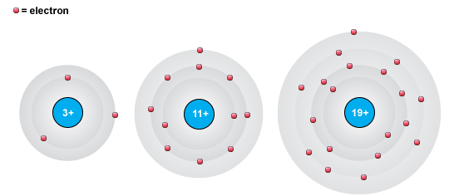
Lithium Sodium Potassium
∆H = 526 kJ mol⁻¹ ∆H = 502 kJ mol⁻¹ ∆H = 425 kJ mol⁻¹
More than one electron can be removed from an atom so we can also have first, second, third and fourth ionisation energies.
Example First ionisation Ca(g) → Ca⁺(g) + e⁻ 596 kJ mol⁻¹
Second ionisation Ca⁺(g) → Ca²⁺(g) + e⁻ 1160 kJ mol⁻¹
Third ionisation Ca²⁺(g)→ Ca³⁺(g) + e⁻ 4930 kJ mol⁻¹
Note that 1 electron is removed each time and so the energy required to remove 3 electrons,
i.e. Ca(g) → Ca³⁺(g) + 3e⁻ would be (596 + 1160 + 4930) = 6686 kJ mol⁻¹
 | Ionisation Energy / kJ mol⁻¹
Element | 1st | 2nd | 3rd | 4th
Lithium
Sodium
Magnesium
Aluminium
Why is there is no 4th ionisation energy for lithium?
___________________________________________________________________________
Why is the 2nd ionisation energy for sodium so much larger than the 1st ?
___________________________________________________________________________
___________________________________________________________________________
Why is the 3rd ionisation energy of magnesium greater than for aluminium?
___________________________________________________________________________
___________________________________________________________________________
Why is the first ionisation energy for helium higher than that of hydrogen?
__________________________________________________________________________

1.2.3 Electronegativity
Electronegativity is a measure of the attraction an atom involved in a bond has for the electrons of the bond.
Electronegativity is measured using the Pauling Scale which runs from 0 to 4. The scale was devised by Linus Pauling.
Element with high electronegativities have the greatest attraction for bonding electrons, whereas elements with low electronegativities attract electrons only weakly.
Using information in the data booklet, draw a graph of electronegativity against atomic number for the first twenty elements
(Use a dotted line between the noble gases and the elements in group 1)

Going across a period, electronegativity increases.
This is because of the increasing nuclear charge. The electrons are more strongly attracted.
Going down a group, electronegativity decreases.
This is because of the larger atom size and the screening effect of the filled electron shells.
Why are there no electronegativity values for the noble gases?
___________________________________________________________________________
Electronegativity values can be used to explain why covalent or ionic bonds are formed.
Example: When two chlorine atoms bond to form Cl₂, they both have electronegativity of 3.0 – the electrons are equally shared as both atoms have exactly the same degree of attraction for the shared electrons
When sodium and chlorine bond, sodium has electronegativity of 0.9 (relatively low) and chlorine has electronegativity of 3.0 (relatively high). The chlorine atom has such a strong attraction for the electrons that they are not shared at all, the outer electron of the sodium is completely transferred to the chlorine and an ionic bond is formed.
Periodicity Past Papers Make sure you have model answers!
2015
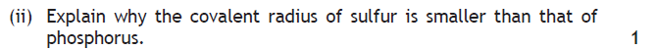
2016
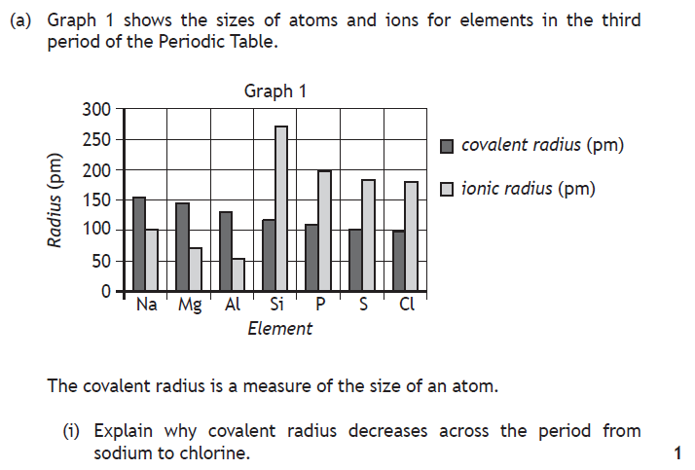
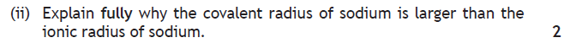
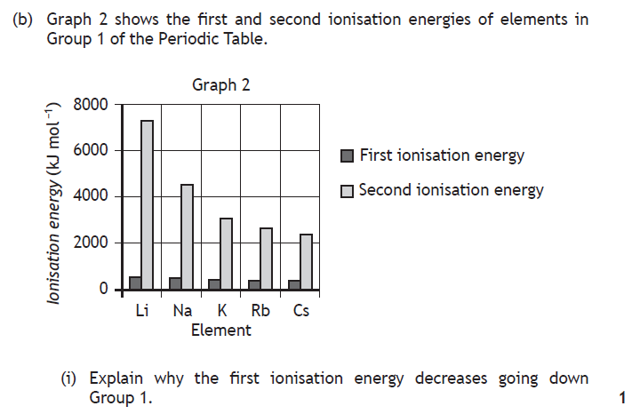

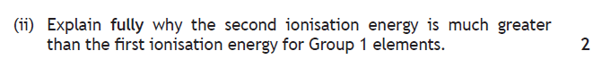
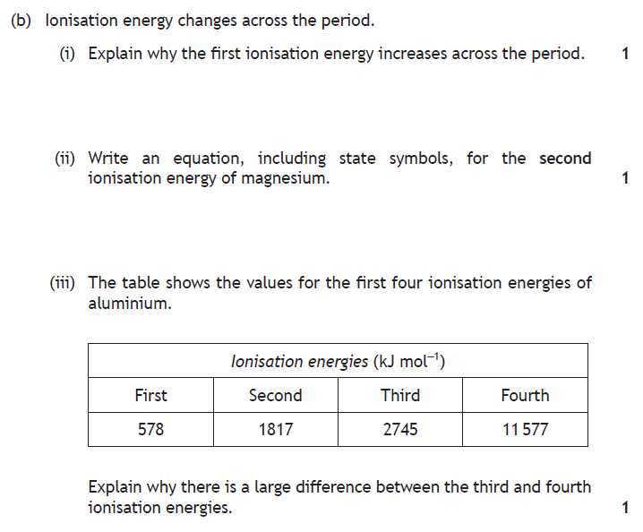
- Bonding and Structure
2.1 Bonding in Elements
2.1.1 Metallic Bonding
The metals in the first 20 elements have 1, 2 or 3 outer electrons. These outer electrons are loosely held and so they become delocalised i.e. they are free to move around the lattice structure.
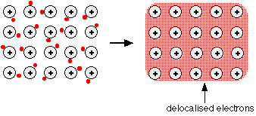
The nuclei and inner electrons can be considered as positively charged ions in a “pool” of delocalised electrons. These delocalised electrons allow metals to conduct in the solid state.
A metallic bond is the electrostatic attraction between the negatively charged electrons and the positive metal ions.
Complete the table and explain the trend:
 | Sodium | Magnesium | Aluminium
Melting Point / °C
Boiling Point / °C

2.1.2 Covalent Bonding
When non-metal atoms bond, their electron clouds overlap and the atoms share electrons.
A covalent bond is the electrostatic attraction between the positively charged nuclei and the negatively charged shared pair of electrons.
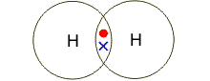
Hydrogen, H₂
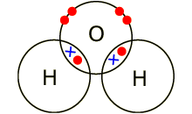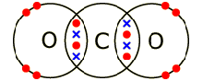
Water, H₂O Carbon dioxide, CO₂
(note the double bond – 2 pairs of shared electrons)
These are examples of molecules – discrete groups of atoms covalently bonded.
Covalent network structures also exist. These are very strong, three dimensional network structures. Diamond, for example:
2.1.3 London Dispersion Forces
In the National 5 course, we learned that there were forces between molecules that increased in strength with increasing molecular mass. This was illustrated, for example, by the increasing boiling points for the organic series (hydrocarbons, alcohols and acids) as carbon atoms are added.
There are three types of these intermolecular forces (called van der Waals forces), but for elements we only need to consider the weakest of these forces – London dispersion forces. These weak forces exist between all atoms and molecules because they occur due to movement of the electron cloud.
The electrons in any atom or molecule are constantly moving. This means that at any point in time, there may be an uneven distribution of charge. This means that one side of the atom/molecule with have a slightly negative charge and the other side will be left with a slightly positive charge.
These charges are shown as δ- and δ+ (the charge is not a full electron, δ means partial). This unequal distribution of charge is called a dipole (2 poles) and in this case they are temporary dipoles as the electrons keep moving.
When the δ- side of an atom or molecule comes close to the electron cloud of a neighbouring atom/molecule, the δ- charge will repel the electrons in the neighbouring atom/molecule and cause a temporary dipole to be set up with the δ+ side closest. This is called an induced dipole. The δ- side of the temporary dipole is then attracted to the δ+ side of the induced dipole.
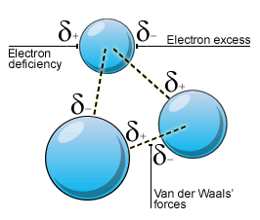
London dispersion force
London dispersion forces are the electrostatic force of attraction between the oppositely charged sides of a temporary dipole and induced dipoles caused by movement of electrons in atoms and molecules.
London dispersion forces increase in strength as the number of electrons increases.
2.1.4 Covalent Network Solids – Boron, Silicon and Carbon
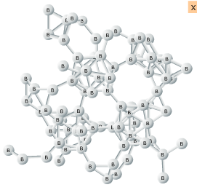
Boron has a covalent network structure that is based on interlocking B₁₂ molecular units.
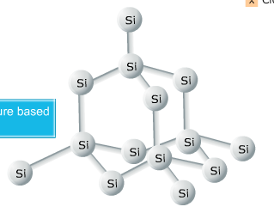
Silicon has a covalent network structure that is based on a tetrahedron.
Carbon has three different structures: diamond and graphite are covalent networks, fullerenes are covalent molecular structures.
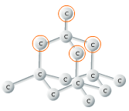
Diamond has a network structure containing only strong covalent bonds and it is based on a tetrahedral structure. Each carbon atom is bonded to 4 other carbon atoms.
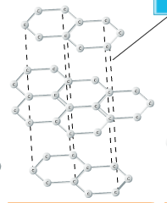
Graphite has a network structure of layers of 6 member rings of carbon. Each carbon is covalently bonded to 3 other carbons leaving 1 delocalised electron to move around the structure.

There are weak London dispersion forces between the layers.

2.1.5 Covalent Molecular Solids – Carbon, Phosphorus and Sulfur
The third form of carbon was discovered in 1985.
Fullerenes are covalent molecules, the smallest of which has 60 carbon atoms. C₆₀ is a spherical molecule named buckminsterfullerene.
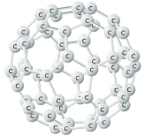
The fullerenes have joined 5 and 6 member carbon rings.
They have spherical, elongated sphere and nanotube shapes.
(Buckminster Fuller was an American architect who popularised the geodesic dome – structures of 5 and 6 membered rings)
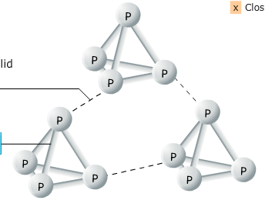
Phosphorus forms tetrahedral P₄ molecules.
London dispersion forces between the molecules.
Covalent bonds within the molecules

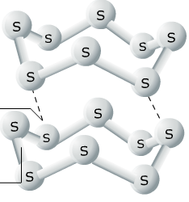
Sulphur forms 8 membered puckered ring shaped molecules, S₈.
London dispersion forces between the molecules.
Covalent bonds within the molecules

Note: The diatomic elements (H₂, N₂, O₂, F₂, Cl₂) are gases at room temperature whereas the larger molecules, P₄, S₈ and fullerenes are solids at room temperature. This is because the London dispersion forces increase in strength with increasing molecular mass – which means more electrons to move.
2.2 Properties of the First Twenty Elements
Type of Bonding and Structure | Conducts or Not | Moving Charged Particles
Metallic solids

Covalent network solids

Covalent molecular solids

Covalent molecular (diatomic) gases
Monatomic (Noble) gases

Melting Points and Boiling Points

This graph illustrates the differences in melting and boiling across the first 20 elements.
The molecular elements:

The covalent network elements:

The metals:

Complete the table and explain the trend:
Group 7 Element | Boiling Point / °C | Group 0 Element | Boiling Point / °C

  - Bonding in Compounds
The first twenty elements can form compounds with ionic or covalent bonds between the atoms. The molecular compounds also have intermolecular forces between the molecules. These intermolecular forces are called van der Waals forces.

2.3.1 Ionic Bonding
Ionic bonding is the electrostatic attraction between the positive ions of one element and the negative ions of another element.
The greater the difference in electronegativity between the two elements, the less likely they are to share electrons. The element with the greater electronegativity will gain electrons to form a negatively charged ion, whilst the less electronegative element will lose electrons to form a positively charged ion. Elements that are far apart in the Periodic Table are more likely to form ionic bonds and so they are normally formed between metals and non-metals.
For example:
Element Name | Lithium | Fluorine
Symbol
Electronegativity
Ion Formed

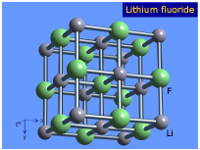
Ionic bonds are strong (100 to 450 kJ mol-1) and ionic compounds exist as crystal lattice structures in which each ion is attracted to a number of oppositely charged ions.

2.3.2 Covalent Bonding in Compounds
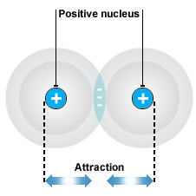
Covalent bonding in elements is known as pure covalent (or non-polar covalent) bonding. The electrons are equally shared as two atoms of the same element must have the same electronegativity.
When a covalent bond forms between atoms with different electronegativity values the electrons are not equally shared. This gives rise to a polar covalent bond. The atom with the greater electronegativity has a greater share of the electrons and carries a slightly negative charge, δ-, the atom with the lower electronegativity will then carry a slightly positive charge, δ+. This is called a permanent dipole (compare with temporary dipoles seen in London dispersion forces).
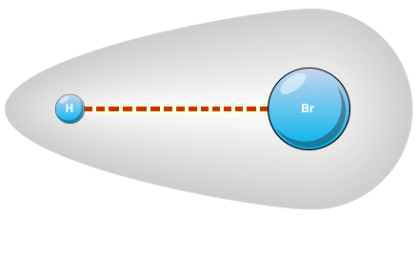
Example:
Hydrogen chloride H – Cl
Electronegativity 2.2 3.0
δ-
δ+
Cl
Use electronegativity values to assign a charge (δ- or δ+) to each atom in the molecules:
H – F O O = C = O
H H
Which pairs of different elements in the first twenty will form pure covalent bonds?

______________________________________________________________________________
2.3.2 The Bonding Continuum
Pure covalent bonding and ionic bonding can be considered as being at opposite ends of a bonding continuum with polar covalent bonding lying between these two extremes.
The larger the difference in electronegativities between bonded atoms is, the more polar the bond will be. If the difference is large then the movement of bonding electrons from the element of lower electronegativity to the element of higher electronegativity is complete resulting in the formation of ions.
ZERO INTERMEDIATE LARGE
Difference in electronegativity

Pure covalent Polar covalent Ionic

Increasing ionic character

Compounds formed between metals and non-metals are often, but not always ionic. The properties of the compound should be used to deduce the type of bonding and structure rather than the type of elements present in the formula.
Example: Titanium chloride is a liquid at room temperature, so it cannot be ionic. Ionic substances are always solids at room temperature.

2.4 Intermolecular Forces
The forces of attraction between molecules are known as van der Waals forces. There are three main types of van der Waals forces: London dispersion forces, permanent dipole-permanent dipole interactions and hydrogen bonding.
The weakest of the intermolecular forces are London dispersion forces. They are only significant for non-polar molecules (and atoms like the noble gases).
Hydrocarbons are considered to be non-polar molecules. The trend in physical properties such as boiling point and viscosity with increasing molecular mass of the alkanes is a result of London dispersion forces. The forces increase in strength with increasing molecular mass as the number of electrons increases. For polar molecules, permanent dipole-permanent dipole and hydrogen bonding are of greater significance.
2.4.1 Polar Molecules
Just because a molecule has polar bonds, it does not mean that the molecule is polar. The symmetry of the molecule has to be considered. The molecule must have an overall dipole – a positive end and a negative end.
Diatomic molecules with two atoms of different electronegativity must be polar:
e.g. 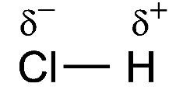 one end is δ- and the other end is δ+
Planar molecules can be polar or non-polar.
Water is a polar molecule. Carbon dioxide is non-polar.
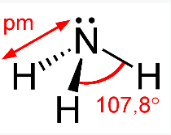
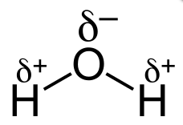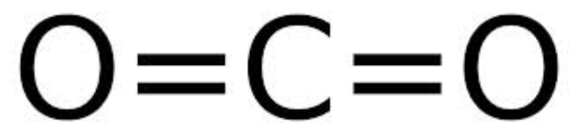
δ-
δ-
δ+
δ-
δ-
Pyramidal molecules can be polar, ammonia is the principal example
δ+
δ+
δ+

Tetrahedral molecules can be polar or non-polar. The atoms around the central atom must be considered.
If all four atoms around the central atom If at least one atom is different atom are the same, the molecule is symmetrical from the others the molecule is not symmetrical and therefore polar. symmetrical and therefore non-polar.
δ-
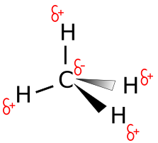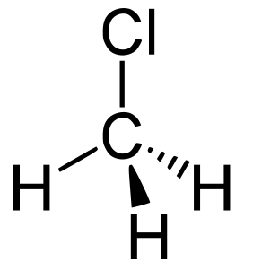
δ+
δ+
δ+

Demonstration: Polar and non-polar molecules can be distinguished by their behaviour in an electric field.
Describe this demonstration:
Polar Liquid | Non-Polar Liquid

How would you expect the following liquids to behave in an electric field?
Hydrochloric acid: _______________________________
Nitrogen: _____________________________________
Ammonia: _____________________________________
Methane: _____________________________________
2.4.2 Permanent Dipole – Permanent Dipole Interactions
These interactions occur between polar molecules and are much stronger than London dispersion forces.
The dipole in HCl, for example, is permanent because chlorine always has a greater attraction for the shared electrons (electronegativity) compared with hydrogen.
The δ- Cl is attracted to the δ+ H in a neighbouring molecule. Thus, permanent dipole-permanent dipole interaction.

2.4.3 Hydrogen Bonding
Hydrogen bonding is the strongest of the intermolecular interactions. It is a form of permanent dipole – permanent dipole interaction concerning molecules where hydrogen is bonded to a highly electronegative atom, namely nitrogen, oxygen and fluorine.
The compounds which exhibit hydrogen bonding all have N-H, O-H or H-F bonds.
Name | Formula | H bonding or Not
Hydrogen bromide | HBr
Propanol | CH₃-CH₂-CH₂-OH
Aminoethane | CH₃-CH₂-NH₂
Methoxymethane | CH₃-O-CH₃
Hydrogen | H₂
Propanone | CH₃-CO-CH₃
Tetrafluoromethane | CF₄

2.5 Properties of Compounds
The melting and boiling points and solubility of compounds depends on the types of bonding present.
Substance | Molecular Mass | Melting Point/°C | Boiling Point/°C | Polar or Non-Polar
Butane
Methanal
Ethane
Propanone
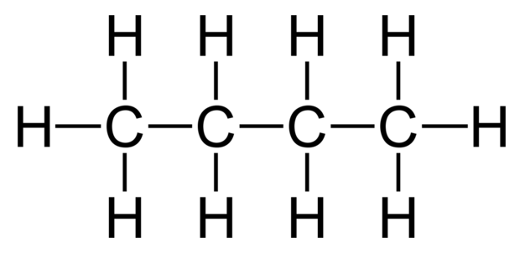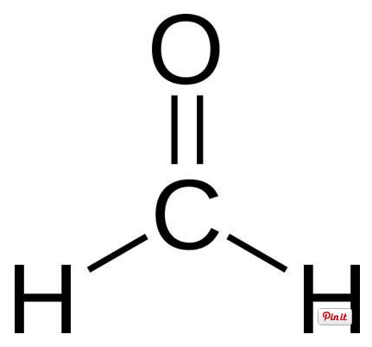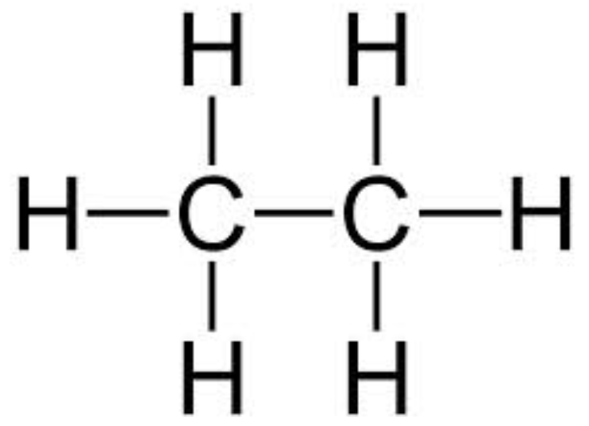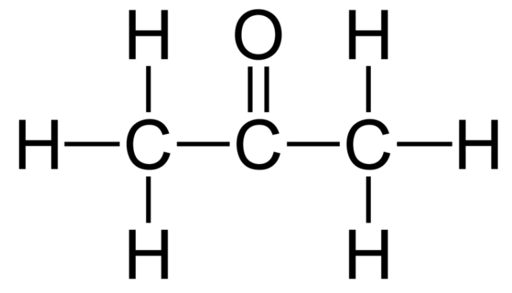
How do the melting and boiling points of polar substances compare with those of non-polar substances of similar molecular mass? Explain.

___________________________________________________________________________

___________________________________________________________________________

___________________________________________________________________________

Why is it important to compare substances with similar molecular mass?

___________________________________________________________________________

___________________________________________________________________________
The graph shows the boiling points of the hydrides of Groups 4, 5, 6 and 7.
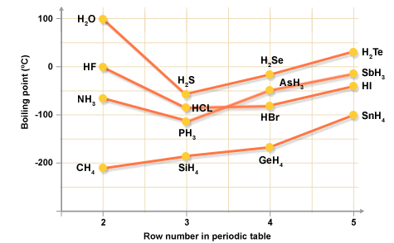

Explain the trend in the Group 4 hydrides:

___________________________________________________________________________

___________________________________________________________________________

Explain the high boiling points of the hydrides of the row 2 elements in Groups 5, 6, and 7

___________________________________________________________________________

___________________________________________________________________________

___________________________________________________________________________

The viscosity of a liquid depends on the strength of the intermolecular forces present.
E.g. the viscosity of the fractions obtained from the distillation of crude oil increases with increasing molecular mass. This is because the London dispersion forces increase with increasing molecular mass.
The stronger the intermolecular force, the greater the viscosity. So:
Hydrogen bonding > permanent dipole-permanent dipole > London dispersion forces

Solubility is dependent on the types of bonding present in the solute and the solvent.
The general rule is that like dissolves like. This means that polar solutes will dissolve in polar solvents and non-polar solutes in non-polar solvents.
When a bond forms, energy is released. Energy is required to break a bond. When a substance dissolves, bonds are broken in the solute and in the solvent and then bonds are formed between solute and solvent.
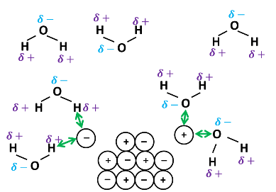
Ionic substances dissolve in water because the energy released in the making of the bonds between the polar water molecules and the ions is enough to keep breaking up the ionic lattice.
The ions become surrounded by water molecules – the ions are hydrated.

Polar Solvents | Non-polar Solvents

Miscibility of liquids is similar to solubility, two polar liquids or two non-polar liquids can mix (are miscible) but a polar liquid and a non-polar liquids will not mix (are immiscible).
    - Anomalous Properties of Water

In addition to the higher than predicted boiling point of water (considering it’s molecular mass), water is unusual in that it is less dense as a solid than as a liquid; ice floats on water.

This is due to hydrogen bonds between the molecules forming an open lattice structure.

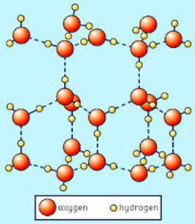

Bonding and Structure Past Papers Make sure you have model answers!
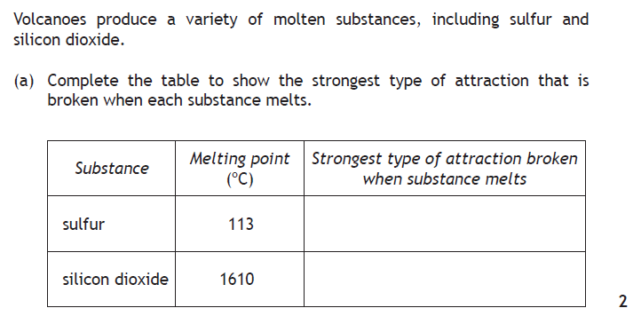
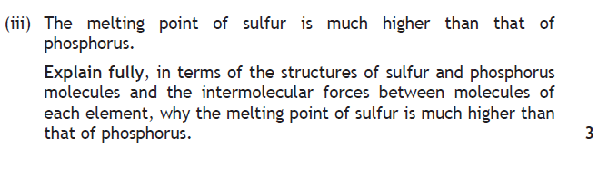
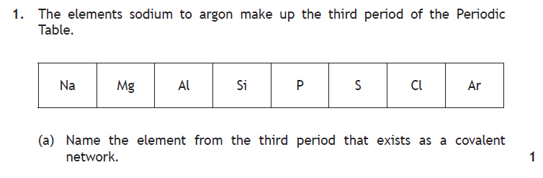
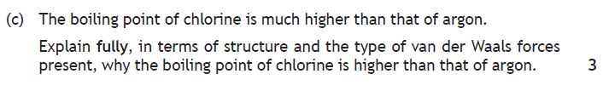
- Oxidising and Reducing Agents

What is meant by:

Oxidation

Reduction

Redox

Page 12 of the data booklet, the electrochemical series, lists the reduction reactions for a variety of substances

Use the data booklet to write ion-electron equations for the reduction of:
Magnesium ions in solution

Liquid bromine

Permanganate ions in solution

Use the data booklet to write ion-electron equations for the oxidation of:

Aluminium metal

Iodide ions in solution

Sulphite ions in solution

To form an overall redox equation, the ion-electron equations for the oxidation and the reduction are combined, ensuring that the number of electrons lost in oxidation equals that number gained in the reduction. Electrons do not appear in the redox equation.

Writing a redox reaction by combining half equations.
If magnesium is added to a solution containing Fe(III) ions, a displacement reaction occurs.
- Write the equation for the oxidation of magnesium metal
Mg(s) Mg²⁺(aq) + 2e⁻

- Write the equation for the reduction of iron (III) ions to Fe atoms
Fe³⁺(aq) + 3e⁻ Fe(s)

- Multiply through so the number of electrons is the same on both sides
Combine the equations to write the overall redox reaction.
Mg(s) Mg²⁺(aq) + 2e⁻ (x3) 3Mg(s) 3Mg²⁺(aq) + 6e⁻
Fe³⁺(aq) + 3e⁻ Fe(s) (x2) 2Fe³⁺(aq) + 6e⁻ 2Fe(s)
3Mg(s) + 2Fe³⁺(aq) 3Mg²⁺(aq) + 2Fe(s)

Write the redox equations for:
The reaction of aluminium with dilute hydrochloric acid:

The reaction of acidified potassium permanganate with iron (II) sulfate

Extracting the half equations from the redox equation.
a. Zn + 2Ag ⁺ → 2Ag + Zn ²⁺

b. I₂ + SO₃ ²⁻ ⁺ H₂0 → 2I – + SO₄ ²⁻ + 2H ⁺

c. 2I – + 2Fe ³⁺ → I₂ + 2Fe ²⁺

The substance that is oxidised ‘gives’ electrons to the substance that is reduced, therefore is the REDUCING AGENT.
The substance that is reduced accepts electrons from the substance that is oxidised, therefore is the OXIDISING AGENT.
In the equations below, circle the reducing agent and underline the oxidising agent.
Zn + 2Ag ⁺ → 2Ag + Zn ²⁺

I₂ + SO₃ ²⁻ ⁺ H₂0 → 2I – + SO₄ ²⁻ + 2H ⁺

2I – + 2Fe ³⁺ → I₂ + 2Fe ²⁺

2Br – + SO₄ ²⁻ + 2H ⁺ → Br ₂ + SO₃ ²⁻ ⁺ H₂0

MnO₄ – + 8H ⁺ + 5Fe ²⁺ → Mn²⁺ + 4H₂0 + 5Fe ³⁺

Oxidation and reduction reactions can be represented by ion-electron equations.
When molecules or group ions are involved, if the reactant and product species are known, a balanced ion-electron equation can be written by adding appropriate numbers of water molecules, hydrogen ions and electrons.
The sequence is:
- Balance the atoms apart from oxygen and hydrogen.
- Balance the oxygen and hydrogen atoms by adding hydrogen ions/water
- Balance the charges by adding electrons to the most positive side

e.g. CIO₃ ⁻ → CI₂
Balance the atoms other than oxygen and hydrogen
2CIO₃ ⁻ → CI₂
Balance the oxygen by adding water to the other side
2CIO₃ ⁻ → CI₂ ⁺ 6H₂0
Balance the hydrogen by adding H⁺ to the other side
2CIO₃ ⁻ + 12H ⁺ → CI₂ ⁺ 6H₂0
Total up the charges on each side and add electrons to the most positive side to equalise the charge.
2 - + 12+ = 10+ → no charge
therefore add 10 electrons to the left hand side.

CIO₃ ⁻ + 12H ⁺ + 10e ⁻ → CI₂ ⁺ 6H₂0

Redox reactions of this type only take place in acidic solutions – the H⁺(aq) are required as a reactant.
Try these:
SO₃²⁻ → SO₄²⁻

MnO₄⁻ → Mn²⁺

IO₃⁻ → I₂

PbO₂ → Pb²⁺

XeO₃ → Xe
Problems
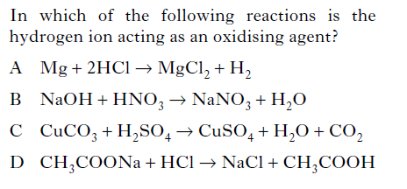
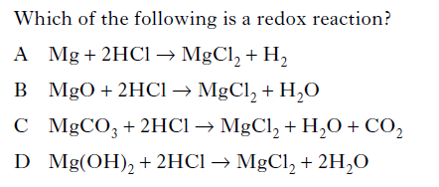
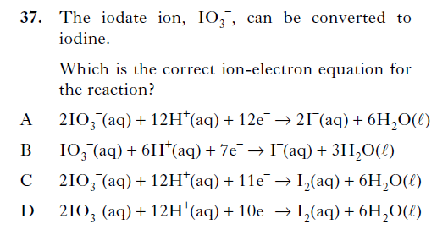
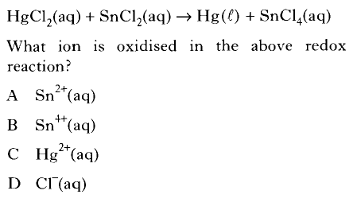
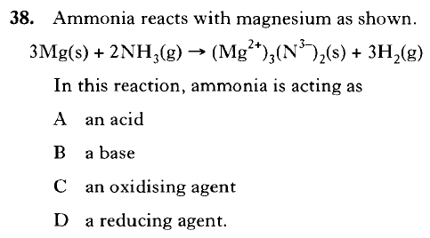
Everyday Uses for Oxidising Agents
Oxidising agents are widely employed because of the effectiveness with which they can kill fungi and bacteria and can inactivate viruses. The oxidation process is also an effective means of breaking down coloured compounds making oxidising agents ideal for use as "bleach" for clothes and hair.

Oxidising agents remove electrons from other chemicals forcing them to lose electrons. Oxidising agents are found on the bottom left hand side of the ECS. Oxidising agents are reduced in the reaction.
Example:
Acidified potassium dichromate is an excellent oxidising agent e.g. oxidation of alcohol in the breathalyzer test. The dichromate ion is reduced in the process. Write the half equation for the dichromate ion when it acts as an oxidising agent.

Research task
Investigate some possible uses for oxidising agents. It is important to discuss the impact on society / environment.

Elements as oxidising or reducing agents

The elements with low electronegativities (metals) tend to form ions by losing electrons (oxidation) and so can act as reducing agents. The strongest reducing agents are found in group 1.

The elements with high electronegativities (non-metals) tend to form ions by gaining electrons (reduction) and so can act as oxidising agents. The strongest oxidising agents are found in group 7.

Comparing the strength of oxidising agents from group 7.
Which halogen would you expect to be the best oxidising agent? Why?

Questions:

Which halogen solution is the strongest bleaching agent?

Which halogen is the most reactive?

Write symbol equation for the reaction of chlorine with potassium bromide.

Rewrite the above equation omitting spectator ions

Write a half equation for the oxidising agent in the above reaction

Molecules and group ions can act as oxidising and reducing agents

Eg MnO₄⁻ (aq) + 8H⁺ (aq) + 5e⁻ → Mn²⁺ (aq) + 4H₂O(l)

1. Is MnO₄⁻ acting as a reducing or oxidising agent in the reaction with glycerol?

2. The dichromate and permanganate ions are strong oxidising agents in acidic solutions. How is this shown in the half equation?

Hydrogen peroxide is an example of a molecule which is a strong oxidising agent. Carbon monoxide is an example of a gas that can be used as a reducing agent. Oxidising and reducing agents can be selected using an electrochemical series from a databook or can be identified in the equation showing a redox reaction.

The blue bottle experiment.
Methylene blue is reduced by dextrose to a colourless compound. This can be oxidised back to the blue form by a gas. Which gas is acting as the oxidizing agent?

Explain why is it necessary to periodically remove the stopper?

Elephants toothpaste. Write the equation for the decomposition of hydrogen peroxide.

A slight brown colour can be seen as the iodide ions are converted to iodine molecules by the hydrogen peroxide. Is hydrogen peroxide acting as a reducing agent or an oxidizing agent?

H₂O₂ + 2H⁺ + 2 I⁻ → 2 H₂O + I₂
Oxidising and Reducing Agents Past Papers
2015
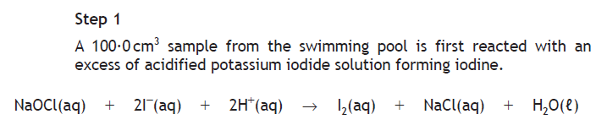
2016
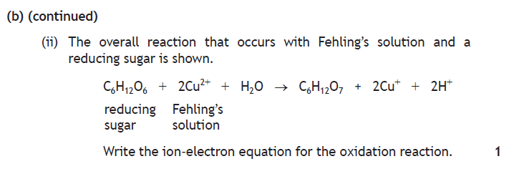
2017
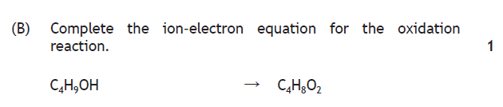

No. | Higher Chemistry Unit 1: Chemical Changes & Structure
 | Higher Chemistry Unit 1a Periodicity
1 | Elements are arranged in the periodic table in order of increasing atomic number.
2 | The periodic table allows chemists to make accurate predictions of physical properties and  chemical behaviour for any element, based on its position. Features of the table are:  - groups: vertical columns within the table contain elements with similar chemical properties resulting from a common number of electrons in the outer shell  - periods: rows of elements arranged with increasing atomic number, demonstrating an increasing number of outer electrons and a move from metallic to non-metallic characteristics
3 | The first 20 elements in the periodic table are categorised according to bonding and structure:  - metallic (Li, Be, Na, Mg, Al, K, Ca)  - covalent molecular — H2, N2, O2, F2, Cl2, P4, S8 and fullerenes (eg C60)  - covalent network — B, C (diamond, graphite), Si  - monatomic (noble gases)
4 | The covalent radius is a measure of the size of an atom. The trends in covalent radius across periods and down groups can be explained in terms of the number of occupied shells, and the nuclear charge.
5 | The first ionisation energy is the energy required to remove one mole of electrons from one mole of gaseous atoms. The second and subsequent ionisation energies refer to the energies required to remove further moles of electrons.
6 | The trends in ionisation energies across periods and down groups can be explained in terms of the atomic size, nuclear charge and the screening effect due to inner shell electrons.
7 | Atoms of different elements have different attractions for bonding electrons. Electronegativity is a measure of the attraction an atom involved in a bond has for the electrons of the bond.
8 | The trends in electronegativity across periods and down groups can be rationalised in terms of covalent radius, nuclear charge and the screening effect due to inner shell electrons.
 | Higher Chemistry Unit 1b(i) Structure & Bonding – Types of Chemical Bond
9 | In a covalent bond, atoms share pairs of electrons. The covalent bond is a result of two positive nuclei being held together by their common attraction for the shared pair of electrons.
10 | Polar covalent bonds are formed when the attraction of the atoms for the pair of bonding electrons is different. Delta positive (δ+) and delta negative (δ-) notation can be used to indicate the partial charges on atoms, which give rise to a dipole.
11 | Ionic formulae can be written giving the simplest ratio of each type of ion in the substance.  Ionic bonds are the electrostatic attraction between positive and negative ions. Ionic compounds form lattice structures of oppositely charged ions.
12 | Pure covalent bonding and ionic bonding can be considered as opposite ends of a bonding continuum, with polar covalent bonding lying between these two extremes. The difference in electronegativities between bonded atoms gives an indication of the ionic character. The larger the difference, the more polar the bond will be. If the difference is large, then the movement of bonding electrons from the element of lower electronegativity to the element of higher electronegativity is complete, resulting in the formation of ions.
13 | Compounds formed between metals and non-metals are often, but not always, ionic. Physical properties of a compound, such as its state at room temperature, melting point, boiling point, solubility, electrical conductivity, should be used to deduce the type of bonding and structure in the compound.
 | Higher Chemistry Unit 1b(ii) Structure & Bonding – Intermolecular Forces
14 | All molecular elements and compounds and monatomic elements condense and freeze at sufficiently low temperatures. For this to occur, some attractive forces must exist between the molecules or discrete atoms.
15 | Intermolecular forces acting between molecules are known as van der Waals forces. There are several different types of these, such as London dispersion forces and permanent dipole-permanent dipole interactions that include hydrogen bonding.
16 | London dispersion forces are forces of attraction that can operate between all atoms and molecules. These forces are much weaker than all other types of bonding. They are formed as a result of electrostatic attraction between temporary dipoles and induced dipoles caused by movement of electrons in atoms and molecules.
17 | The strength of London dispersion forces is related to the number of electrons within an atom or molecule.
18 | A molecule is described as polar if it has a permanent dipole.
19 | The spatial arrangement of polar covalent bonds can result in a molecule being polar.
20 | Permanent dipole-permanent dipole interactions are additional electrostatic forces of attraction between polar molecules.
21 | Permanent dipole-permanent dipole interactions are stronger than London dispersion forces for molecules with similar numbers of electrons.
22 | Bonds consisting of a hydrogen atom bonded to an atom of a strongly electronegative element such as fluorine, oxygen or nitrogen are highly polar. Hydrogen bonds are electrostatic forces of attraction between molecules that contain these highly polar bonds.  A hydrogen bond is stronger than other forms of permanent dipole-permanent dipole interaction but weaker than a covalent bond.
23 | Melting points, boiling points, and viscosity can all be rationalised in terms of the nature and strength of the intermolecular forces that exist between molecules. By considering the polarity and number of electrons present in molecules, it is possible to make qualitative predictions of the strength of the intermolecular forces.
24 | The melting and boiling points of polar substances are higher than the melting and boiling points of non-polar substances with similar numbers of electrons.
25 | Boiling points, melting points, viscosity and solubility/miscibility in water are properties of substances that are affected by hydrogen bonding.
26 | The anomalous boiling points of ammonia, water and hydrogen fluoride are a result of hydrogen bonding.
27 | Hydrogen bonding between molecules in ice results in an expanded structure that causes the density of ice to be less than that of water at low temperatures.
28 | Ionic compounds and polar molecular compounds tend to be soluble in polar solvents such as water, and insoluble in non-polar solvents. Non-polar molecular substances tend to be soluble in non-polar solvents and insoluble in polar solvents.
29 | To predict the solubility of a compound, key features to be considered are the:  - presence in molecules of O-H or N-H bonds, which implies hydrogen bonding  - spatial arrangement of polar covalent bonds, which could result in a molecule possessing a permanent dipole
 | Higher Chemistry Unit 1c Oxidising and Reducing Agents
30 | Reduction is a gain of electrons by a reactant in any reaction.
31 | Oxidation is a loss of electrons by a reactant in any reaction.
32 | In a redox reaction, reduction and oxidation take place at the same time.
33 | An oxidising agent is a substance that accepts electrons.
34 | A reducing agent is a substance that donates electrons.
35 | Oxidising and reducing agents can be identified in redox reactions.
36 | Elements with low electronegativities tend to form ions by losing electrons and so act as reducing agents.
37 | Elements with high electronegativities tend to form ions by gaining electrons and so act as oxidising agents.
38 | In the periodic table, the strongest reducing agents are in group 1, and the strongest oxidising agents are in group 7.
39 | Compounds, group ions and molecules can act as oxidising or reducing agents:  - hydrogen peroxide is a molecule that is an oxidising agent  - dichromate and permanganate ions are group ions that are strong oxidising agents in acidic solutions  - carbon monoxide is a gas that can be used as a reducing agent
40 | Oxidising agents are widely used because of the effectiveness with which they can kill fungi and bacteria, and can inactivate viruses. The oxidation process is also an effective means of breaking down coloured compounds, making oxidising agents ideal for use as ‘bleach’ for clothes and hair.
41 | The electrochemical series represents a series of reduction reactions.
42 | The strongest oxidising agents are at the bottom of the left-hand column of the electrochemical series.
43 | The strongest reducing agents are at the top of the right-hand column of the electrochemical series.
44 | An ion-electron equation can be balanced by adding appropriate numbers of water molecules, hydrogen ions and electrons.
45 | Ion-electron equations can be combined to produce redox equations.

