**Hand-out 5**

**Removal of neurotransmitters**

* Neurotransmitters are **rapidly removed** from the synaptic cleft once the impulse has been transmitted.

Why is this important?

Removal of neurotransmitters can be achieved in two different ways…

|  |  |
| --- | --- |
| **Method of removal** | **Description** |
|  |  |
|  |  |

**Excitatory and Inhibitory signals**

* We know that neurotransmitters bind with ______________.
* It is the _____________________ which determines whether a signal is **excitatory or inhibitory**.
* A neuron can have many _____________ with other neurons.
* It is the __________ the excitatory and inhibitory signals that determines the **overall effect** and whether the impulse is passed on (‘fired’).

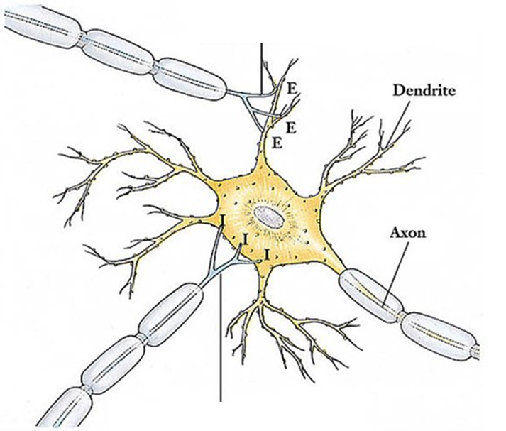

|  |  |
| --- | --- |
| **Threshold** |  |
| **Weak stimuli** |  |
| **Summation** |  |

**Summation of weak stimuli**

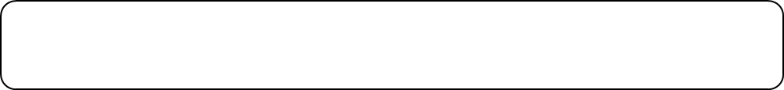



**Complex Neural Pathways**

These pathways enable the nervous system to carry out its many complex functions.

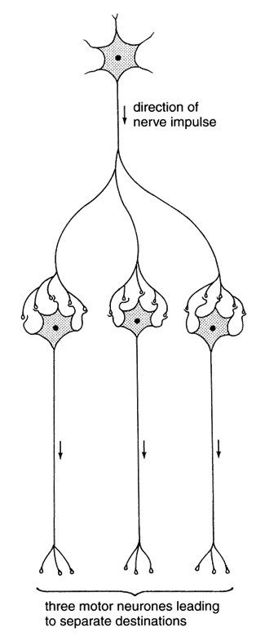

**Diverging neural pathways**

This is where ________ neurone is linked to ____________ neurones.

This allows impulses from the CNS to be sent to ______________________ (effectors/ muscles) at the _______________.

**Example**:

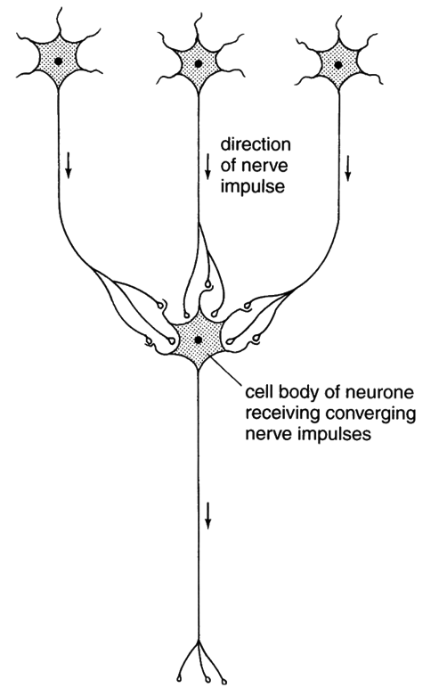

**Converging Neural pathways**

This pathway has **several neurons come together**, and link to ____________ neuron.

This allows _____________ from a number of nerve cells to be brought together making it more likely that the _____________ is reached and the impulse is ________________.

Converging neural pathways increase the ________________ to **excitatory** or **inhibitory signals**.

**Example:**

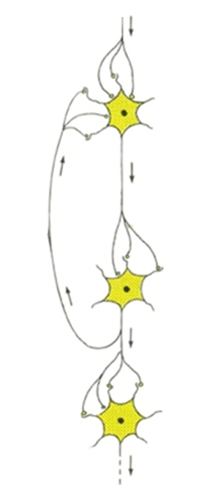**Reverberating neural pathways**

Neurons __________ in a neural pathway possess axon branches that form **synapses** with neurones ____________ in the pathway.

This can be used to send the impulse ______________________.

Impulses can therefore be **recycled** back through the pathway ____________ which brings about repeated activities

**Example:**