Hand-out 4

Cells of the Nervous System

Name of cell
Function | Receive and transmit electrical impulses from one part of the body to another | Support and maintain the neurons

There are 3 types of neuron:

- _____________________

- _____________________

- _____________________

Structure of neurons

The 3 types of neurone share the same basic structures:

- _____________________

- _____________________

- _____________________

The direction in which a nerve impulse travels is always:

Dendrites

A single nerve fibre which carries impulses Away from a cell body onto the next neurone in the sequence or to the effector. The axon ends at a junction called the synapse.

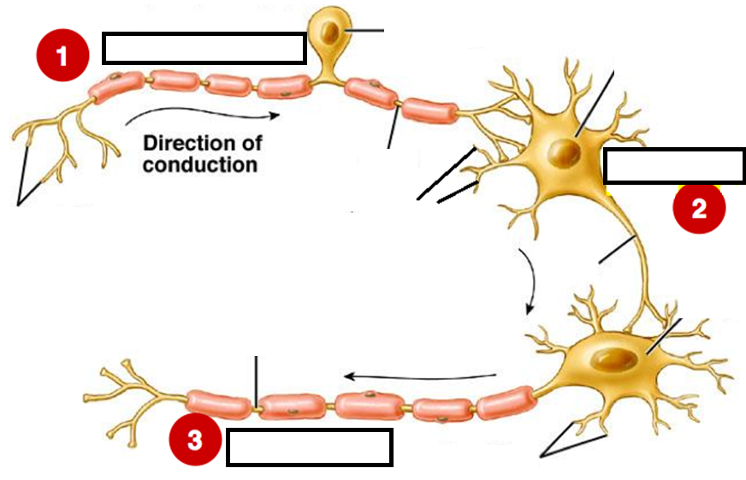

Glial Cells

- There are several types of glial cells which have numerous functions.

- They do not transmit nerve impulses but are essential to provide neurons with….

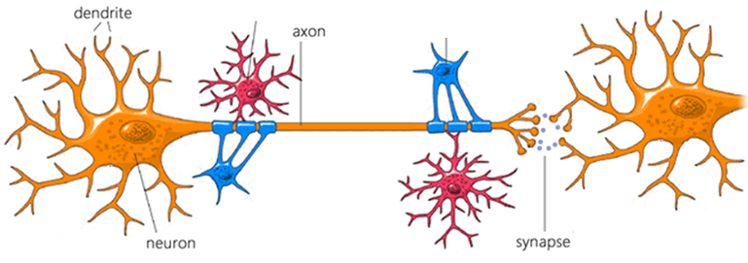

neuron is supported physically and chemically by glial cells

Myelination

- The __________ of nerve fibres are _______________ by a layer of fatty material called the ____________________.

- The myelin sheath is formed from special __________ cells which wind their membrane around the axon many times.

- Describe the important function played by the myelin sheath:

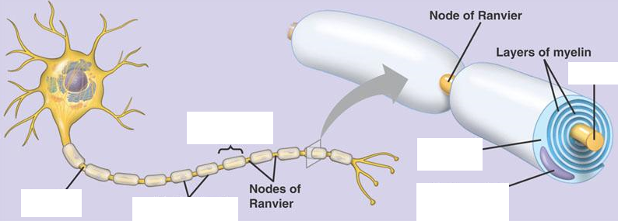

Myelination and development

- Myelination is not complete at birth but continues from birth into ________________.

- As a result responses to stimuli in the first two years of life are not as ___________ or _________________ as those of an older child or adult.

Myelination and disease

- Certain diseases damage or destroy the myelin sheath causing a loss of co-ordination.
- These include: __________________________________________

If time is available investigate one of the above conditions.

Synaptic Cleft
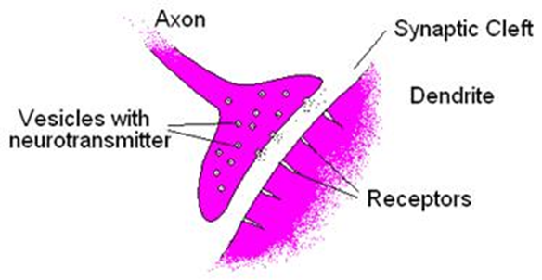
- Neurons are separated from each other by tiny microscopic gaps.

- The junction where two neurons meet (axon on one cell and dendrite of the next) is called the _______________.

- The synapse allows the transmission of nerve impulses between ____________.

- The narrow space which separates the plasma membranes of the two neurones is called the ______________ _________.

- Neurons connect with other __________ at the synaptic cleft.

Neurotransmitters

- The nerve cell before the synapse is called the _________________ neuron.
- The one after the synapse is called the ___________________ neuron.
- Neurons also connect with __________________ and __________________ cells via spaces similar to synaptic clefts.
- For a nerve impulse to cross the synaptic cleft, chemicals called __________________ have to enter the synapse.
e.g. ____________________________________________________
- Neurotransmitters relay messages within and out with the ____________ from __________ to neuron.
- Neurotransmitters are stored in _______________.

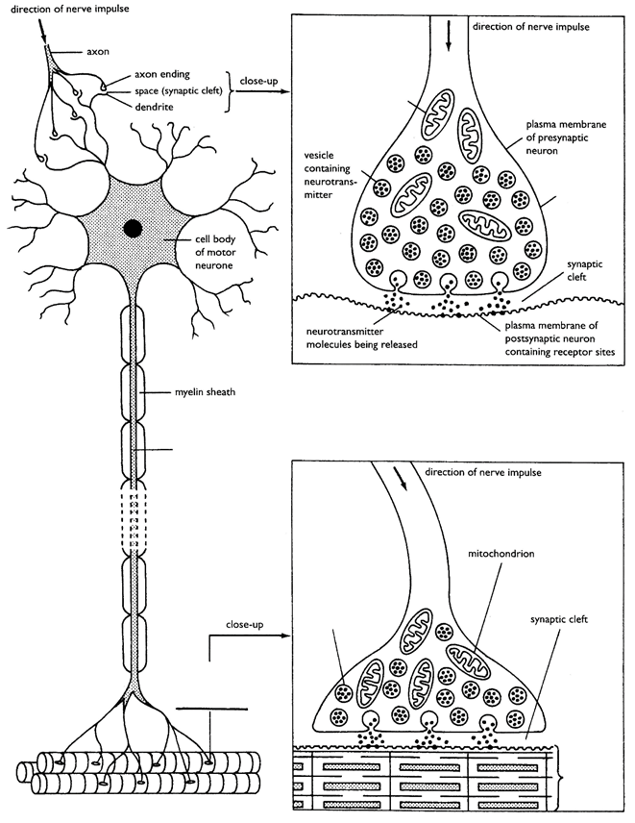
Chemical Trasnsmission at the Synapse

Nerve endings of postsynaptic neuron

Neurotransmitter diffuses across synaptic cleft
Arrival of impulse causes vesicles to fuse with presynaptic membrane

Direction of a nerve impulse
Summing up: Chemical transmission at a synapse

