Hand-out 2

Replication of DNA

- DNA is a unique molecule because it can make exact copies of itself using a process called DNA _______________. This is a complex process involving many ___________.
- DNA replication is the process used by cells to duplicate their _________________ prior to cell division.
- It ensures the new cells have the same ________________________ as the original parent cell.

The process is shown in a simple way in the diagram below. Label the diagram:
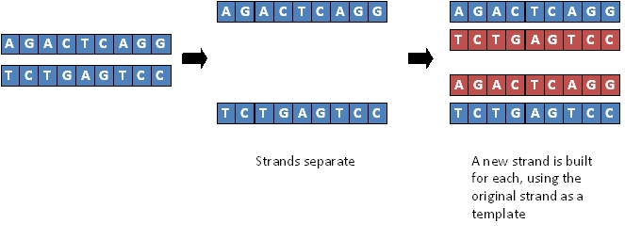

Steps in DNA Replication: A simple overview

Requirements for DNA Replication

- __________________________________________________________

- __________________________________________________________
- __________________________________________________________
- __________________________________________________________
- __________________________________________________________
Stages of DNA replication
Just for info! (you don’t need to know this)
Helicase - enzyme that breaks the bonds between base pairs in DNA, leaving two rows of bases with free-ends, on which new complementary strands can form
- Write notes to give a summary of DNA replication.

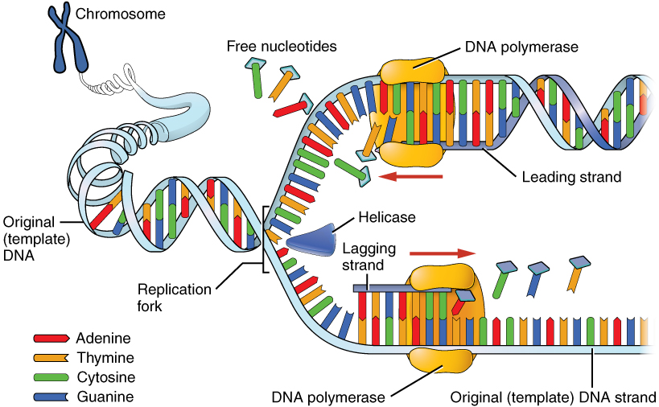

Key terms: In a sentence!

Term | In a sentence….
Replication fork
DNA polymerase
Primer
Leading strand
Lagging strand
Ligase

- Why is DNA replication described as being semi-conservative?

- Explain the Importance of DNA replication:

