Hand-out 1

The Nervous System

- The nervous system analyses _______________________ from the body and the external environment, stores some aspects and makes decisions regarding appropriate _______________ and behaviours.

- It makes motor responses by initiating _______________________ and _________________________.

Structural Division of the nervous system

The nervous system consists of the brain, spinal cord and peripheral nerves.
It can be divided into the central nervous system (CNS) and the peripheral nervous system (PNS).

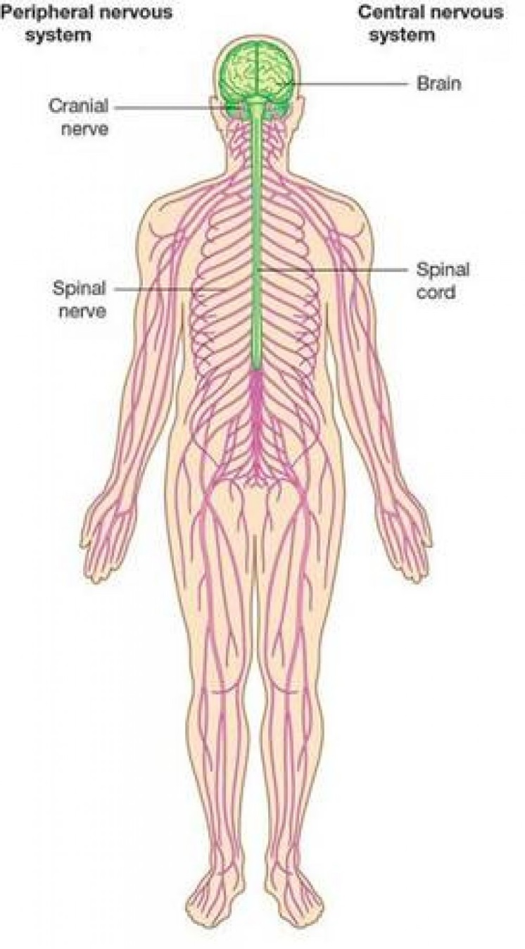

Complete the key to the structural division of the nervous system:
nervous system

Sensory and motor pathways

Many of the peripheral nerves contain a sensory pathway consisting of sensory nerve cells (neurons) and/or a motor pathway consisting of motor neurons.

Functional division of the nervous system

The nervous system can also be divided with reference to functions as well as structurally.

Part of nervous system | Structure | Function
 | Brain
 |  | Sends nerve impulses to and from the body and links the brain to the PNS.
Peripheral nervous system (PNS)

Peripheral nervous system (PNS)
The overall function of the PNS can be split into two functional parts:

PNS

Complete this diagram showing the functional divisions of the nervous system:
Peripheral Nervous System
Somatic nervous system (SNS)

- The somatic nervous system (which includes spinal nerves) controls the body’s ________________________.

- This involves ___________ and ____________ pathways as outlined on the flow diagram on the second page.

- The somatic nervous system is responsible for bringing about certain involuntary reflex actions (e.g. limb withdrawal) but most of the control that it exerts is over ______________ movements of the ____________________.

Autonomic nervous system (ANS)

- The autonomic nervous system normally works _______________ without the person’s conscious control.

- It controls functions that bring about a steady internal state within the body, thereby playing its part in the process of _________________.

These functions include regulating:

- The ANS is composed of _________________ and _________________ systems that work to regulate these processes.

- The sympathetic and parasympathetic systems are described as being ________________ because they have opposite effects on the same body structures.

- The autonomic nervous system originates in the ___________ of the brain.
Sympathetic and Parasympathetic Systems: Antagonistic in Action

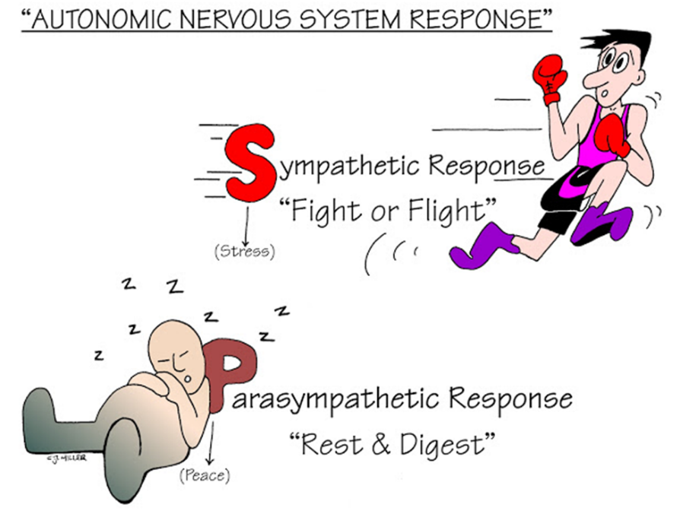

Organ/Tissue | Sympathetic | Parasympathetic
 | Rate and force of contractions increases
Lungs |  | Smooth muscle in bronchiole wall contracts
 | Rate of peristalsis and intestinal secretions decreases

Summary: Nervous System

Brain and Spinal cord
Somatic
Nervous System (SNS)

- Mostly voluntary

- Controls:

_____________

___________

_____________ _____________

- ______________

- Regulates internal structures and organs e.g. heart, lungs etc.

Sympathetic System
_________________

_________________

e.g.
increases heart rate
Parasympathetic system

Calms the body down returning it to its ‘normal’ state
e.g. _______________

_______________
Classified according to structure

Finished? Test Yourself…

- Collect a white board and pen.

- Try the questions on page 212 of your textbook – without notes!

